**Introduce yourself:**

Hi, I’m Ramkumar. I started my career in 2003 as a developer at ABT Limited. After that, I spent 8 years working on SQL Server development, administration and performance tuning. During this time, I worked with companies like Verizon, Cognizant, and Bank of America.

In 2015, joined Capgemini as a Technical Architect and I worked on both on-prem big data and aws cloud technologies.

In 2017, I joined Credit Suisse bank, which is recently acquired by UBS bank. Since then, I’ve been playing various roles such as Big Data and Cloud Architect, ARB member, Product Owner of an application. I have been driving few department-level cost optimization initiatives as-well.

My core focus areas are to make use of the full potentials of Databricks and Delta Lake and started exploring MLOps capabilities as-well.

**Azure Well Architected Framework:**

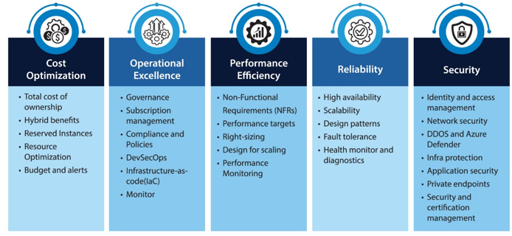

**Databricks Well Architected Framework**

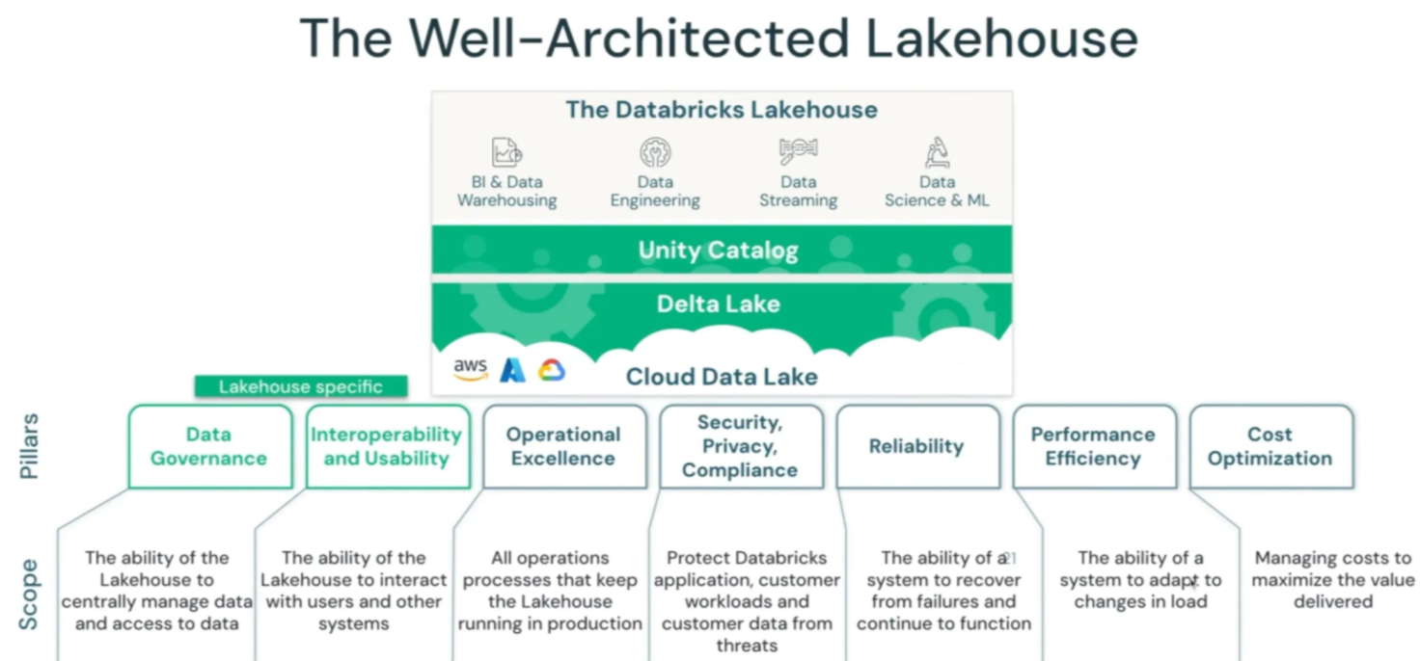

**Terms for Architects:**

**Data Governance, Cost optimization, Security, Reliability, Performance**, Availability/Fault tolerance, Scalability, Risk/Compliance, DR

**Responsibilities:** Ensure that architectural decisions within an organization align with its strategic goals, standards, and best practices.

**Data governance pillars:** Data ownership, Data quality, Data security & compliance, metadata management, data lifecycle management.

**Data architecture** is a discipline that define the structure, processes, governance, standards and best practices for collecting, storing, transforming, and using data to support business needs

**Concepts:**

**Issue in On premise:** CAPEX & OPEX costs. Cost and delay in procuring server, cost for NW/System admins. Overhead for HW, OS, Libraries, license, maintenance, upgrade, security

**Virtualization**: Allows to run multiple OS on a singly host server

**Virtualization software’s**: VMWare workstation/vSphere, KVM (AWS), XEN (AWS), VirtualBox

**Cloud computing** - Providing Infra/platform/software as services over the Internet.

**Cloud Benefits:** No CAPEX, Time to market, pay as-you-go, Agility, Auto scaling, Highly available, Fault tolerance Wide range of services to meet all our needs

**IAAS**: Control Host, OS, Runtime, Application, Data. We are responsible for license, maintenance, upgrade, security

**PAAS**: Control over Application, data. No need to worry about HW, OS, Libraries related license, maintenance, upgrade, security

**SAAS**: Control over data. No need to worry about HW, OS SW license, maintenance, upgrade, security

- Cloud providers have limits on Compute, storage.

- Elasticity - add, remove, modify compute capacity depends on the load.

- Vertical Scalability (Add more capacity to existing server. downtime is required) vs Horizontal Scalability (Add more servers in the cluster for better performance)

- Cloud service providers supports Auto scalling based on metrics (ex: cpu load) or schedule.

**Ports**: HTTP 80, HTTPS 443, FTP 21, SSH 22 (Putty/Mobaxterm), IMAP 143, DNS 54, SQL 3306

**Benefits of distributed system:** Scalability, Fault tolerance, parallism and high availability

**Microsoft fabric is an end to end data and analytics platform enterprises that requires a unified solution.**

**Principles of Software Development: SOLID, DRY, KISS, and more**

* **Single Responsibility Principle (SRP)**

a class should have only one well-defined responsibility.

* **Open/Closed Principle (OCP)**

Emphasizes designing code that is open for extension but closed for modification. In other words

* **Liskov Substitution Principle (LSP)**

LSP highlights the importance of adhering to contracts when inheriting classes. Specifically, if a class B is a subclass of class A, then it should be able to be used as a replacement for A without affecting the system’s overall consistency

* **Interface Segregation Principle (ISP)**

(ISP) advocates for defining specific interfaces for clients rather than having a monolithic interface. In other words, clients should not be forced to implement methods they don’t use.

* **Dependency Inversion Principle (DIP)**

The Dependency Inversion Principle (DIP) encourages the use of abstract dependencies rather than relying on concrete classes. In other words, high-level modules should not depend directly on low-level modules but on common abstractions.

**DRY - DRY (Don’t Repeat Yourself)**

* Reduction of Complexity
* Elimination of Duplicate Code
* Grouping by Functionality
* Code Reusability

**KISS (Keep It Simple, Stupid)**

**YAGNI (You Ain’t Gonna Need It) – don’t implement if not immediately required**

**c:**

Databricks UniForm, or Delta Lake Universal Format, allows Delta Lake tables to be read by Iceberg clients without rewriting the data. It essentially provides interoperability between Delta Lake and Iceberg, enabling you to use Iceberg clients with your Delta Lake tables

**Billing Tip**: Billing for databricks DBUs starts when Spark Context becomes available. Billing for the cloud provider starts when the request for compute is received and the VMs are starting up.

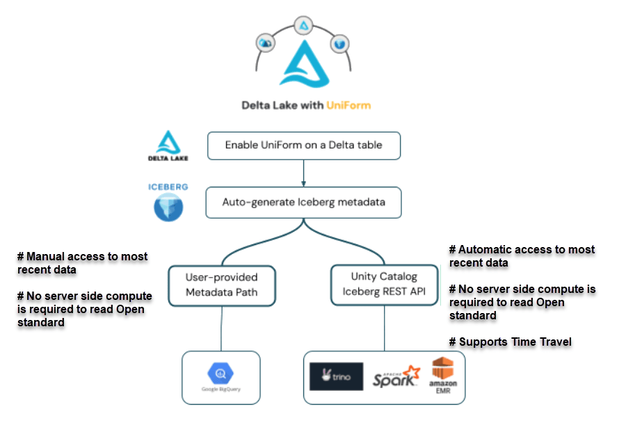

**Azure Databricks Reference Architecture**

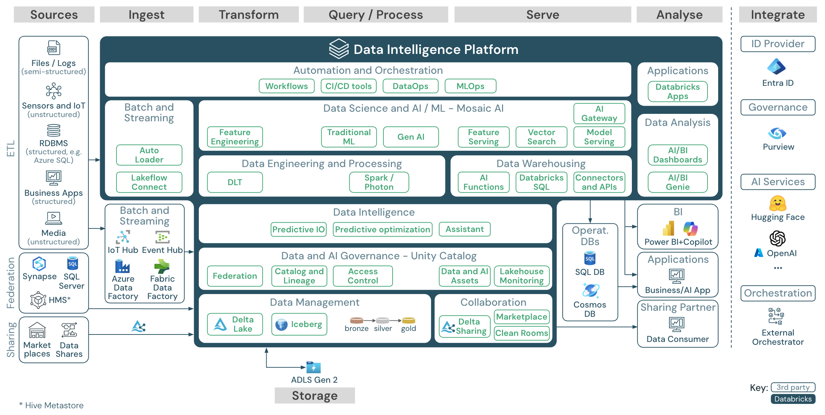

| **Azure Data Service** | **Top 3 Use Cases** | **Top 3 Features** |
| --- | --- | --- |
| **Azure Synapse Analytics** | 1. Data warehousing for BI  2. Big data analytics (Spark/SQL)  3. ETL/ELT with Pipelines | 1. Unified SQL + Spark engine  2. Serverless & dedicated pools  3. Power BI integration |
| **Azure Data Lake Storage (ADLS)** | 1. Centralized data lake for all formats  2. Staging for ETL pipelines  3. Data science and ML data source | 1. Hierarchical namespace (HNS)  2. Fine-grained RBAC + ACLs  3. Scalable to petabytes |
| **Azure Databricks** | 1. Scalable data engineering  2. Machine learning/AI  3. Streaming + batch pipelines | 1. Optimized Apache Spark platform  2. Delta Lake for ACID transactions  3. MLflow for ML lifecycle |
| **Azure Cosmos DB** | 1. Globally distributed transactional apps  2. Real-time IoT/telemetry  3. Product catalogs & personalization | 1. Multi-model support (SQL, MongoDB, etc.)  2. Global replication  3. <1ms read/write latency |
| **Azure SQL Database** | 1. OLTP applications  2. Web & mobile app backends  3. Modernizing on-prem SQL workloads | 1. Fully managed PaaS  2. Built-in HA & backup  3. Intelligent performance tuning |
| **Microsoft Fabric** | 1. Unified lakehouse analytics  2. Power BI + data engineering integration  3. Real-time pipelines and business insight | 1. OneLake as a single data store  2. Integrated Spark + Power BI  3. No-code data pipelines |

| **Cluster Type** | **Use Case** | **Recommended?** | **Notes** |
| --- | --- | --- | --- |
| **All-Purpose Cluster** | Interactive dev, notebooks, ad-hoc work | 🚫 Not for prod | Good for development. Costly if left running. |
| **Job Cluster** | Automated ETL jobs, batch pipelines | ✅ Yes | Cost-efficient for jobs; auto-terminates after job ends. |
| **DLT Cluster** | Managed ETL pipelines (batch/streaming) | ✅ Yes | Built-in reliability, monitoring, and data quality. |
| **SQL Warehouse - Classic** | Interactive SQL, BI dashboards | 🚫 Outdated | Older option, being phased out for Pro/Serverless. |
| **SQL Warehouse - Pro** | Fast queries, high concurrency BI | ✅ Yes | Good for shared dashboards and frequent queries. |
| **SQL Warehouse - Serverless** | Pay-per-use SQL for BI tools | ✅ Yes (BI) | No cluster setup needed. Best for Power BI/Tableau/Looker. |

**Spark vs Databricks**

|  |  |  |  |
| --- | --- | --- | --- |
| **Feature** | **Spark** | **Databricks** | **Key Features** |
| Databricks Runtime | NO | YES | Photon  Run multiple versions of Spark Built-in optimized for cloud storage Compute optimizations Multi-user cluster sharing Second level billing |
| Managed Data Lake | NO | YES | ACID Transations Schema management Batch/Stream read-write support Data versioning Performance optimizations |
| Integrated Workspace | NO | YES | Interactive Notebooks Real-time collaboration Github integration One-click visualizations |
| Enterprise Security | NO | YES | Access control for notebooks, clusters, jobs and data Audit logs Data encryption (at rest and motion) Compliance (HIPAA, SOC 2) |
| Integration | NO | YES | Connect with Power-BI/Tableau via JDBC/ODBC REST API Data Source Connectors |
| Expert Support | NO | YES |  |

**Others feature:** Delta Lake, Unity Catalog, DLT, MLOps, Cloud Integrations

**Azure Services:**

**Azure VM Types**

**General purpose (A, B, and D family series):** These VMs have a balanced CPU-to-memory ratio. They are best suited for testing and development (A series only), burstable workloads (B series only), and general-purpose workloads (D series only).

**Compute optimized (F family series):** These VMs have a high CPU-to-memory ratio. They are best suited for web servers, application servers, network appliances, batch processes, and any workload where bottlenecks and a lack of resources will typically originate in the CPU over memory.

**• Memory optimized (E and M family series):** These VMs have a high memory-to-CPU ratio. They are best suited for relational databases, in-memory analytics, and any workload where bottlenecks and a lack of resources will typically originate in the memory over the CPU.

**• Storage optimized (L family series):** These VMs have high disk throughput and I/O. They are best suited for data analytics, data warehousing, and any workload where bottlenecks and a lack of resources will typically relate to the disk over the memory and CPU.

**• GPU optimized (N family series):** These VMs have graphics processing units (GPUs). They are best suited for compute-intensive, graphics-/gaming-intensive, visualization, and video conferencing/streaming workloads.

**• High performance (H family series):** These are the most powerful CPU VMs that Azure provides, offering high-speed throughput network interfaces. They are best suited for compute and network workloads such as SAP HANA

**[Family] + [Sub-Family] + [# of vCPUs] + [Additive Features] + [Version]**

**VM series naming:**

• Family: This represents the VM family series.

• Sub-Family: This represents the specialized VM differentiations.

• # of vCPUs: This represents the number of vCPUs of the VM.

• Additive Features examples:

a = AMD-based processor  
b = Block Storage performance  
d = diskful (that is, a local temp disk is present);

i = isolated size  
l = low memory; a lower amount of memory than the memory intensive size  
m = memory intensive; the most amount of memory in a particular size  
p = ARM Cpu  
t = tiny memory; the smallest amount of memory in a particular size  
s = Premium Storage capable, including possible use of [Ultra SSD](https://learn.microsoft.com/en-us/azure/virtual-machines/disks-types#ultra-disks)

Some example breakdowns are as follows:

• B2ms: B series family, two vCPUs, memory-intensive, Premium Storage-capable

• D4ds v5: D series family, four vCPUs, local temp disk, Premium Storage-capable, version 5

• **D4as v5**: D series family, four vCPUs, AMD, Premium Storage-capable, version 5

• E8s v3: E series family, eight vCPUs, Premium Storage-capable, version 3

• NV16as v4: N series family, NVIDIA GRID, 16 vCPUs, AMD, Premium Storage-capable, version 4

**Normalization**

Normalization is the process of organizing the data in a relational database to minimize redundancy and dependency by dividing large tables into smaller ones and linking them using relationships.

**Normal Forms**

1. **First Normal Form (1NF):** Eliminate repeating groups and ensure that each column contains only atomic values (no arrays or lists).

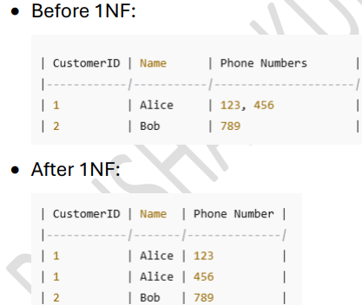

1. **Second Normal Form (2NF):** Eliminate partial dependency, which means each non-prime attribute must depend on the whole of the primary key

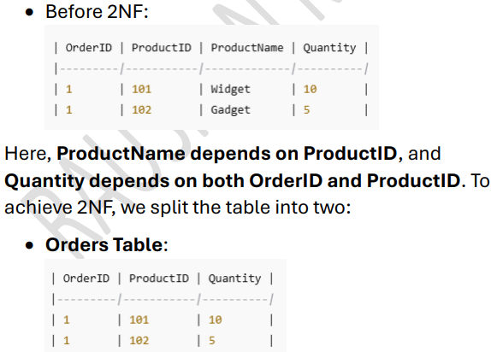

1. **Third Normal Form (3NF):** Eliminate transitive dependency, meaning non-key attributes must not depend on other non-key attributes

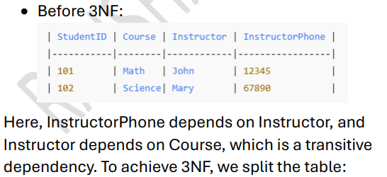

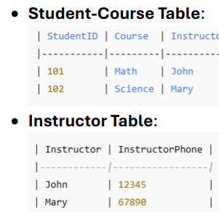

**Data Modelling**

**Definition:** Data modeling is the process of creating a visual representation of data and its relationships to facilitate database design and ensure data integrity, performance, and usability. It helps structure data logically and physically for storage and analysis.

1. **Conceptual Data Model:**

* High-level, abstract model focused on business requirements.
* Defines entities, relationships, and attributes without technical details.
* Example: Entities like Customer, Order, Product.

1. **Logical Data Model**:

* Intermediate model that defines the structure of the data, including entity relationships, attributes, and data types, without focusing on the DBMS.
* Example: Customer has attributes like CustomerID (Primary Key), Name, Address.

1. **Physical Data Model**:

* Implementation-focused, includes DBMS-specific details like table structures, indexes, data types, and constraints.
* Example: MySQL table creation with fields CustomerID INT AUTO_INCREMENT PRIMARY KEY.

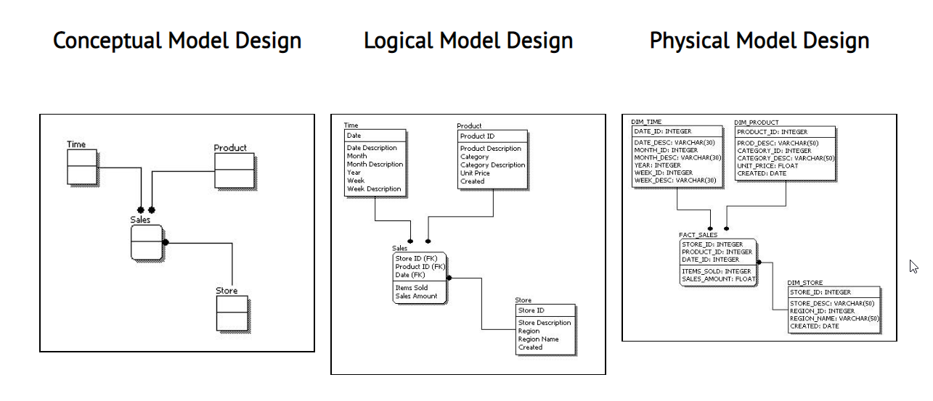

**ER Diagram (conceptual data model):**

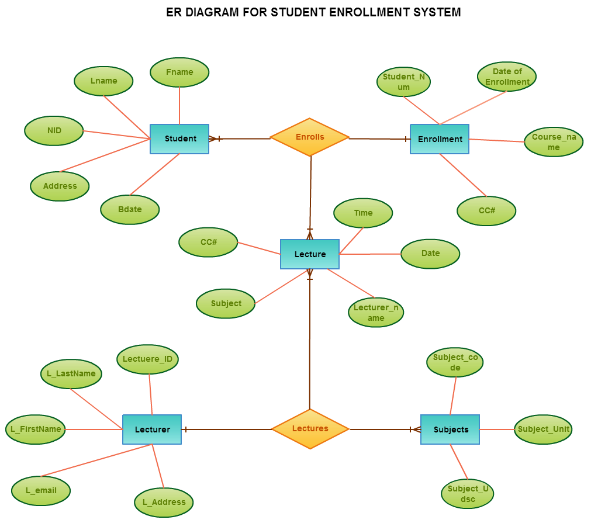

**Data Warehousing**

A data warehouse is a centralized repository that combines data from various sources to support business intelligence (BI) and analytical activities.

* Denormalized. OLAP, Optimized for read, Historical data

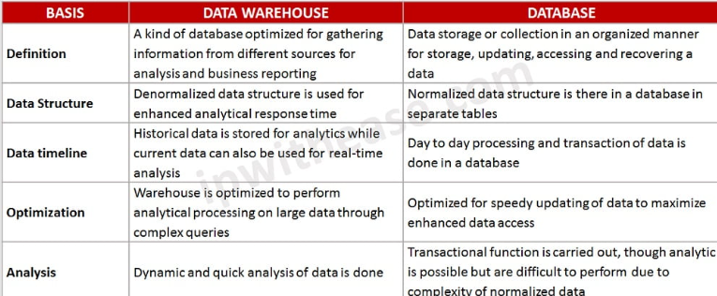

**Kimball’s Dimensional Modeling Approach**

Kimball’s dimensional modeling is a widely used approach for data modeling in data warehousing and business intelligence (BI) applications.

In Kimball’s dimensional modeling approach, data is organized into two main types of tables: fact tables and dimension tables. Fact tables store the quantitative measures or metrics of interest, while dimension tables provide descriptive attributes or context for these measures. The relationships between fact tables and dimension tables are established through keys.

**Star Schema**

The central component of the star schema is the fact table, which holds the quantitative measures or metrics that are the focus of analysis. Surrounding the fact table are dimension tables

**Snowflake Schema**

The snowflake data modeling technique is an extension of the star schema. It aims to further normalize dimension tables to eliminate redundancy and improve data integrity.

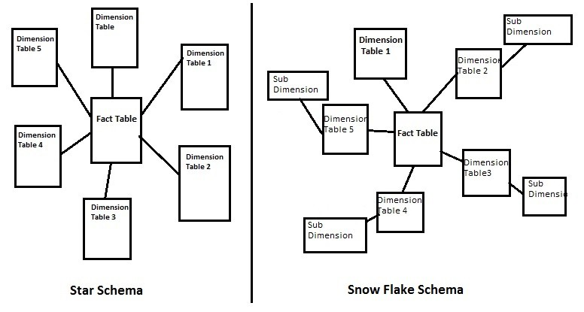

**Fact tables:**

**Fact Table:** Facts are numeric measures that represent business metrics.

* Central table that contains measurable, numeric data (facts).
* Includes foreign keys referencing dimension tables.
* Example: Sales_Fact table with fields SaleID, DateID, ProductID, CustomerID, and Revenue.

**Types of Facts -**

* **Additive Facts:**
  + Can be summed across all dimensions.
  + Example: Sales_Amount can be totalled by date, region, or product.
* **Semi-Additive Facts:**
  + Can be summed across some dimensions but not others.
  + Example: Account_Balance can be totalled by region but not over time.
* **Non-Additive Facts:**
  + Cannot be summed across any dimension.
  + Example: Ratios or percentages like Profit_Margin.

**Types of fact tables:**

* **Transactional Fact Tables -** Transactional fact tables are designed to capture individual business events or transactions
* **Periodic Snapshot Fact Tables -** A periodic snapshot fact table captures a summary of data at a fixed interval, such as daily, weekly, or monthly.
* **Accumulating Snapshot Fact Tables -** An accumulating snapshot fact table tracks the progress of a transaction/event
* **Factless fact table** - is a link table that contains only foreign keys to dimensions, but no numeric facts.

**Dimension Tables:** Dimensions provide the descriptive context for facts, enabling users to analyze and filter data from various perspectives.

* Surround the fact table and store descriptive, textual information about the facts.
* Example: Product_Dimension with fields ProductID, ProductName, Category.

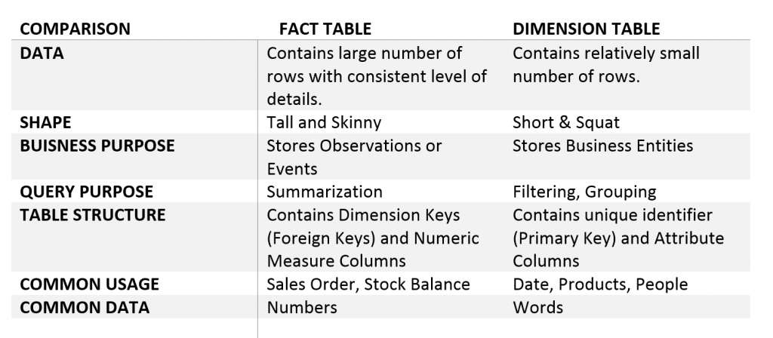

**Examples of Dimensions:**

* Time Dimension:
  + Attributes: Date, Week, Month, Year.
* Product Dimension:
  + Attributes: ProductName, Category, Price.
* Customer Dimension:
  + Attributes: CustomerName, Region, Age.

**Types of Dimensions:**

* Conformed Dimensions:
  + Shared across multiple fact tables or data marts.
  + Example: Time_Dimension used in both Sales_Fact and Inventory_Fact.
* Junk Dimensions:
  + Combines unrelated attributes into a single dimension to reduce clutter.
  + Example: Flag_Dimension for binary indicators like NewCustomer, PromotionalSale.
* Degenerate Dimensions:
  + Dimension data stored in the fact table itself.
  + Example: OrderID in a sales fact table.
* Role-Playing Dimensions:
  + A single dimension table used in different contexts.
  + Example: Time_Dimension used as Order_Date and Ship_Date.
* Slowly Changing Dimensions (SCDs)

Slowly Changing Dimensions (SCDs) are a methodology for handling changes in dimension data over time in a data warehouse while preserving the history of changes where required.

**Types of SCDs**

**SCD Type 0 (Fixed Dimensions)** - The dimension data is static and does not change over time.

**SCD Type 1 (Overwrite)** - When a change occurs, the old data is overwritten with the new data, and no history is maintained.

**SCD Type 2 (Versioning)** - Maintains full history by creating a new record for each change in dimension data.

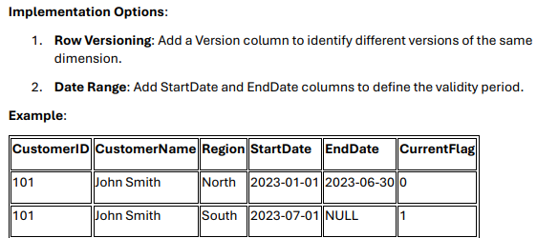

**SCD Type 3 (Tracking Limited History) -** Maintains limited history by adding columns to store previous values alongside the current value.

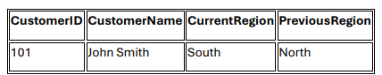

**SCD Type 4 (History Table) -** Maintains history in a separate table, while the main dimension table holds only the current data

**SCD Type 6 (Hybrid SCD - 1+2+3) -** Combines elements of SCD Types 1, 2, and 3 to track both historical and current data while maintaining versioning.

**Data Warehouse vs Data Lake vs Data Lakehouse**

**Difference between Lakehouse vs Delta lake vs Medallion Architecture**

A lakehouse is a data platform that combines the features of data lakes and data warehouses into a single platform.

Delta Lake is an open-source storage layer that provides reliability, ACID transactions, and metadata management for tables within a lakehouse.

Medallion architecture is a data design pattern used to organize data within a lakehouse, typically into Bronze, Silver, and Gold layers, each representing a different level of data quality and structure

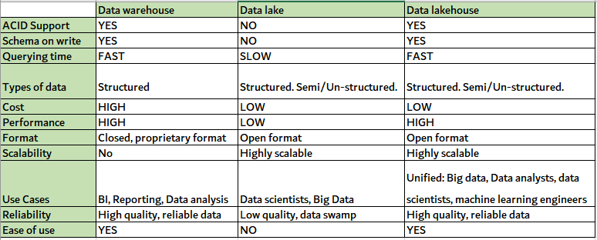

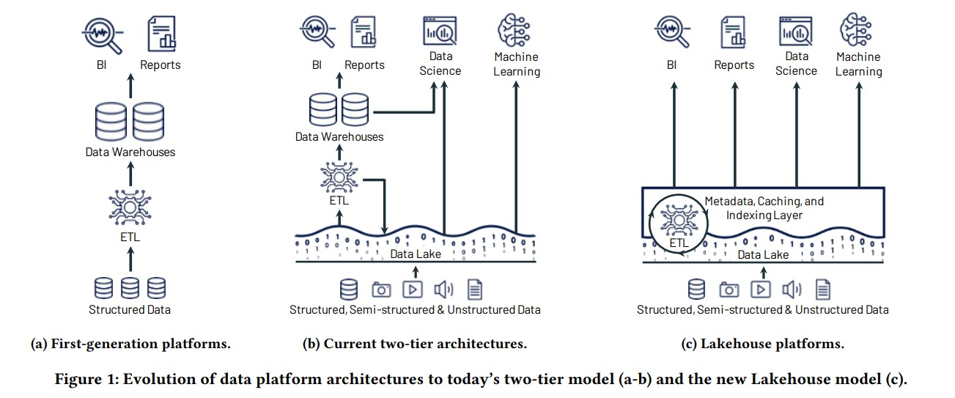

**Delta Lake:  
Cheat-sheet:** **file:///C:/Users/geram/OneDrive/Desktop/Learning/Curated/delta-lake-cheat-sheet.pdf**

Delta lake is the storage layer within the lake house which uses cloud storages such as ADLS or S3 for storing the data in open source Delta format along with transaction logs which guarantees ACID transactions, time travel and history.

[Delta Lake](https://databricks.com/wp-content/uploads/2020/08/p975-armbrust.pdf) is an open-source storage framework that enables building a format agnostic [Lakehouse architecture](http://cidrdb.org/cidr2021/papers/cidr2021_paper17.pdf) with compute engines including **Spark, PrestoDB, Flink, Trino, Hive, Snowflake, Google BigQuery, Athena, Redshift, Databricks, Azure Fabric and APIs for Scala, Java, Rust, and Python.** With [Delta Universal Format](https://docs.delta.io/latest/delta-uniform.html) aka UniForm, you can read now Delta tables with Iceberg and Hudi clients.

**Components of Delta Lake:**

1. **Storage Layer:**High performant, low-cost, scalable object storage in Azure, AWS or GCP.
2. **Delta Table:** Data in Parquet format gets stored in the cloud storage along with the Delta or transaction logs (JSON files).

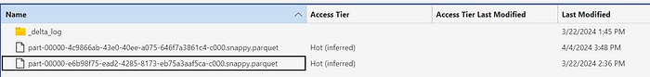

A Delta table can be registered in the unity catalog metastore. Please refer to the below article to set up a unity catalog.

Delta Lake does come with a built-in processing engine called Delta Engine. This engine is part of Databricks and is designed to optimize the performance of queries against Delta Lake data

**1.ACID Transactions:**

Delta Lake guarantees ACID properties (Atomicity, Consistency, Isolation, Durability) for data operations, ensuring reliable and consistent data operations, even with concurrent reads and writes, according to a Databricks blog post.

**2.Schema Evolution and Enforcement:**

Delta Lake allows you to evolve the schema of your tables by adding, modifying, or deleting columns without rewriting existing data. Schema enforcement prevents data pipeline issues caused by schema mismatches, according to a Medium article.

**3.Time Travel:**

Delta Lake's time travel feature allows you to query previous versions of your data, enabling auditing, debugging, and data recovery.

**4.Liquid Clustering:**

This feature optimizes data layout for query performance by automatically rearranging data in a way that makes it more efficient to scan, according to Databricks documentation.

**5.Z-Ordering (Work with OPTIMIZE. Works will for range based queries)**

Delta Lake's Z-ordering feature **groups related data in the same files**, optimizing queries on multiple dimensions. This improves query performance by reducing the amount of data that needs to be scanned, according to a Databricks blog post.

**Example:** OPTIMIZE flights ZORDER BY (DayofMonth)

**6. Auto-Compaction:**

Automatically combines small files into larger ones, improving query performance and reducing storage costs

**7. OPTIMIZE Command – Consolidate large number of small files into big files:**

This command can be used to further consolidate and optimize data layout, especially beneficial for larger tables.

**8. Data Skipping:**

Delta Lake intelligently avoids reading unnecessary data files based on metadata, further improving query performance.

**9. Unified Batch and Streaming:**

Delta Lake supports both batch and streaming data processing, making it a versatile solution for various data workloads.

**10. Scalable Metadata Handling:**

Delta Lake efficiently manages metadata for large tables with billions of partitions and files.

**11. Data Versioning**

Delta Lake tracks every change to the table, providing a history of all versions, which is essential for auditing and recovery.

**12. DML Operations (Merge):**

Delta Lake's support for the MERGE operation allows you to efficiently perform updates and inserts based on specified conditions, simplifying incremental data updates

**13. Access and Governance Controls:**

Delta Lake provides robust access control and governance mechanisms.

**14. Change Data Feed (CDF):**

Delta Lake's CDF tracks changes to the data, enabling efficient data processing and synchronization.

**15. VACUUM Command:**

Removes outdated files from the Delta Lake directory, ensuring efficient storage utilization

**Delta lake concurrency control:**

**Optimistic Concurrency Control (OCC)**

Optimistic Concurrency Control is a method for handling concurrent transactions by assuming that conflicts are rare. Instead of locking resources to prevent conflicts, OCC allows transactions to proceed independently and checks for conflicts only at the time of commit. If a conflict is detected, the transaction is aborted and must be retried.

**Key Principles of OCC:**

1. No Locking: Transactions do not lock resources, allowing for high concurrency.
2. Conflict Detection: Conflicts are detected at commit time by comparing the transaction's changes with the current state of the data.
3. Retry Mechanism: If a conflict is detected, the transaction is aborted and must be retried.

**How Delta Lake Implements OCC:**

**Isolation Levels in Delta Lake**

Delta Lake provides serializable isolation, the highest level of isolation in database systems. This means that the result of executing multiple concurrent transactions is the same as if they were executed one after the other in some serial order.

**How Isolation is Achieved:**

* **Read Isolation:** Readers always see a consistent snapshot of the data as of the start of their transaction. This is achieved by reading the transaction log up to the version number at which the transaction started.
* **Write Isolation:** Writers are isolated from each other by checking for conflicts at commit time. If two transactions attempt to modify the same data, one will succeed, and the other will fail and need to retry.

**Types of Conflicts in Delta Lake:**

**a. Write-Write Conflicts:**

* Scenario: Two transactions attempt to modify the same file or partition.
* Example:
* Transaction A starts and reads version 1 of the table.
* Transaction B starts and reads version 1 of the table.
* Transaction A modifies file X and commits, creating version 2.
* Transaction B attempts to modify file X but detects that the table has been updated to version 2. Transaction B is aborted.

**b. Append-Only Conflicts:**

* Scenario: A transaction attempts to append data to a table while another transaction deletes or modifies the same data.
* Example:
* Transaction A starts and reads version 1 of the table.
* Transaction B deletes some rows and commits, creating version 2.
* Transaction A attempts to append data but detects that the table has been updated to version 2. Transaction A is aborted.

**c. Schema Conflicts:**

* Scenario: A transaction attempts to modify the schema of a table while another transaction is reading or writing data.
* Example:
* Transaction A starts and reads version 1 of the table.
* Transaction B modifies the schema and commits, creating version 2.
* Transaction A attempts to write data but detects that the schema has changed. Transaction A is aborted.

**Lambda vs Kappa vs Medallion Architectures**

Lambda, Kappa, and Medallion are distinct data processing architectures designed to handle big data

**Lambda**

Lambda Architecture is a data-processing architecture designed to handle massive quantities of data by taking advantage of both batch and stream-processing methods. It consists of three layers: batch processing (cold path) , real-time/speed (hot path) processing, and a serving layer for responding to queries.

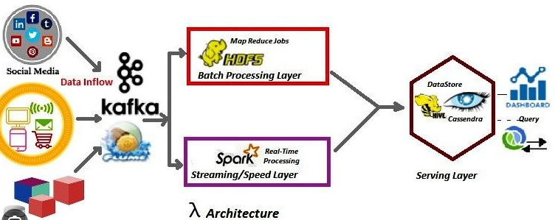

**Kappa**

Kappa architecture is true event-base. It differs from the Lambda architecture in a sense that it avoids maintaining complexities of two different codebases between the batch and speed layers

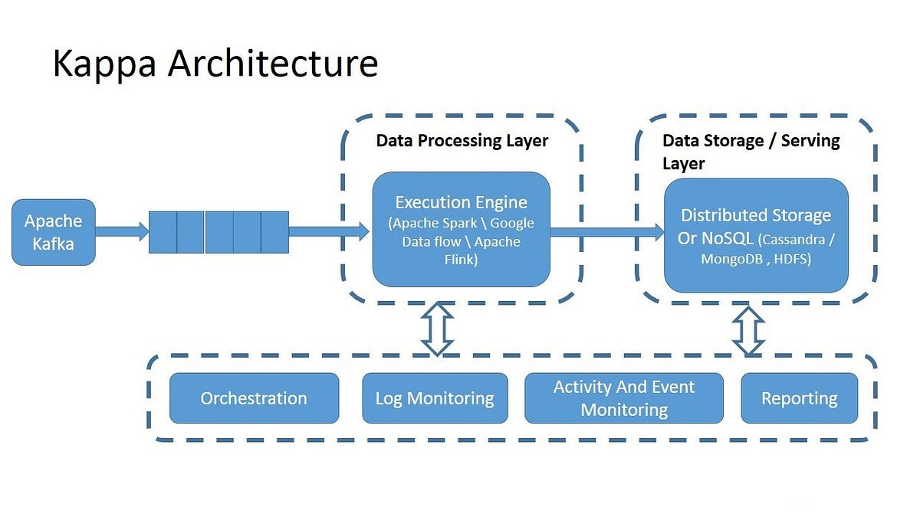

**Medallion architecture – Data quality is improved in each layer (Bronze – Silver – Gold)**

Medallion Architecture is a **data design pattern** used to logically organize data in a **lakehouse**. It aims to incrementally and progressively improve the structure and quality of data as it flows through each layer of the architecture (from Bronze ⇒ Silver ⇒ Gold layer tables).

**Advantages:** ACID, Data quality, Data Lakehouse benefits

BRONZE – RAW/Unstructured. In Source Format. Maintain History

Silver – Structured (delta format). Refined. Filtered. Joined. Transformed.

Gold – Aggregated. Highly refined for BI/AI-ML needs

**Medallion Architecture sample 1**

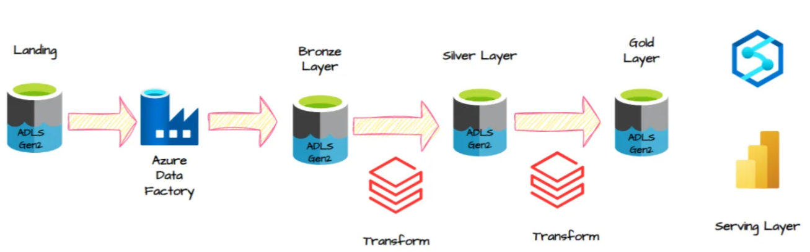

Medallion Architecture sample 2

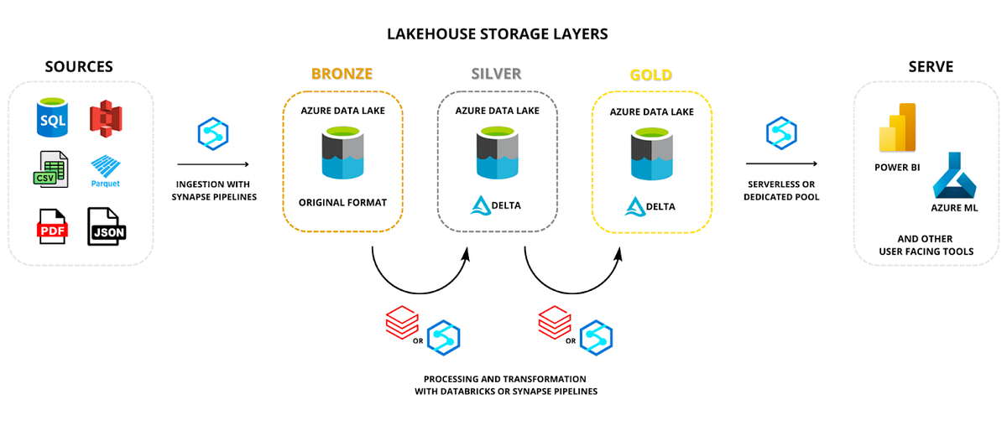

**Lambda vs Kappa Comparison:**

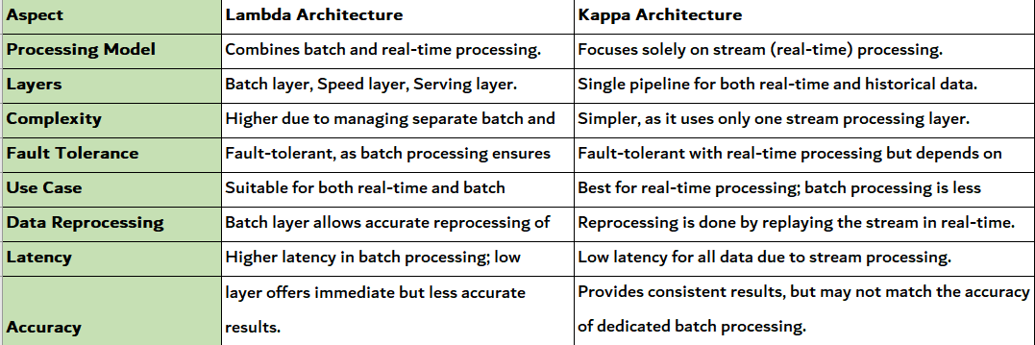

**Data Lake vs Medallion Architecture**

|  |  |  |
| --- | --- | --- |
| **Aspect** | **Traditional Data Lake** | **Medallion Architecture** |
| Foundation | Generic files in storage (CSV, Parquet, etc.) | Built on Delta Lake, offering ACID transactions, schema enforcement, and versioning |
| Data Quality | Handled via external tools/scripts | Enforced natively via Delta constraints, expectations, and Delta Live Tables (DLT) |
| Lineage & Observability | Not native; added via external tools | Native support in Databricks via Unity Catalog, DLT, and data lineage tracking |
| Modularity | Often monolithic pipelines | Designed with modular, scalable modular pipeline patterns (e.g., CDC, streaming, batch) |
| Automation & CI/CD | Manual or semi-automated | Supports full CI/CD pipelines, testing, and alerting with Databricks tools |
| Governance | Difficult to enforce consistently | Built-in with Unity Catalog, RBAC, audit logs, and data classification |

**Apache Spark**

Apache Spark is a open-source, in-memory, distributed computing framework designed for big data processing in parallel. It supports languages such as Pythan, Scala, Java, SQL and R. 100 times faster than Mapreduce

Unified means it offers both batch and stream processing

**Spark has 3 components on high level:**

* Low level API - Consists of RDDs Resilient Distributed Datasets & Distributed Variables
* Structured APIs – Built on top of RDD, Highly optimized. Dataframes, Datasets and Spark SQL
* Libraries & Ecosystem – Structured streaming, graph etc

**Note:** Shuffle is the boundary that divides jobs into stages

**Transformations:** Transformations in Spark involve **operations that modify Data structures (and create new data frame)**, they are lazily evaluated.

**Narrow transformations** process data within a single partition without requiring data to be shuffled or redistributed across partitions. **Ex:** SELECT, WITHCOLUMN, FILTER, UNION, DISTINCT, ORDER BY,

**Wide transformations** require data to be shuffled or redistributed across partitions.   
Exa: Sort() or OrderBy() both are same. GroupBy(), Join(), Repartition(), distinct(), dropduplicates(),

**Note**: Wide transformations leads to shuffles (and stages in job).

**Actions** are **operations that trigger the execution of transformations** and return a value to the driver program or write data to an external.

**Common Actions:**

* count(): Gets the total number of rows in a DataFrame or RDD.
* collect(): Retrieves all rows of a DataFrame or RDD as a list.
* show(): Displays a preview of the first few rows of a DataFrame.
* save(): Writes the DataFrame to external storage (e.g., a file).
* take(n): Returns the first n rows of a DataFrame or RDD.
* first(): Returns the first row of a DataFrame or RDD.

**Driver process** is known as SparkSession. 1 session per 1 sparkApplication.

**DataFrames** are most commonly used Structured API organized in table (row, column) format.

We can **Cascade multiple transformations** in one go. Ex: select.filter.orderby().show  
They create lineage or Directed acyclic graph (DAG) of operations.

In Databricks, a Spark application's workflow involves a driver that manages the overall execution and executors that perform the actual computation. The driver splits the application's work into smaller tasks and distributes them to executors, which process the data in parallel and return results back to the driver.

**Spark components:**

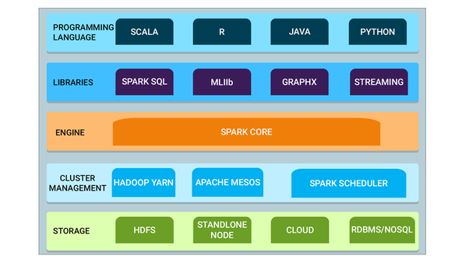

* **Spark Core**: The underlying engine that supports all Spark functionalities.
* **Spark SQL**: For structured data processing.
* **Spark Streaming**: For real-time data processing.
* **MLlib**: Machine learning library.
* **GraphX**: For graph processing.

- **Languages Supported**: Java, Scala, Python, and R.

- **Deployment Modes**: Hadoop YARN, Apache Mesos, Kubernetes, Standalone cluster manager.

**Spark Core component responsibility includes:** managing memory, handling fault recovery, scheduling and distributing tasks, and interacting with storage systems

**A SparkSession acts** as a connection manager between the user and a Spark cluster. It's the entry point for working with Spark core functionalities , providing a unified interface for accessing various Spark functionalities, including DataFrame and Dataset APIs, as well as SQL queries.

This means you can load data, perform transformations, execute SQL queries, and interact with Spark's APIs all through this one object.

**Spark Key Components:**

1. **RDDs (Resilient Distributed Datasets)**:
   * Low-level abstraction.
   * Enables fault tolerance using lineage graphs.
   * **Operations**:
     + **Transformations**: map(), filter(), flatMap(), etc.
     + **Actions**: collect(), reduce(), count(), etc.
2. **DataFrames**:
   * High-level abstraction over RDDs with schema support.
   * Optimized for SQL-based operations.
3. **Datasets**:
   * Typed DataFrames (Scala/Java only).
   * Combines functional programming with SQL optimisations.

**RDD vs Data Frames vs Datasets**

In Apache Spark, an RDD (Resilient Distributed Dataset) is a fundamental data structure representing a distributed collection of objects. It's an immutable, partitioned collection of elements that can be operated on in parallel across a cluster. RDDs are fault-tolerant, meaning they can recover from node failures by tracking the lineage of operations.

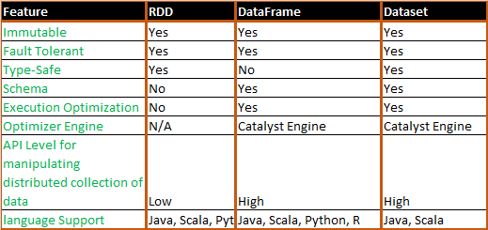

In dynamically typed languages, the type of a variable is not declared explicitly

Spark Datasets, **a type-safe structured API**, are **primarily designed for statically typed languages like Scala and Java**. Python, being a dynamically typed language, doesn't have the same compile-time type checking capabilities, making it unsuitable for Datasets

**Python is considered a dynamically typed language**, meaning the type of a variable is determined during program execution

**Spark Application Workflow**

1. **Submit the Job**: The job is submitted to the **cluster manager**.
2. **Cluster Manager Starts the Driver**: The cluster manager **starts the driver program** if it isn’t already running.
3. **Driver Creates a Plan and Asks for Executors**: The driver reads the code, creates a **plan for the job**, and sends a request for **executors** to the cluster manager.
4. **Cluster Manager Assigns Executors**: The cluster manager assigns **executors** on worker nodes based on available resources.
5. **Executors Process Data and Report to Driver**: The executors **run their tasks** in parallel and **send results back to the driver**.
6. **Driver Gathers Results**: Once all tasks are complete, the driver combines the results and presents them to the user.

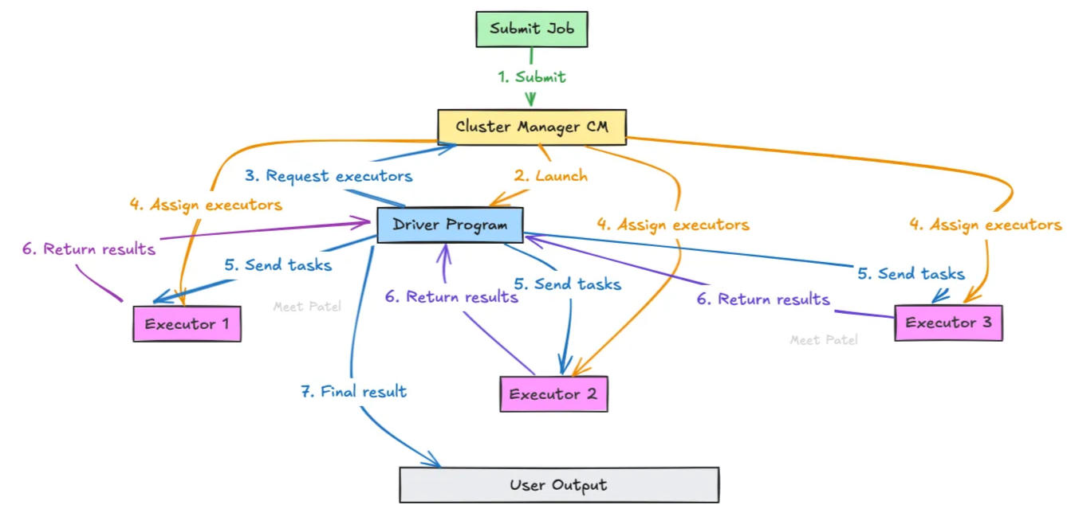

**Apache Spark Deployment Modes**

**\* Client Mode (Driver in local machine)**

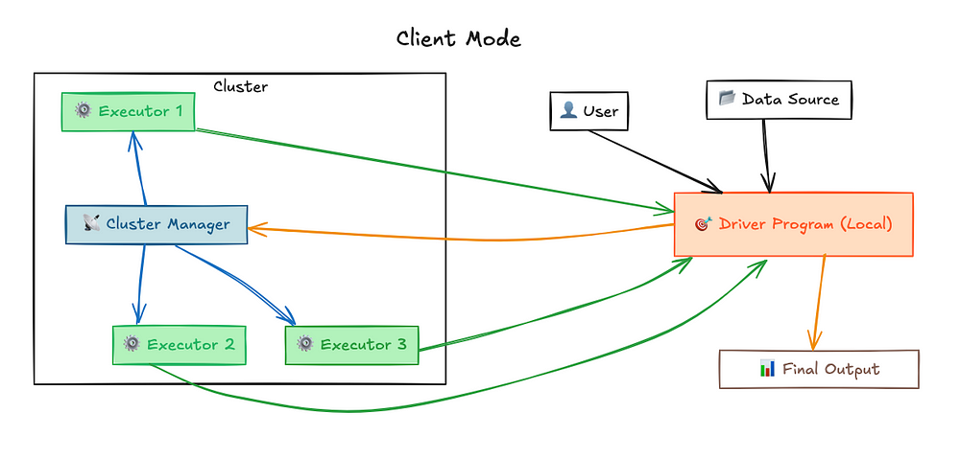

**\*Cluster Mode: (Driver in Cluster)**

Once you submit a job in Cluster-Mode, the Cluster Manager assigns the driver program to one of the worker nodes in the cluster

Cluster Mode’s driver program runs on a separate machine within the cluster, not your local machine. This means the Cluster Manager is responsible for scheduling jobs, allocating resources, and ensuring everything runs smoothly.

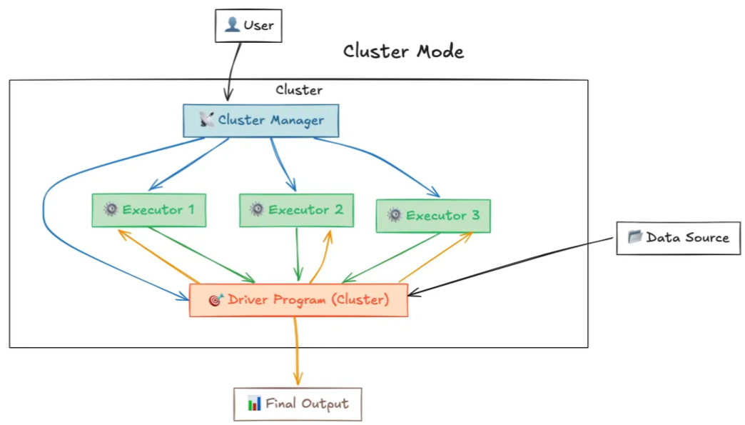

**Local Mode (Drivers and Executors in Local machine)**

In Spark's local mode, there is no actual cluster manager involved. The driver (the main Spark program) runs on the client machine, and all tasks are executed locally on the same machine

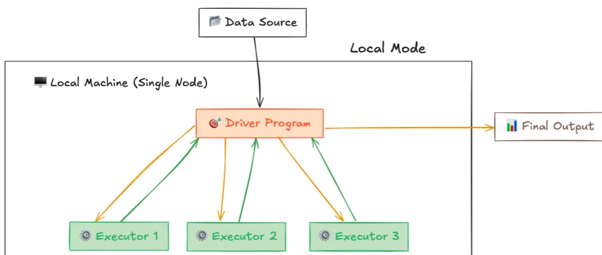

**Spark cluster managers –** Resource allocation and prioritizeConcept to remember: Preemption

* Standalone
  + - Default scheduler FIFO (First In, First Out)
    - Optional: Faire
    - **Preemption:** Unlike YARN or Mesos, Spark Standalone does not support preemption out of the box. Once resources are allocated to a job, they are not preempted or reallocated unless the job finishes or is manually killed.
* YARN
  + - - **Capacity Scheduler:** Divides cluster resources into multiple queues, each with a guaranteed capacity (e.g., a percentage of total resources). Jobs within each queue are scheduled based on priority or FIFO, depending on configuration.
    - **Fair Scheduler:** Allocates resources to jobs so that all jobs receive a fair share of resources over time. Jobs with higher priority are given more resources, but overall fairness is maintained across the cluster.
    - **FIFO**
* Kubernetes - for running Spark applications in containerized fashion.

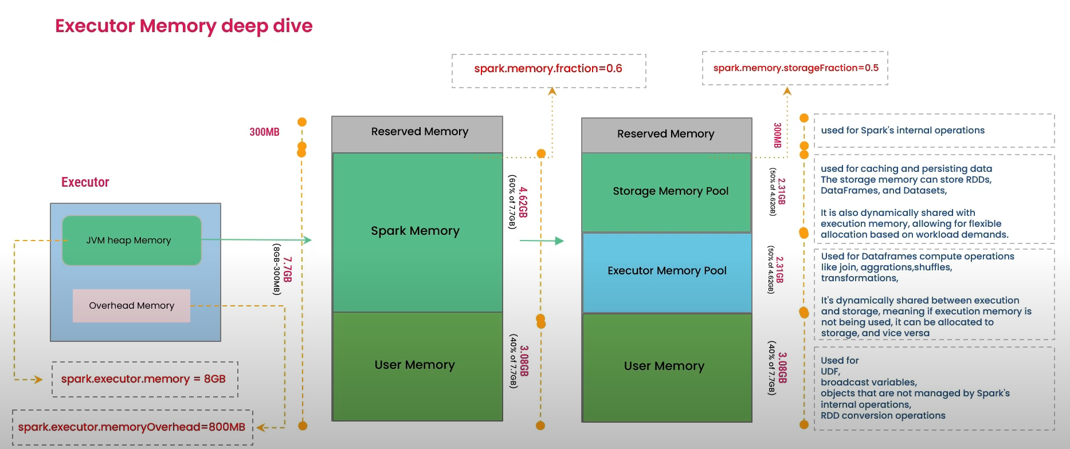**Spark Memory Management**

In Apache Spark, **execution memory (top priority)** can release memory for storage memory, but only up to a certain threshold. The execution memory is used for computations like **shuffles, joins, and aggregations**, while storage memory is used for **caching data**.

When no execution memory is used, storage can occupy all available memory, and vice versa. However, execution can evict storage memory if necessary, but only until the total storage memory usage falls below a threshold.

**OOM error scenarios and solutions:**

**Driver Memory Errors:**

**Case 1: Collect Operation**

The collect operation in Spark retrieves data from distributed workers and consolidates it on the driver. This can lead to OOM errors if the collected data is too large to fit into the driver's memory

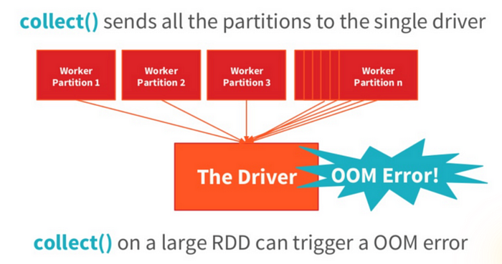

**Solution:** Increase driver memory **spark.driver.memory** and increase spark.driver.maxResultSize

**Case 2:** **Broadcast Join**

Broadcast joins are useful for optimizing joins when one side of the join is small enough to fit in memory. However, if the broadcasted data is too large, it can exhaust driver memory:

*from pyspark.sql import SparkSession  
from pyspark.sql.functions import broadcast  
  
spark = SparkSession.builder.appName("BroadcastSenerio").getOrCreate()  
large_df = spark.read.parquet("large_data_file.parquet")  
small_df = spark.read.parquet("small_data_file.parquet")  
joined_data = large_****df.join(broadcast(small_df)****, "common_column")*

**Solution:**

Increase driver memory and Adjust Broadcast Threshold **spark.sql.autoBroadcastJoinThreshold**

**Executor Memory Errors:**

**Case 1: Inefficient Queries**

Selecting all columns from a large table without filtering can lead to memory issues due to the in-memory state needed for each column:

**Solution:** Filter data as much as possible and use partition pruning.

**Case 2: Incorrect Configuration**

Each Spark application has unique memory requirements. Misconfigured settings can lead to OOM errors. Properly configuring executor memory and overhead is crucial:

--conf "spark.executor.memory=12g"  
--conf "spark.yarn.executor.memoryOverhead=2048"

**Solution**: Adjust memory settings based on the application’s requirements.

**Addressing OOM Errors: Practical Configurations**

* **For Executor Memory:**

--conf "spark.executor.memory=12g"   
--conf "spark.yarn.executor.memoryOverhead=2048"   
--conf "spark.executor.pyspark.memory=2g"

* **For Driver Memory**

--conf "spark.driver.memory=4g" --conf "spark.driver.maxResultSize=2g"

* **Managing Concurrency and Partitions:**

--conf "spark.default.parallelism=100"   
--conf "spark.sql.shuffle.partitions=200"   
--conf "spark.executor.cores=4"

* **Using Off-Heap Memory:**

--conf "spark.memory.offHeap.enabled=true"   
--conf "spark.memory.offHeap.size=4g"

**Spark can also allocate memory off-heap, outside the JVM heap space**, which can reduce GC overhead. This memory is used for off-heap storage (like **caching**) and is managed by Spark's memory manage.

**Using off-heap memory can improve performance** as it reduces the frequency of garbage collection, as off-heap memory is not subject to the garbage collector's automatic reclamation.

**AQE (Adaptive Query Execution)**

AQE **dynamically perform coalescing shuffle partitions, switching join strategies** (like broadcast vs. shuffle), and handling skewed joins efficiently.

**Catalyst Optimizer**

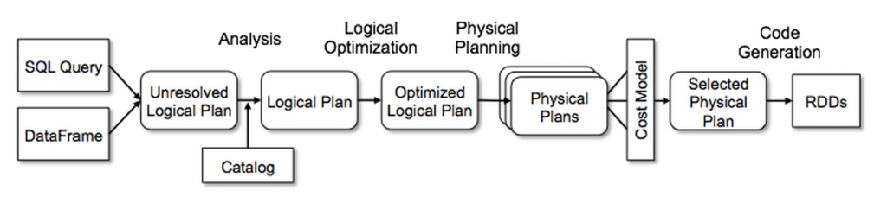

**Predicate Pushdown:** This technique pushes down filter predicates to the data source to reduce the amount of data processed.

**Projection Pushdown:** This technique minimizes the amount of data transfer between data source and the Spark engine by eliminating unnecessary fields (cols) from the table scanning process.

**Column Pruning:** This technique removes unnecessary columns from the operations to reduce the amount of data processed.

**Join Reordering:** This technique reorders the join operations to minimize the amount of data shuffled between nodes.

**Constant Folding:** This technique evaluates constant expressions at compile time to reduce the amount of computation performed at runtime.

**Subquery Optimization:** This technique optimizes subqueries to reduce the amount of data processed.

**Logical planning:**

Optimizing the Logical Plan: Once the logical plan is resolved, Catalyst applies a series of optimization rules to improve its efficiency without changing its meaning.

* **Predicate Pushdown:** Moving filters (WHERE clauses) as early as possible in the plan to reduce the amount of data processed in subsequent steps.
* **Column Pruning:** Removing columns that are not needed for the final result, reducing the data read and shuffled.
* **Constant Folding:** Evaluating constant expressions at compile time instead of runtime.  
    
  *df.selectExpr("col1 + 5 * 2 as result").show() # 5 * 2 is calculated to 10 at compile time  
    
  df.selectExpr("'abc' + 'def' as result").show() # "abc" + "def" is evaluated to "abcdef"  
    
  df.selectExpr("CASE WHEN 2 > 1 THEN 1 ELSE 0 END as result").show() # The condition 2 > 1 is always true, resulting in 1*
* **Join Reordering:** Finding the most efficient order for joining multiple tables.
* **Eliminating Common Subexpressions:** Identifying and removing redundant computations.  
  These optimizations are applied repeatedly until the plan reaches a fixed point where no further improvements can be made.

**Physical Plan Generation and Selection:** This is where Catalyst translates the optimized logical plan into one or more physical execution plans and then selects the most efficient one.

* **Cost-Based Optimization (CBO):** In more recent versions of Spark, Catalyst can use statistics (like table size, distinct values, data distribution) to estimate the cost of different physical plans and choose the one with the lowest estimated cost.
* **Physical Plan Generation:** Creating multiple alternative physical execution plans based on the optimized logical plan. For example, a logical "Join" operator could be translated into a "Sort-Merge Join," "Broadcast Hash Join," or "Shuffle Hash Join" physical operator. The choice depends on factors like data size, distribution, and available memory.

**Project Tungsten (memory optimization)** includes a code generation framework that translates parts of Spark's physical execution plan into highly optimized bytecode.

**Top 5 common Spark performance issues**

* **Spill, Skew, Shuffle, Storage, and Serialization**
* **1. Spill:**

When Spark's memory is insufficient, it writes **temporary data to disk (spill)** to avoid out-of-memory errors. This can slow down processing due to the increased I/O operations.

* **2. Skew:**

Data skew occurs when **some partitions have significantly more data** than others, leading to uneven workload distribution among executors. This can cause some tasks to finish much faster than others, resulting in idle resources and increased overall job duration.

* **3. Shuffle:**

Shuffles occur during transformations like joins or aggregations when Spark needs to **redistribute data across executors**. Excessive shuffling can increase network I/O and slow down job execution.

* **4. Storage:**

The way data is stored on disk (e.g., using appropriate **data formats like Parquet**) and how it's persisted (e.g., **caching**) can significantly impact read/write speeds.

* **5. Serialization:**

Serialization is the process of converting objects into a byte stream to be transmitted across the network for distributed processing. **Poor serialization techniques** can lead to increased serialization/deserialization overhead

**Top 5 Performance Optimization Technique to resolve most common performance issues**

**1. Adaptive Query Execution (AQE)**

**Issue Solved:** Poor join strategies and skewed data **Optimization:**

* Spark 3.5 automatically adjusts join strategies, partition sizes, and parallelism at runtime.
* Enables dynamic switch from sort-merge join to broadcast join.
* Helps reduce shuffles and handle data skew more efficiently.

**Enable it (usually on by default):***spark.conf.set("spark.sql.adaptive.enabled", "true")*

**2. Broadcast Hash Join**

**Issue Solved:** Slow performance on joins with small dimension tables **Optimization:**

* Small tables (e.g., lookup/dim tables) are broadcasted to all worker nodes, eliminating shuffles.
* Much faster than sort-merge joins for small datasets.

Manually broadcast if not auto-detected:

*from pyspark.sql.functions import broadcast  
df1.join(broadcast(df2), "key")*

**3. Optimize File Sizes in Delta Tables**

**Issue Solved:** Too many small files (small file problem) hurt performance  
Optimization:

* Use Auto Optimize and Auto Compaction or run OPTIMIZE manually.
* Improves scan and shuffle performance.

*OPTIMIZE delta.`/path/to/table`*

Or enable auto-optimize on Delta table:

*ALTER TABLE my_table SET TBLPROPERTIES (*

*'delta.autoOptimize.optimizeWrite' = 'true',*

*'delta.autoOptimize.autoCompact' = 'true'*

*)*

**4. Caching & Persistence**

**Issue Solved:** Repeated recomputation of expensive transformations  
**Optimization:**

* Use .cache() or .persist() when a DataFrame is reused multiple times.
* Avoid caching intermediate results that are used only once.

*df.cache()*

*df.count() # triggers caching*

**5. Partition Pruning & Predicate Pushdown**

**Issue Solved:** Reading unnecessary data leading to slow queries  
**Optimization:**

* Use partitioned tables effectively and filter on partition columns.
* Spark will skip unnecessary partitions (partition pruning).
* Pushes filters to data source for efficiency.

*df = spark.read.format("delta").load("/data/sales")  
df_filtered = df.filter("country = 'US'")*

**These five techniques** cover execution planning (AQE, joins), data layout (file size, partitioning), and caching, which **together resolve over 80% of common performance issues** in production Spark workloads.

**Actions vs Transformations:**

**Transformations** in PySpark DataFrames are operations that modify the structure or content of the DataFrame, creating a new DataFrame in the process. These operations are lazy, meaning they don't execute immediately

**Actions** in PySpark execute the transformations and either send the results back to the user or store the results.

**Common Actions:**

* count(): Gets the total number of rows in a DataFrame or RDD.
* collect(): Retrieves all rows of a DataFrame or RDD as a list.
* show(): Displays a preview of the first few rows of a DataFrame.
* save(): Writes the DataFrame to external storage (e.g., a file).
* take(n): Returns the first n rows of a DataFrame or RDD.
* first(): Returns the first row of a DataFrame or RDD.

**Common Transformation:**

* select(): Selects specific columns in a DataFrame
* limit(): Limits the number of rows in a DataFrame.
* filter(): Selects elements that meet a specific condition, creating a new RDD or DataFrame.
* join(): Combines two RDDs or DataFrames based on a common key.
* distinct(): Removes duplicate elements.
* union(): Combines two RDDs or DataFrames.
* sortByKey(): Sorts an RDD by its keys.
* groupByKey(): Groups elements with the same key, useful for aggregation.
* withColumnRenamed(): Renames a column in a DataFrame.
* dropDuplicates(): Removes duplicate rows from a DataFrame.
* sample(): Creates a random sample of a DataFrame.

**Comparisons:**

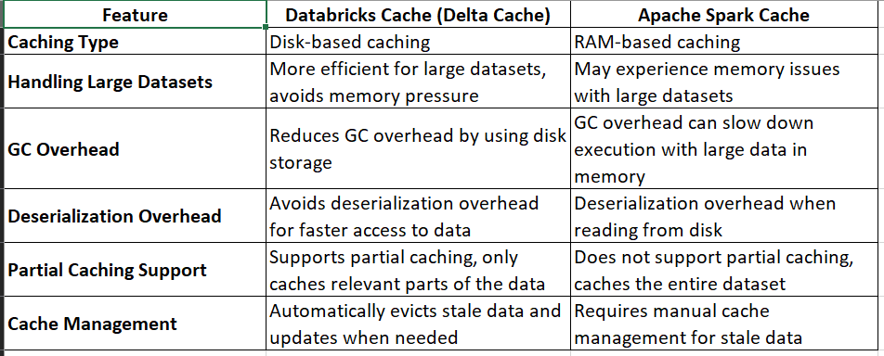

**Spark Cache vs Persist**

|  |  |  |
| --- | --- | --- |
| **Feature** | **cache()** | **persist()** |
| Purpose | Store data in memory for quick access | Store data in memory or disk with flexible storage levels |
| Default Storage | Memory only (MEMORY_ONLY) | Flexible, can be memory only, memory and disk, etc. |
| Storage Levels | Limited to memory | Multiple storage levels, including memory and disk |
| Convenience | Shorthand for persist() with default memory storage | More control over storage location and type |
| Flexibility | Less flexible | More flexible for different performance needs |

**Repartition vs Collesce**

|  |  |  |
| --- | --- | --- |
| **Feature** | **repartition()** | **coalesce()** |
| Purpose | Redistribute data across partitions | Reduce the number of partitions |
| Shuffle? | Always, for even distribution | Sometimes, to avoid full shuffle |
| Increase/Decrease | Both (increase or decrease) | Only decrease |
| Partition Size | Generally even (balanced) | May be uneven (unbalanced) |
| Use Cases | Balancing data, increasing parallelism | Optimizing after transformations |

**GroupBy vs ReduceBy**

|  |  |  |
| --- | --- | --- |
| **Feature** | **groupByKey()** | **reduceByKey()** |
| Purpose | Group values for each key into an iterable of values | Combine values for each key using a reduce function |
| Data Shuffling | Shuffles all values for each key, potentially causing performance issues | Performs local reductions on each partition before shuffling, minimizing data movement |
| Memory Usage | Can be memory-intensive as it collects all values for each key | Less memory-intensive as it reduces values locally before shuffling |
| Aggregation | Groups values, doesn't allow custom aggregation logic | Performs a fixed, predefined aggregation (e.g., sum, average) |
| Use Cases | When you need to group data and process all values together | When you need to aggregate values based on keys (e.g., calculate sums, averages) |
| Function Signature | rdd.groupByKey() | rdd.reduceByKey(func) |

**Broadcast Join vs Shuffle Join**

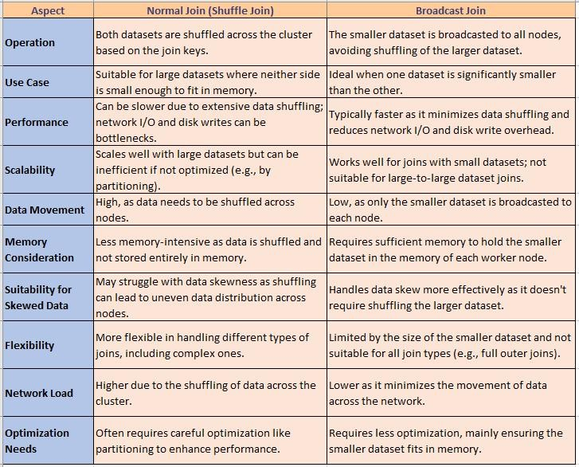

**Parquet vs Delta**

|  |  |  |
| --- | --- | --- |
| **Feature** | **Parquet** | **Delta Tables** |
| File Format | Columnar file format | Based on Parquet, with added metadata and transaction log |
| Data Integrity | No native transaction support | Supports ACID transactions (Atomicity, Consistency, Isolation, Durability) |
| Schema Evolution | Supports schema evolution but without strict enforcement | Enforces schema integrity with controlled evolution |
| Time Travel | No built-in time travel | Supports time travel to access previous versions of data |
| Data Updates | No in-place updates | Supports in-place updates (upsert, merge, delete) |
| Performance | Optimized for read-heavy workloads, query performance | Offers performance optimizations like file compaction and Z-Ordering |
| Use Cases | Static or batch datasets, data lakes | Transactional workloads, real-time analytics, managing data lakes |
| Integration | Broad compatibility across the Hadoop ecosystem | Seamless integration with the Spark ecosystem |

**CSV vs Parquet:**

|  |  |  |
| --- | --- | --- |
| **Feature** | **CSV** | **Parquet** |
| Storage | Row-based | Columnar |
| Data Format | Plain text (human readable) | Binary (machine readable) |
| File Size | Larger | Smaller (due to compression) |
| Performance | Slower for large datasets, especially when querying specific columns | Faster, especially for large datasets and analytical workloads |
| Compression | Limited compression options | Advanced compression options (e.g., Snappy, LZ4) |
| Schema | No built-in schema, requires external definition | Includes schema metadata |
| Data Types | Limited to basic types, manual data type detection | Supports a wide range of data types, including nested and complex structures |
| Querying | Requires reading entire rows, even if only specific columns are needed | Optimized for querying specific columns, can skip irrelevant data |
| Data Integrity | Lacks built-in validation, potential for data inconsistencies | Includes schema metadata for data integrity and consistency |
| Ease of Use | Simple and widely supported, easy to read and write manually | Requires libraries and tools for reading and writing, not ideal for human editing |
| Use Cases | Smaller datasets, quick manual analysis, data exchange | Large-scale data processing, analytical workloads, data lakes |

**Storage levels**

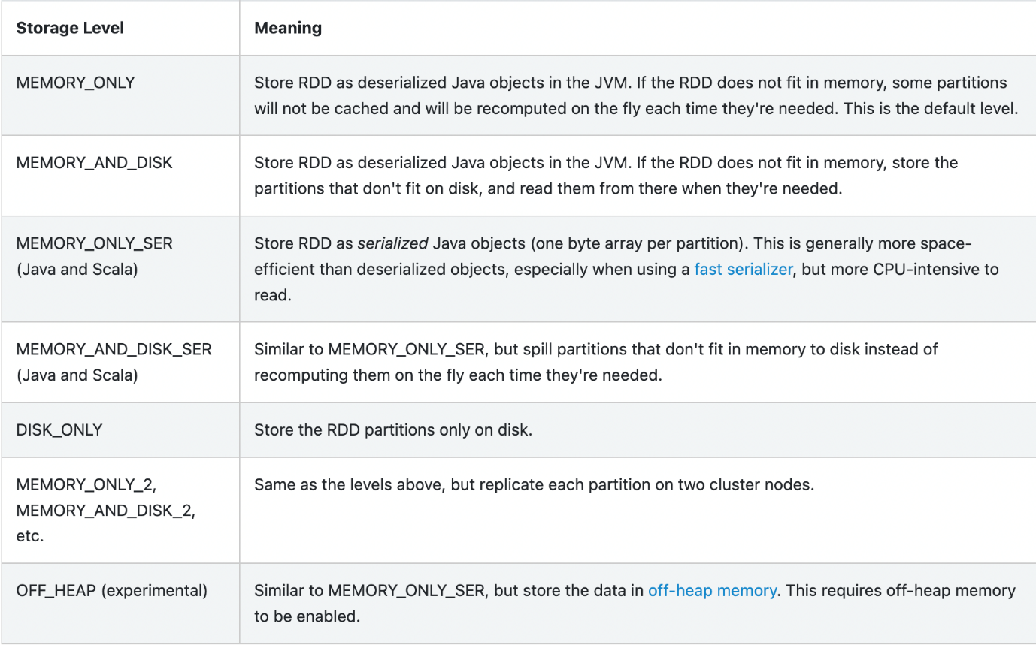

**Static vs Dynamic Resource Allocation**

PySpark manages resources (like CPU and memory) by using executors to run tasks. With static allocation, you pre-define a fixed number of executors for the entire job. This is simple but can be inefficient if workloads vary. Dynamic allocation is more flexible. PySpark requests more executors when tasks are numerous or demanding, and releases them when they are no longer needed. This optimizes resource usage and can save costs, especially for unpredictable workloads. It works by interacting with a cluster manager like YARN or Kubernetes.

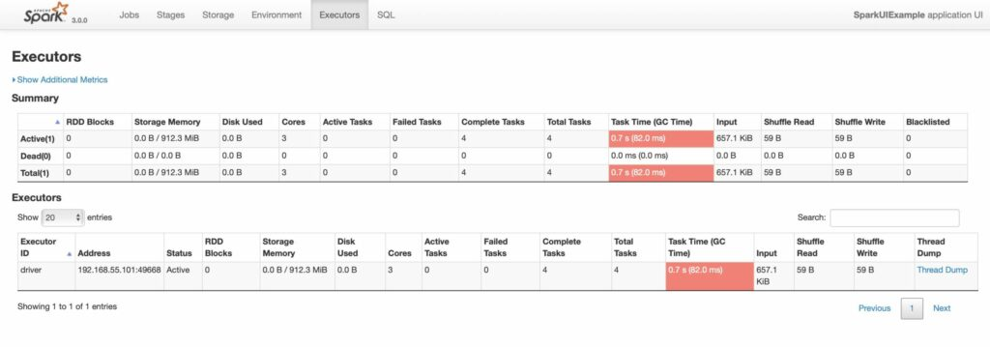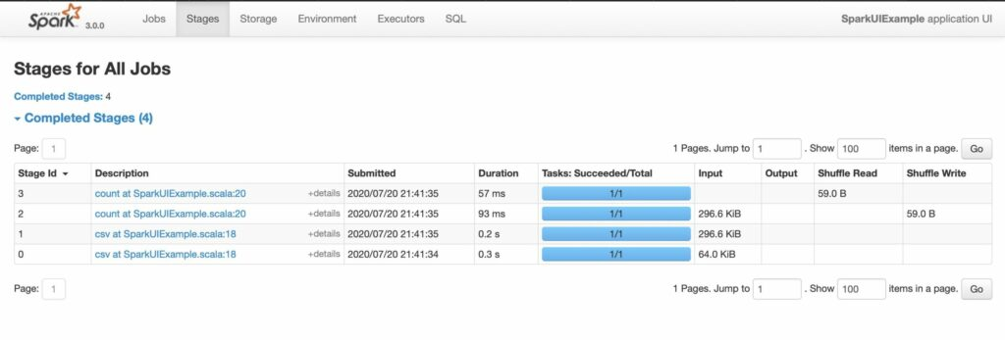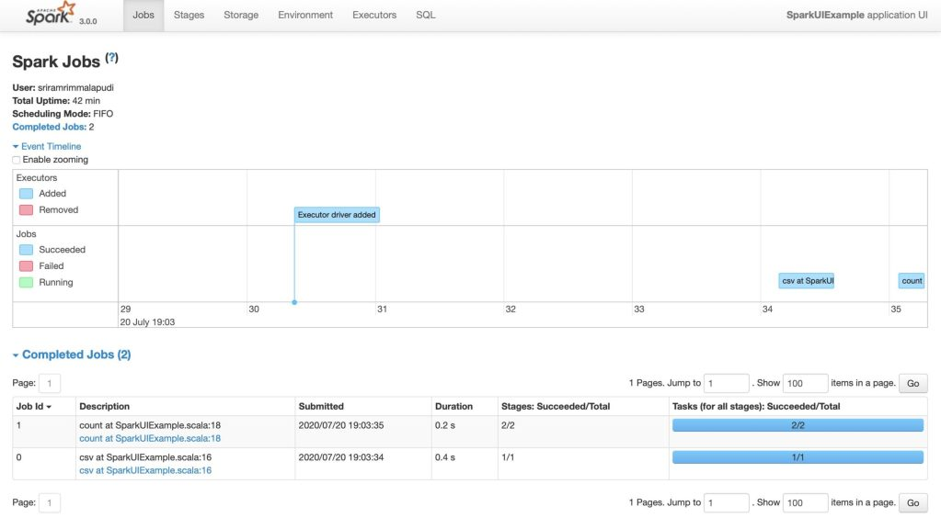**Spark Web UI**

**Kafka or Azure Event Hub (Azure based, fully managed)**

1. What is Kafka?

1. Kafka is a distributed event streaming platform used to build real-time data pipelines.
2. Kafka is highly scalable, fault-tolerant, and optimized for high-throughput, low-latency messaging between producers and consumers.
3. It supports publish-subscribe and message queue models, making it ideal for decoupled microservices, log aggregation, real-time analytics, and ETL workflows.

🔹 2. Kafka Architecture Components

1. Producer: Sends (publishes) messages to Kafka topics. Can send data continuously, such as logs, metrics, or transactional events.
2. Consumer: Reads (subscribes to) messages from Kafka topics. Typically part of a consumer group that helps with parallel processing.
3. Topic: Logical channel or stream to which messages are published and from which consumers read. Topics can have one or more partitions.
4. Partition (2 copies. Leader/followers): Kafka splits each topic into partitions for parallelism and scalability. Each partition is an ordered, immutable sequence of messages.
5. Broker: Kafka server that stores and delivers messages. A Kafka cluster consists of multiple brokers.
6. Cluster: A group of brokers that collectively manage topics, partitions, and client requests.
7. Zookeeper: Manages cluster metadata, broker coordination, and leader election for partitions. (Note: Being phased out with KRaft mode in newer Kafka versions.)
8. Offset: A unique identifier for each message within a partition. Consumers use offsets to track their read position.
9. Replication: Kafka replicates partitions across multiple brokers for high availability and data durability.

🔹 3. End-to-End Message Lifecycle in Kafka

1. A producer writes a message to a topic, optionally with a key (used for partitioning logic).
2. Kafka routes the message to a specific partition within the topic.
3. The broker stores the message in that partition and assigns it a sequential offset.
4. Kafka replicates the message to follower brokers as per the topic’s replication factor.
5. A consumer (or consumer group) reads the message from the partition via its offset.
6. After processing, the consumer commits the offset, either automatically or manually, to avoid reprocessing in case of a failure.

from pyspark.sql import SparkSession

from pyspark.sql.types import StructType, StructField, StringType

import json

# Initialize SparkSession

spark = SparkSession.builder.appName("KafkaToDelta").getOrCreate()

spark.sparkContext.setLogLevel("ERROR")

# Kafka configuration

kafka_bootstrap_servers = "your_kafka_broker:9092" # Replace with your Kafka broker

kafka_topic = "your_kafka_topic" # Replace with your Kafka topic

delta_table_path = "/path/to/your/delta/table" # Replace with your desired Delta table path

# Define the schema of the Kafka messages (adjust according to your needs)

# Example schema for JSON messages

kafka_schema = StructType([

StructField("id", StringType(), True),

StructField("event_data", StringType(), True),

])

# Read streaming data from Kafka

df = (spark.readStream

.format("kafka")

.option("kafka.bootstrap.servers", kafka_bootstrap_servers)

.option("subscribe", kafka_topic)

.option("startingOffsets", "earliest") # or "latest" to start from the most recent

.load()

)

# Extract and parse the message value (assuming it's in JSON format)

df_value = df.selectExpr("CAST(value AS STRING)")

# Parse the JSON message

df_parsed = df_value.withColumn("json_data", json.loads(df_value.value))

df_final = df_parsed.selectExpr("json_data.*")

# Write the streaming data to Delta table

(df_final.writeStream

.format("delta")

.option("checkpointLocation", "/path/to/your/checkpoint") # Create a checkpoint directory

.outputMode("append") # Or "update" if you want to update the table

.start(delta_table_path))

# Keep the program running until explicitly stopped

df_final.writeStream.awaitTermination()

**Read from Azure Event Hub**

from pyspark.sql import SparkSession  
from pyspark.sql.types import StructType, StructField, StringType, TimestampType  
from pyspark.sql.functions import *  
import json  
  
*# Event Hubs configuration*  
EVENT_HUB_NAMESPACE = "your-event-hub-namespace"  
EVENT_HUB_NAME = "your-event-hub-name"  
EVENT_HUB_KEY_NAME = "your-event-hub-key-name"  
EVENT_HUB_KEY_VALUE = dbutils.secrets.get(scope = "your-secrets-scope", key = EVENT_HUB_KEY_NAME)  
  
*# Delta table path*  
DELTA_TABLE_PATH = "/path/to/your/delta/table"  
  
*# Create SparkSession*  
spark = SparkSession.builder.appName("EventHubToDelta").getOrCreate()  
  
*# Define schema for Event Hub messages*  
eventHubSchema = StructType([  
 StructField("device_id", StringType(), True),  
 StructField("temperature", StringType(), True),  
 StructField("humidity", StringType(), True),  
 StructField("timestamp", TimestampType(), True)  
])  
  
*# Configure Event Hubs source*  
event_hub_options = {  
 "eventhubs.namespace": EVENT_HUB_NAMESPACE,  
 "eventhubs.eventhubname": EVENT_HUB_NAME,  
 "eventhubs.sasl.jaas.config": "org.apache.kafka.common.security.plain.PlainSaslClientFactory",  
 "eventhubs.sasl.mechanism": "PLAIN",  
 "eventhubs.security.protocol": "SASL",  
 "eventhubs.sasl.client.callback.handler.class": "org.apache.kafka.common.security.plain.PlainSaslClientCallbackHandler",  
 "eventhubs.eventhubs.sasl.username": "your-event-hub-key-name", *# Replace with your key name*  
 "eventhubs.eventhubs.sasl.password": EVENT_HUB_KEY_VALUE *# Replace with your key value*  
}  
  
*# Read streaming data from Event Hubs*  
streamingDF = spark.readStream \

.format("eventhubs") \

.options(**event_hub_options) \

.schema(eventHubSchema) \

.load()  
  
*# Apply transformations (e.g., convert JSON to data types, etc.)*  
*# For demonstration purposes, we assume the messages are already in the correct format*  
*# You might need to add transformations here to parse JSON, convert data types, etc.*  
*# transformedDF = streamingDF.selectExpr("device_id", "cast(temperature as double) as temperature", "cast(humidity as double) as humidity", "timestamp")*  
  
*# Apply watermark (handle late data)*  
transformedDF = streamingDF.selectExpr("device_id", "cast(temperature as double) as temperature", "cast(humidity as double) as humidity", "timestamp")  
watermarkedDF = transformedDF.withWatermark("timestamp", "10 minutes")  
  
*# Write the stream to a Delta table*  
def write_batch(df, batch_id):  
 df.write.mode("append").delta(DELTA_TABLE_PATH)  
  
query = watermarkedDF.writeStream \

.outputMode("append") \

.foreachBatch(write_batch) \

.start()  
  
query.awaitTermination()

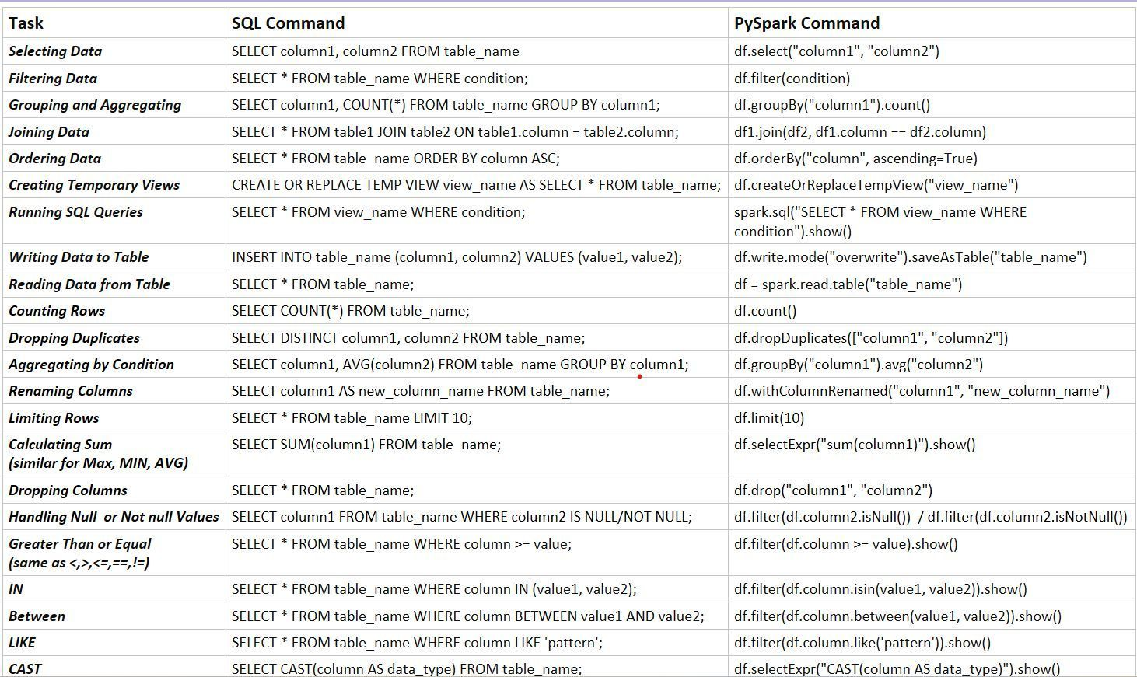**PySpark vs Spark SQL file:///C:/Users/geram/OneDrive/Desktop/Learning/Curated/Pyspark%20quick%20notes.pdf**

**Databricks**

Azure Databricks is a cloud-based, unified analytics platform built on Apache Spark that provides a collaborative and interactive workspace for data engineering, data science, and machine learning tasks

- **Commercial Product**: Created by the original creators of Apache Spark. While Spark is open-source, Databricks is a commercial product that provides additional features on top of Spark.

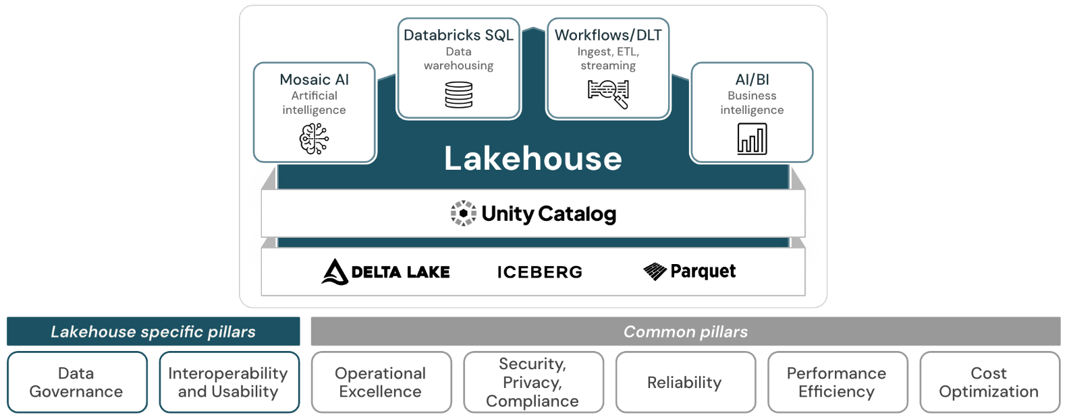

**Databricks Key Features**:

**1. Unity Catalog**

* Centralized **data governance** and **fine-grained access control** across workspaces.
* Supports **table, column, row-level security**, and **data lineage** tracking.

**2. Delta Live Tables (DLT)**

* Simplifies **ETL pipeline development** using **declarative syntax**.
* Supports **automatic lineage**, **error handling**, **testing**, and **auto-scaling**.
* Ensures **data quality with expectations** (like unit tests for data).

**3. Delta Lake**

* Brings **ACID transactions**, **time travel**, and **schema evolution** to your data lake.
* Supports **Merge (Upserts)** and **CDC (Change Data Capture)** use cases.

**4. Medallion Architecture (Bronze, Silver, Gold)**

* Standard design pattern in Databricks for **structured data transformation pipelines**.
* Promotes **modularity**, **data quality**, and **performance**.

**5. Databricks SQL**

* Fully managed SQL interface to **query Delta tables** using BI tools (Power BI, Tableau).
* Offers **query history**, **alerts**, **dashboards**, and **serverless SQL endpoints**.

**6. Photon Engine**

* Next-gen vectorized query engine for **blazing-fast SQL performance**.
* Optimized for **Delta Lake** and **Databricks SQL** workloads.

**7. Lakehouse Architecture**

* Combines **data lake** and **data warehouse** benefits in a single platform.
* Supports both **BI/SQL analytics** and **ML workloads** on the same data.

**8. Job Orchestration & Workflows**

* Schedule and manage **notebooks, scripts, JARs** with dependencies.
* Supports **parameter passing**, **retry policies**, and **multi-task pipelines**.

**9. Data Lineage**

* Unity Catalog and DLT provide **automated lineage** for datasets, helping with **audits** and **impact analysis**.

**10. Access Control & Auditing**

* Unity Catalog enables **central policy enforcement** and **audit logging** across catalogs.
* Integration with **Azure Active Directory** for secure role-based access.

**11. Built-in MLflow Integration**

* Native support for **ML lifecycle management** – tracking, packaging, and deploying ML models.

**12. Workspace Repos & Git Integration**

* First-class support for **GitHub, Azure DevOps**, etc., for version-controlling notebooks and jobs.
* Enables **CI/CD** best practices in data workflows.

**13. Auto-Optimize & Auto-Compaction**

* Delta Lake optimizations that manage **file sizes** and **data layout** automatically for better performance.

**14. Serverless Compute Options**

* Serverless SQL endpoints and **serverless Model Serving** reduce infrastructure management overhead.

**15. Powerful Runtime Optimizations**

* Databricks Runtime includes **Spark optimizations**, **I/O caching**, **adaptive query execution**, and support for **pandas API on Spark**.

**16. Intelligent Workload Management**

Efficient job scheduling, autoscaling, and prioritization.

* **Cluster reuse**, **job prioritization**, **resource limits**
* Auto-terminate idle clusters

**17. Autoloader**

Efficient ingestion of streaming/batch data from cloud storage.

* Supports **schema inference**, **incremental processing**
* Scales with **millions of files** (JSON, CSV, Parquet)

**Databricks Architecture:**

Databricks architecture has two main components:

* **Control plane** is the management layer, handling the workspace WebApp, notebooks, configuration and clusters. Objects are **stored in a Microsoft-managed subscription**, not in your customer's subscription. Objects are managed securely through a combination of **encryption at rest, customer-managed keys, and network isolation**.

* **Data Plane:** The data plane, where your data is actually stored and processed, **resides in your customer's Azure subscription**

**Databricks' main components include the Control Plane, Compute Plane, and Unity Catalog**

**Databricks Runtime**

Databricks Runtime is the set of core components that run on your cluster.

Runtime includes:

* Ubuntu OS
* Spark
* Java, Python, Scala, R libraries
* Delta Lake
* GPU libraries
* Azure databricks services (Notebooks, jobs)
* Photon

**Photon Engine** (rewritten in C++, Vectorized processing and optimized algorithms)**:**

* Photon is a high-performance, native vectorized query engine within [Databricks](https://www.databricks.com/product/photon).
* Accelerates Spark SQL and DataFrame workloads, potentially reducing overall costs.
* It achieves this by replacing parts of Spark's execution engine with its own C++-based implementation, **leveraging vectorized processing and optimized algorithms**.

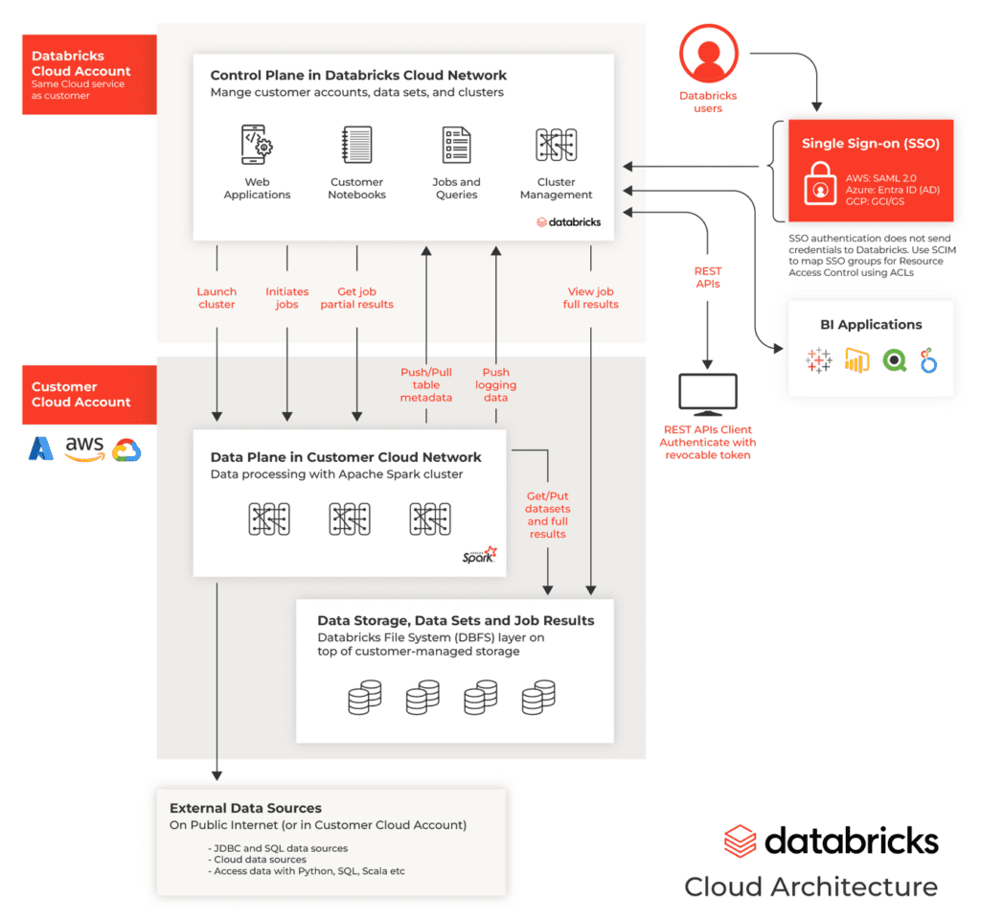

**Types of Clusters:**

**All purpose**

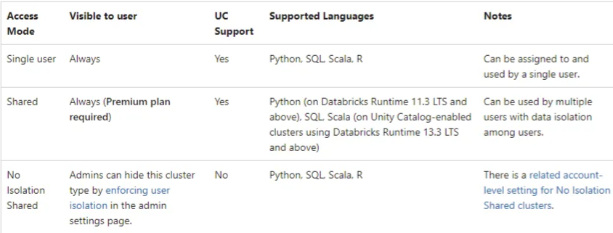

**Permission Settings:** Can Manage (owner), Can Restart, Can attach

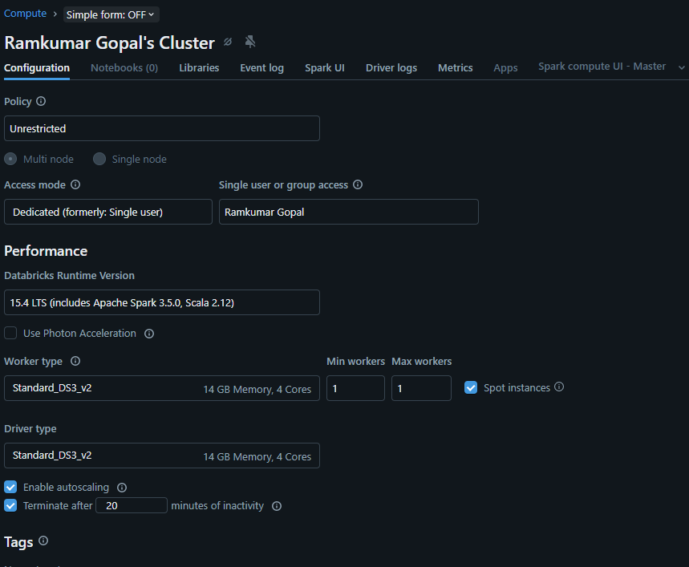

**Sample Custom Policy (Overrides the shared policy):**

{

"node_type_id": {

"type": "unlimited",

"defaultValue": "Standard_DS4_v2",

"isOptional": true

},

**"spark_version": {**

**"type": "fixed",**

**"defaultValue": "auto:latest-lts",**

**"value": "auto:latest-lts"**

**},**

**"num_workers": {**

**"type": "fixed",**

**"hidden": false,**

**"value": 3**

**},**

"data_security_mode": {

"type": "fixed",

"value": "USER_ISOLATION",

"hidden": true

},

"driver_instance_pool_id": {

"type": "forbidden",

"hidden": true

},

"azure_attributes.spot_bid_max_price": {

"type": "fixed",

"value": -1,

"hidden": true

},

"cluster_type": {

"type": "fixed",

"value": "all-purpose"

},

"instance_pool_id": {

"type": "forbidden",

"hidden": true

},

"azure_attributes.availability": {

"type": "unlimited",

"defaultValue": "ON_DEMAND_AZURE"

},

"spark_conf.spark.databricks.cluster.profile": {

"type": "forbidden",

"hidden": true

},

**"autoscale.min_workers": {**

**"type": "forbidden",**

**"defaultValue": 2**

**},**

**"autotermination_minutes": {**

**"type": "fixed",**

**"defaultValue": 10,**

**"value": 10**

**},**

**"autoscale.max_workers": {**

**"type": "forbidden",**

**"defaultValue": 10**

**}**

}

**Shared Compute Policy vs Custom Policy**

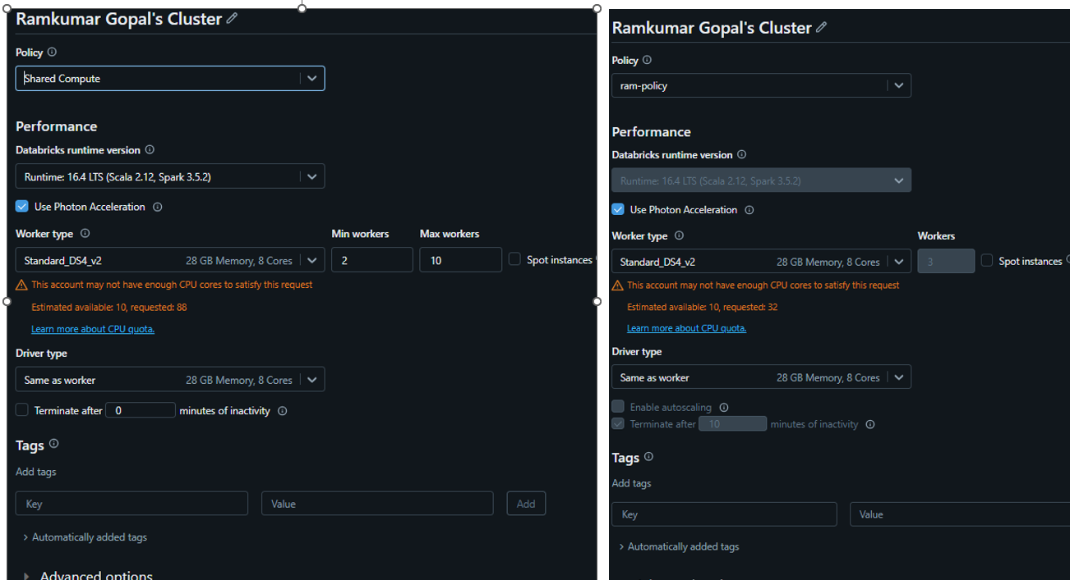

**SQL Warehouse**

| **Warehouse type** | **Photon Engine** | **Predictive IO** | **Intelligent Workload Management** |
| --- | --- | --- | --- |
| Serverless | X | X | X |
| Pro | X | X |  |
| Classic | X |  |  |

**Unity Catalog - is a centralized data governance solution for Databricks.**

**Features:**

* Access Control
* Row level & Column level security.
* Audit
* Lineage
* Data Discovery
* Data sharing
* and system tables

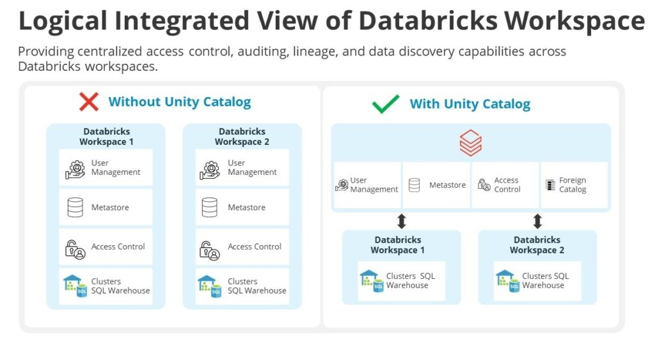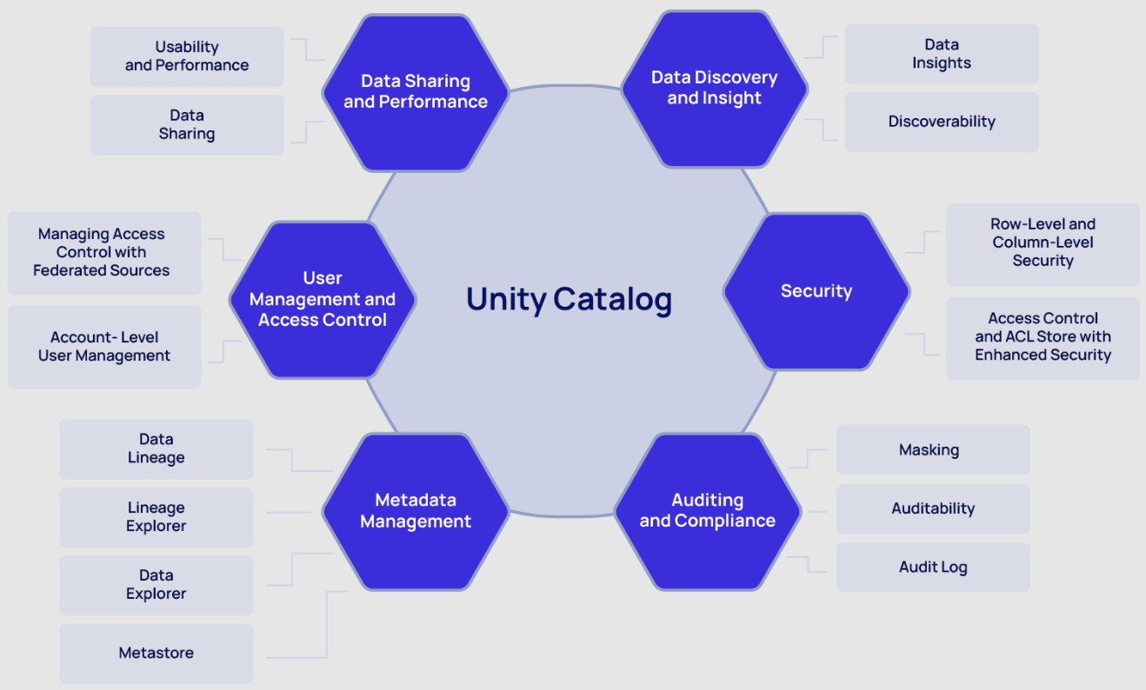

**Unity Catalog Object Model**

you could have catalogs for different environments (dev, test, prod) or departments (finance, marketing). This approach allows for clear separation of data, simplified access control, and easier data discovery

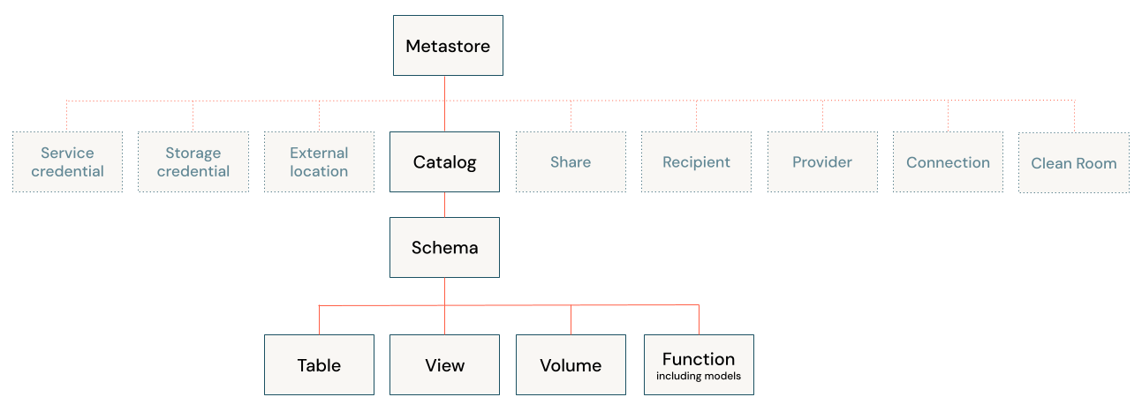

Metadata of unity catalog is stored in Control plane. Data in User Storage Accounts.

By using catalog binding, you can assign specific catalogs to designated workspaces, enabling clear segmentation between teams and environments. This approach ensures that each workspace handles only the data relevant to its specific tasks.

**Managed Table Data Storage Location Hierarchy**

If you create a table, data will be stored in metastore location.

If path is mentioned in catalog, data will be stored in catalog location

If path is mention in schema, data will be stored in schema location.

If no path is mentioned in metastore, it’s mandatory to provide location for catalog

**Why Managed Tables are better**

**🔹 Simplified Data Management**

With managed tables, Databricks automatically handles the underlying storage, file organization, and cleanup. This eliminates the headache of orphaned files or leftover data when a table is dropped. Managed tables ensure your data storage remains clean and organized without manual intervention.

**🔹 Enhanced Data Governance and Security**

One of the biggest advantages of Unity Catalog managed tables is their built-in governance capabilities. Managed tables are tightly integrated with Unity Catalog, ensuring:

* Seamless enforcement of access controls.
* End-to-end data lineage tracking.
* Comprehensive auditing to track data access and changes.

In contrast, external tables pose a higher security risk because they allow direct access to the underlying storage paths. This creates two major challenges:

1. Users may bypass Databricks access controls and gain unauthorized access to data.
2. Auditing becomes harder since users can access the data directly via cloud storage services instead of Databricks itself.

**Databricks with Unity Catalog supports two types of tables:**

* **Managed Tables:**These are fully managed by Unity Catalog, including their location, lifecycle, and file layout. By default, managed tables are stored in the root storage location configured when the metastore is created. Alternatively, you can specify a storage location at the catalog or schema level.  
    
  *CREATE TABLE catalog.schema.sales  
  (  
   id INT,  
   deptname STRING,  
   amt DECIMAL(10,2)  
  );*
* **External Tables:**Unity Catalog does not manage these tables’ lifecycle and file layout.   
    
  *CREATE TABLE catalog.schema.sales  
  ( id INT,  
   deptname STRING,  
   amt DECIMAL(10,2)  
  )  
  LOCATION 'abfss://container@account.dfs.core.windows.net/sales';*
* **Volumes -** Volumes provide a mechanism to access files stored in a storage account. They are useful when scripts need to access files directly. The file location structure for volumes is Volumes/catalog/schema/directory

**There are two types of volumes:**

* **Managed Volumes:**Created within the default storage location of the containing schema.

**CREATE VOLUME <catalog>.<schema>.<volume-name>;**

* **External Volumes:**These allow specifying an external location not governed by Unity Catalog. They are ideal for accessing files in a landing area, for instance. Users do not need direct access to the storage account; Unity Catalog manages access through volumes.

CREATE EXTERNAL VOLUME <catalog>.<schema>.<volume-name>  
LOCATION 'abfss://container@account.dfs.core.windows.net/path/directory';

**Data Organization Using Unity Catalog**

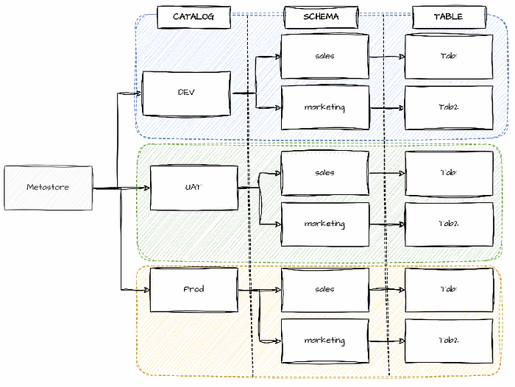

Unity Catalog’s hierarchical structure means that privileges assigned at higher levels (catalog or schema) are inherited by objects at lower levels. Thus, assigning a privilege at the catalog or schema level will automatically apply it to all existing and future objects within that catalog or schema.

Unity Catalog integrates with Microsoft Entra ID (Azure Active Directory), enabling the creation of entities such as users and groups in Microsoft Entra ID to manage access to Unity Catalog assets.

**Catalog Creation:**

*CREATE CATALOG IF NOT EXISTS demo_catalog MANAGED LOCATION 'abfss://mycontainer@mystorageaccount.dfs.core.windows.net/demo_catalog';*

create catalog dev_sql comment 'created using sql'

drop catalog dev_sql cascade;

**Create Catalog with external location:**

* 1. **Create storage credential under workspace/catalog**
  2. **Create external location***create external location ext_catalog*

*url 'abfss://data@sauccentralindia.dfs.core.windows.net/adb/catalog'*

*with (storage credential `sc_catalog_storage`)*

* 1. **Create Catalog***create catalog dev_ext*

*managed location 'abfss://data@sauccentralindia.dfs.core.windows.net/adb/catalog'*

* 1. *describe catalog extended dev_ext*

**Schema creation**

*CREATE SCHEMA test MANAGED LOCATION 'abfss://container@account.dfs.core.windows.net/path/directory'*

After creating schemas, you can proceed with developing tables, views, functions, volumes, and models using SQL commands in notebooks or the Databricks GUI, depending on the specific use case.

*CREATE TABLE test.my_table (id INT, name STRING);*

*Grant Access:*

*GRANT USE CATALOG ON CATALOG < catalog_name > TO < group_name >;  
  
GRANT USE SCHEMA ON SCHEMA < catalog_name >.< schema_name > TO < group_name >;  
  
GRANT SELECT ON < catalog_name >.< schema_name >.< table_name >; TO < group_name >;*

**Row and Column Level Access Control with Unity Catalog**

Unity Catalog enables the implementation of column-level security, data masking using dynamic views, and row-level security and column masking using functions.

For example:

*CREATE VIEW < catalog_name >.< schema_name >.< view_name > as  
SELECT  
 id,* ***CASE WHEN is_account_group_member(< group_name >) THEN email ELSE 'REDACTED' END*** *AS email, country, product, total FROM  
 < catalog_name >.< schema_name >.< table_name >;*

Using user-defined functions we can apply security roles on columns or rows to mask data or prevent part of users accessing data.

*CREATE OR REPLACE FUNCTION region_filter(region_param STRING)   
RETURN   
 is_account_group_member('bu_admin') or -- bu_admin can access all regions  
 region_param like "US%"; -- non bu_admin's can only access regions containing US  
  
ALTER TABLE customers SET ROW FILTER region_filter ON (country);*

**Example of masking PII data using a masking function:**

*CREATE OR REPLACE FUNCTION simple_mask(column_value STRING)  
RETURN IF(is_account_group_member('bu_admin'), column_value, "****");*

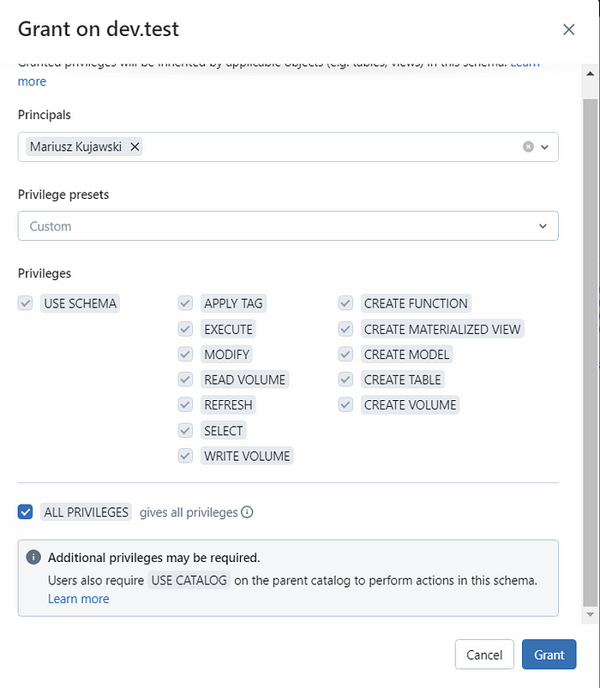

**Drop table functionality difference in Hive and Unity catalog**

* In both, data of external tables are not deleted
* In Hive managed tables, managed table data will be immediately deleted
* In UC managed tables, managed table data will be deleted after 7 days.  
  we can undrop the deleted managed table  
    
  *drop table dev.bronze.emp;*

***show tables dropped*** *in dev.bronze;*

*undrop table dev.bronze.emp;*

**Delta Tables:**

*Show catalogs like ‘dev*’; <- REGX pattern  
Show schemas in <catalog> like ‘xx*’;  
show tables in catalog.schema like ‘xx*’;*

*spark.catalog.tableExists(“dev.bronze.sales”)*

*CREATE SCHEMA <name> IF NOT EXISTS dev.bronze;  
CREATE TABLE <table_name> IF NOT EXISTS dev.bronze.emp(…)  
  
DESCRIBE HISTORY <table_name>; -- to see the change log*

*SELECT * from <table>@1*

*CREATE TEMPORARY VIEW <catalog>.<schema>.<view> -> session scope*

*CREATE OR REPLACE VIEW <catalog>.<schema>.<view>*

***WAYS to Clone Tables***

* 1. ***CTAS*** *(Create table as ) – Create copy of the table*

*CREATE TABLE dev.bronze.emp_ctas  
AS  
SELECT * FROM dev.bronze.emp;*

DESCRIBE EXTENDED dev.bronze.emp;

* 1. DEEP CLONE (Both metadata and Data): - Recommended approach  
       
     *CREATE TABLE dev.bronze.emp_deep  
     DEEP CLONE dev.bronze.emp;  
       
     DESCRIBE EXETENDED dev.bronze.emp_deep;***Note**: Location will be emp_deep path
  2. SHALLOW CLONE (Only metadata. Data will be pointed **to original table of specific data version**)  
       
     *CREATE TABLE dev.bronze.emp_shallow  
     SHALOW CLONE dev.bronze.emp;*

*DESCRIBE EXETENDED dev.bronze.emp_shallow;***Note**: Location will be emp path.  
  
If we make change in original table, that won’t reflect reflect in shallow table.  
If VACCUM command is executed in emp, then it will impact shallow table.

**MERGE:***MERGE INTO training.person TARGET  
USING vw_person SOURCE  
ON TARGET.PersonId = SOURCE.PersonId  
WHEN MATCHED THEN  
 UPDATE SET  
 TARGET.FirstName = SOURCE.FirstName,  
 TARGET.LastName = SOURCE.LastName,  
 TARGET.Country = SOURCE.Country  
WHEN NOT MATCHED THEN  
 INSERT ( PersonId, FirstName, LastName, Country )  
 VALUES ( SOURCE.PersonId, SOURCE.FirstName, SOURCE.LastName, SOURCE.Country )*

**Deletion Vectors:**

* Delete Optimization technique. Enabled by default
* When huge number of records are deleted in parquet, the records will not be deleted immediately.
* Those will be marked for deletion and later deleted when OPTIMIZE command is executed
* Introduced in Delta Lake 3.1 or DB Runtime 13.3 LTS

**Liquid Clustering:**

**Problem statement:**

Let’s say you have a large sales dataset stored on disk as a single Parquet file.

The traditional way to deal with this problem is to partition your data on a partitioning column. This is often called **Hive-style partitioning**.. Here’s what a Hive-style partitioned table might look like on disk:

spark-warehouse/sales_data

├── region=East

│ ├── part-00001.snappy.parquet

│ └── part-00002.snappy.parquet

└── region=North

└── part-00003.snappy.parquet

└── region=South

└── part-00003.snappy.parquet

└── part-00004.snappy.parquet

└── part-00005.snappy.parquet

└── region=West

└── part-00006.snappy.parquet

Queries on the partition column region will now run faster.

On top of this, you could also [Z-order](https://delta.io/blog/2023-06-03-delta-lake-z-order/) your data inside the partitions. **Z-Ordering is a Delta feature that groups related rows together in the same files and can sort your data in multiple dimensions**. For example, rows with similar values for region and date will end up close together. This will make your queries on either or both of those columns run faster.

**The problem with partitioning and Z-ordering is that they are not flexible**. You have to decide on your partitioning columns ahead of time and **if your query patterns change, you will have to rewrite the entire dataset to optimize it for that new query**.

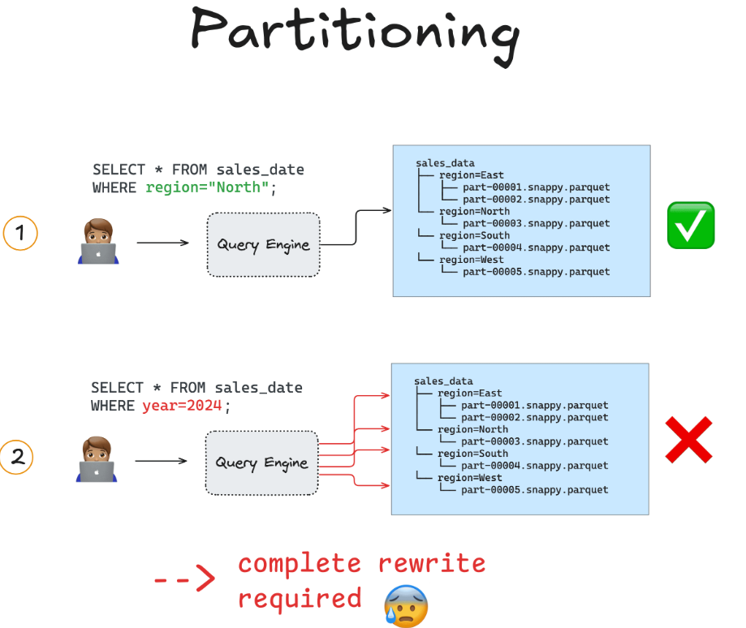

**Solution:**

Liquid clustering gives you flexibility**. With liquid clustering enabled, you can redefine your clustering columns without having to rewrite any existing data**. This allows your data layout to evolve in parallel with changing query patterns.

**CREATE TABLE table1(customer string, sales int) USING DELTA CLUSTER BY (customer);**

**OR**

**ALTER TABLE TABLE_NAME CLUSTER BY (column)**

**REMOVE CLUSTERING:** CLUSTER BY (none)

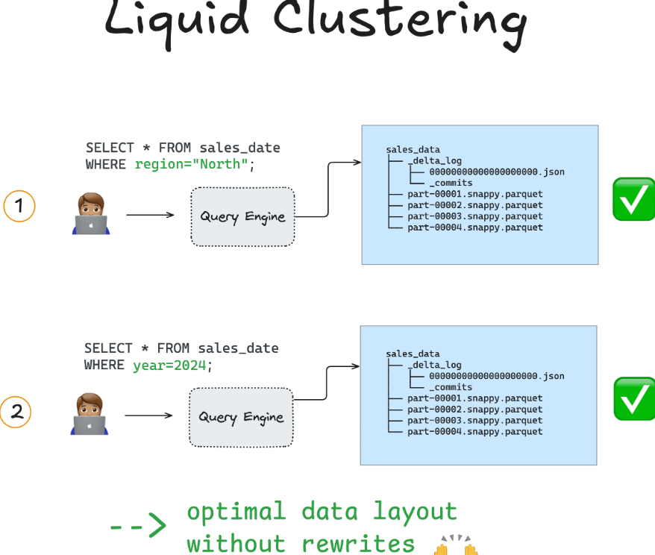

**When should I use Liquid Clustering?**

Liquid clustering is especially useful when:

* Data is skewed
* Filtering columns have different cardinalities
* Tables regularly ingest lots of new data
* System needs to support concurrent writes
* Query filter patterns change over time
* Data might lead to the small file problem if traditionally partitioned

Liquid clustering is not compatible with Hive-style partitioning and Z-ordering

**Note:** Cluster by column should be within first 32 columns

* You can specify up to 4 clustering columns per Delta table.
* Your clustering columns need to be columns with statistics collected in the Delta logs. By default, the first 32 columns in a Delta table have statistics collected

**Volumes in Unity Catalog:**

Govern semi/un-structured data using UC.

**Types:** Managed. External

**Working with managed Volumes:**

*create volume dev.bronze.managed_volume  
comment 'create managed volume'*

*%sh wget https://media.githubusercontent.com/media/subhamkharwal/pyspark-zero-to-hero/refs/heads/master/datasets/emp.csv*

*%python dbutils.fs.mkdirs('/Volumes/dev/bronze/managed_volume/files')*

*%python*

*dbutils.fs.cp('file:/Workspace/Users/geramkumar_gmail.com#ext#@geramkumargmail.onmicrosoft.com/emp.csv','/Volumes/dev/bronze/managed_volume/files')*

***not recommended:*** *select * from* ***csv.****`/Volumes/dev/bronze/managed_volume/files/emp.csv`*

***recommended****:*

*SELECT * FROM* ***read_files****(*

*'/Volumes/dev/bronze/managed_volume/files/emp.csv',*

*format => 'csv',*

*header => true,*

*mode => 'FAILFAST')*

**Working with external Volumes:**

*create external volume dev.bronze.external_volume  
location 'abfss://data@sauccentralindia.dfs.core.windows.net/adb/ext_volume'  
  
%python dbutils.fs.mkdirs('/Volumes/dev/bronze/external_volume/files')*

*%python*

*dbutils.fs.cp('file:/Workspace/Users/geramkumar_gmail.com#ext#@geramkumargmail.onmicrosoft.com/emp.csv','/Volumes/dev/bronze/external_volume/files')*

*SELECT * FROM read_files(*

*'/Volumes/dev/bronze/external_volume/files/emp.csv',*

*format => 'csv',*

*header => true,*

*mode => 'FAILFAST')*

*DROP VOLUME dev.bronze.managed_volume*

*DROP VOLUME dev.bronze.external_volume*

**IMPORTANT DIFFERENCE between managed and external volumes:**

When we drop a **managed volume**, volume definition will be deleted immediately. Data will be marked for deletion and deleted after **7 days**.

When we drop an **external volume**, only the volume will be deleted. Data **will not be deleted**.

**DBUTILS (only for Python or Scala):**

**Common Utilities:**

data: Work with DataFrames.

fs: Interact with files and directories.

jobs: Manage Databricks jobs.

library: Manage libraries and dependencies.

notebook: Work with notebooks and their metadata.

secrets: Manage secrets securely.

widgets: Create interactive widgets in notebooks.

Utilities API library: Access the underlying API for advanced customization.

dbutils.help()

**DBUTILS.FS**

dbutils.fs.help("cp")

df = spark.read.format('csv').load(

'/databricks-datasets/Rdatasets/data-001/csv/ggplot2/diamonds.csv',

header=True, inferSchema=True)

dbutils.data.summarize(df)

dbutils.fs.ls("/Volumes/main/default/my-volume/")

dbutils.fs.cp("/Volumes/main/default/my-volume/data.csv", "/Volumes/main/default/my-volume/new-data.csv")

dbutils.fs.mv("/Volumes/main/default/my-volume/rows.csv", "/Volumes/main/default/my-volume/my-data/")

dbutils.fs.put("/Volumes/main/default/my-volume/hello.txt", "Hello, Databricks!", True)

dbutils.fs.rm("/Volumes/main/default/my-volume/my-data/", True)

dbutils.fs.head("/Volumes/main/default/my-volume/data.csv", 25)

dbutils.fs.mkdirs("/Volumes/main/default/my-volume/my-data")

dbutils.fs.mounts()

dbutils.fs.mount(

source = "wasbs://<container-name>@<storage-account-name>.blob.core.windows.net",

mount_point = "/mnt/<mount-name>",

extra_configs = {"<conf-key>":dbutils.secrets.get(scope = "<scope-name>", key = "<key-name>")})

dbutils.fs.unmount("/mnt/<mount-name>")

**DBUTILS.JOBS**

dbutils.jobs.taskValues.set(key = "my-key", \

value = 5)

dbutils.jobs.taskValues.get(taskKey = "my-task", \

key = "my-key", \

default = 7, \

debugValue = 42)

**DBUTILS.NOTEBOOK**

dbutils.notebook.run("My Other Notebook", 60) <- 60 timeout seconds

dbutils.notebook.exit("Exiting from My Other Notebook")

**DBUTILS.SECRETS**

dbutils.secrets.get(scope="my-scope", key="my-key")

dbutils.secrets.list("my-scope")

**DBUTILS.WIDGETS**

dbutils.widgets.text(

name='your_name_text',

defaultValue='Enter your name',

label='Your name'

)

print(dbutils.widgets.get("your_name_text"))

dbutils.widgets.combobox(

name='fruits_combobox',

defaultValue='banana',

choices=['apple', 'banana', 'coconut', 'dragon fruit'],

label='Fruits'

)

print(dbutils.widgets.get("fruits_combobox"))

CREATE WIDGET COMBOBOX fruits_combobox DEFAULT "banana" CHOICES SELECT * FROM (VALUES ("apple"), ("banana"), ("coconut"), ("dragon fruit"))

SELECT :fruits_combobox

dbutils.widgets.dropdown(

name='toys_dropdown',

defaultValue='basketball',

choices=['alphabet blocks', 'basketball', 'cape', 'doll'],

label='Toys'

)

print(dbutils.widgets.get("toys_dropdown"))

CREATE WIDGET DROPDOWN toys_dropdown DEFAULT "basketball" CHOICES SELECT * FROM (VALUES ("alphabet blocks"), ("basketball"), ("cape"), ("doll"))

SELECT :toys_dropdown

df = spark.sql("SELECT * FROM table where col1 = :param", dbutils.widgets.getAll())

dbutils.widgets.multiselect(

name='days_multiselect',

defaultValue='Tuesday',

choices=['Monday', 'Tuesday', 'Wednesday', 'Thursday',

'Friday', 'Saturday', 'Sunday'],

label='Days of the Week'

)

print(dbutils.widgets.get("days_multiselect"))

dbutils.widgets.removeAll()

**DBUTILS.DATA**

df = spark.read.format('csv').load('abfss://data@sauccentralindia.dfs.core.windows.net/adb/ext_volume/files/emp.csv',  header=True,   inferSchema=True)

dbutils.data.summarize(df)

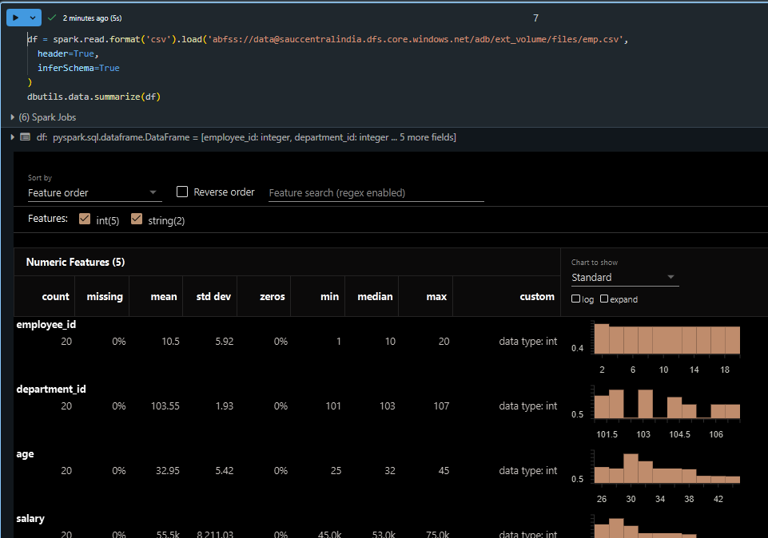

**Jobs and Workflow**

Databricks Workflows is a managed orchestration service within the Databricks platform that allows users to define, manage, and monitor data pipelines for ETL, analytics, and machine learning.

Job types:

Databricks Workflows support various job types to handle different data processing and analysis tasks. These include **Notebooks, Python scripts, JAR files, Databricks SQL queries, Delta Live Tables pipelines, dbt tasks**, and more. Jobs can also incorporate external systems like Azure Data Factory or dbt.

**Types of workflows:**

* **Jobs** are the underlying mechanism for scheduling and orchestrating tasks.
* **ETL pipelines (DLT)** focus on extracting, transforming, and loading data
* **ingestion pipelines** handle the initial data intake from various sources.
  1. **Jobs**

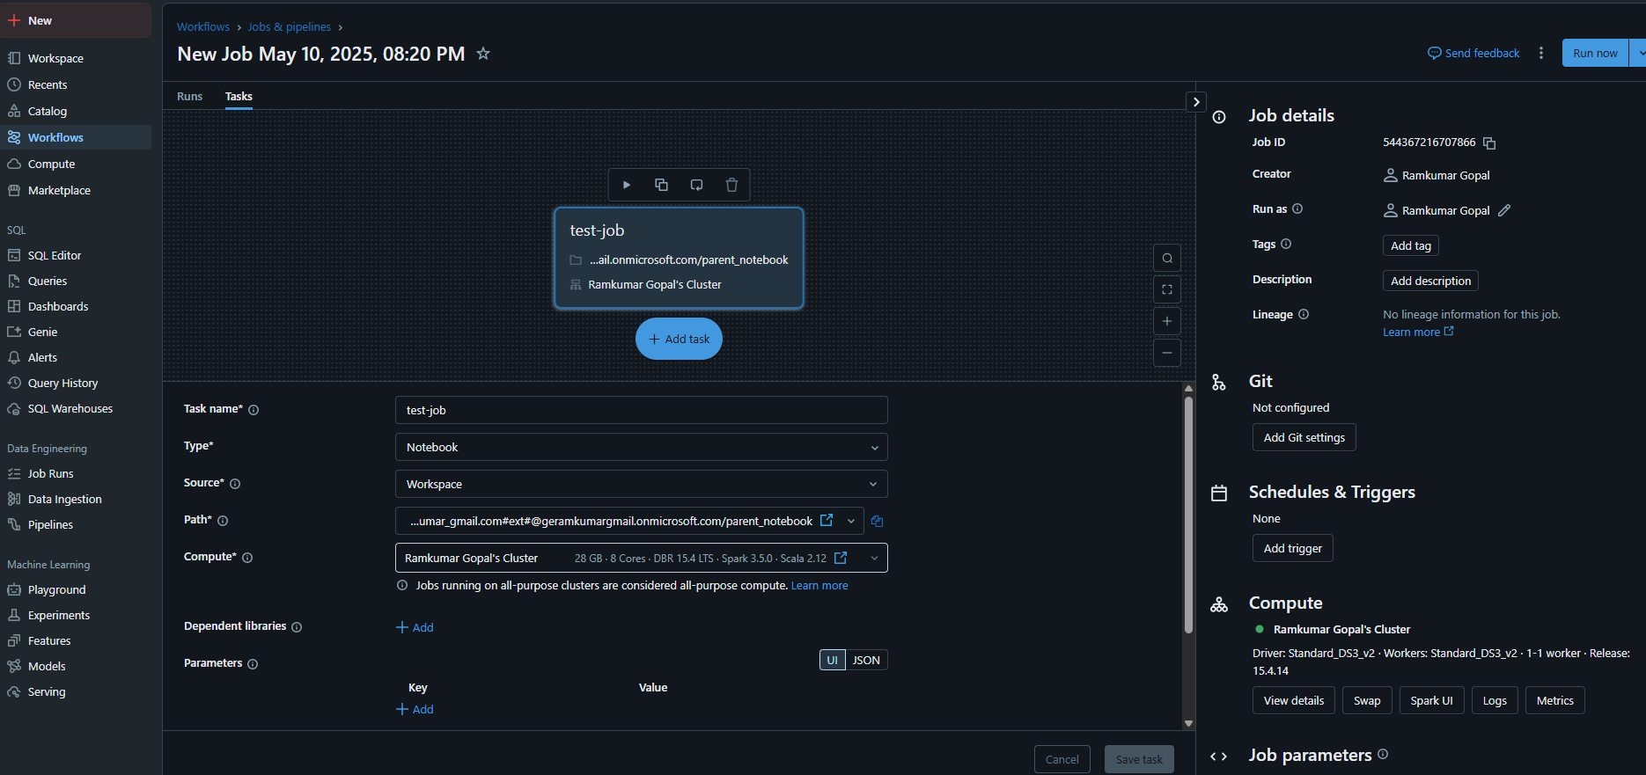**Creating a job**

* 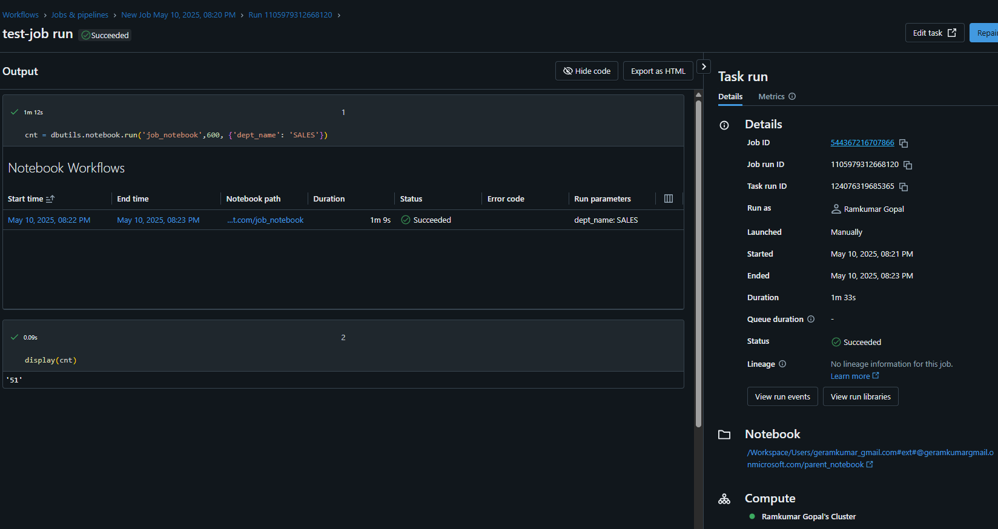**Running a job**
  1. **Pipeline (DLT – Core, Pro, Advanced Compute types)**

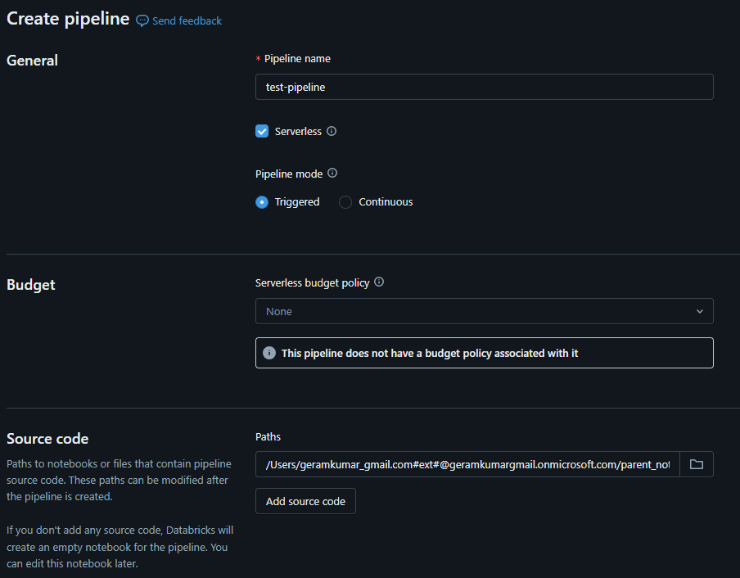

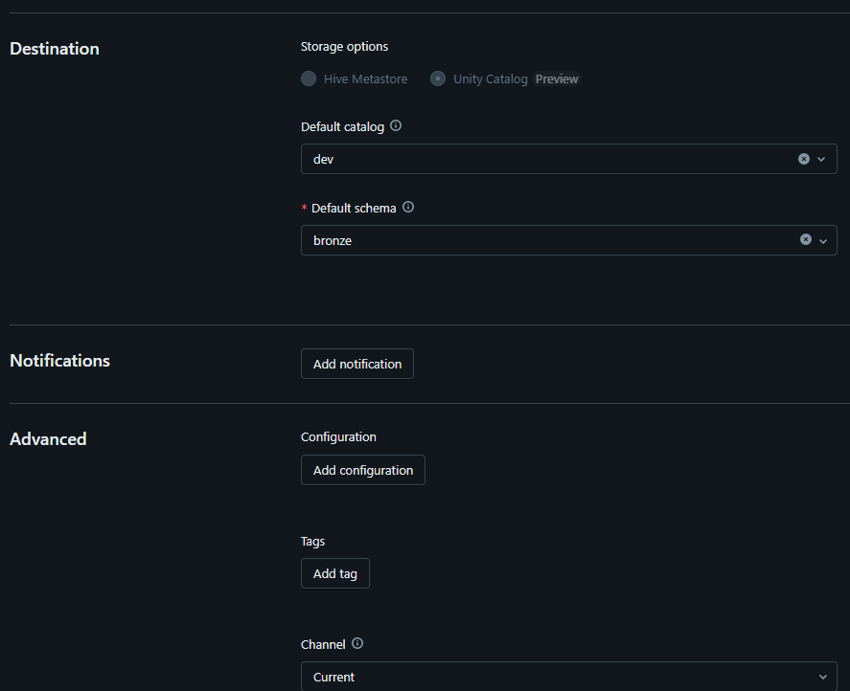

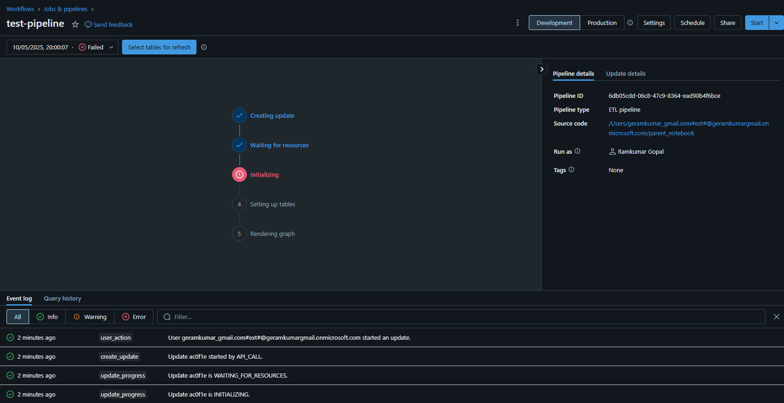

* 1. **Data Ingestion Pipeline**

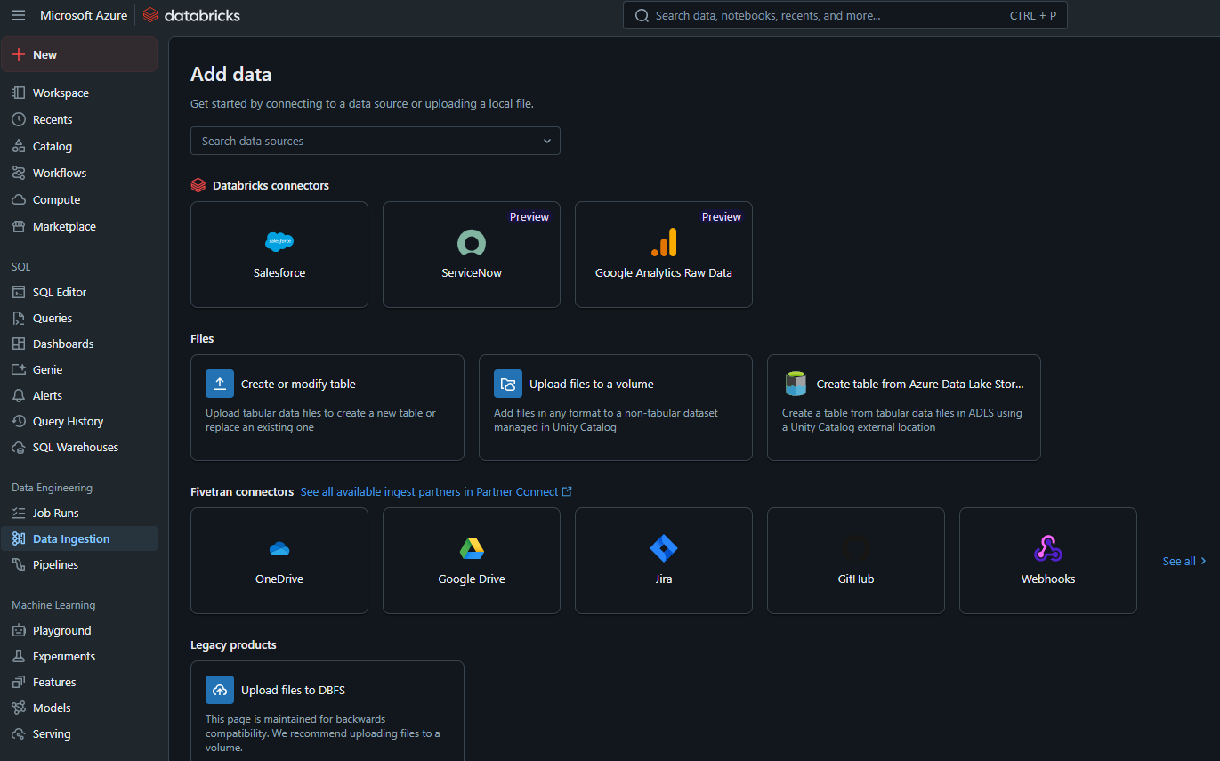

**Types of triggers**

**1. Schedule-Based Trigger**

* **Description**: Runs workflows at specific intervals (daily, weekly, hourly, etc.).
* **Use Case**: Automate ETL jobs or data refresh tasks on a routine basis.
* **Customization Options**:
* Cron expressions for precise scheduling.
* Timezone selection.

**2. Event-Based Trigger (File Arrival)**

* **Description**: Triggers workflows when a new file arrives in cloud storage (e.g., Azure Blob, AWS S3).
* **Use Case**: Automatically process files as soon as they arrive in a data lake.
* **Common Example**: Run a job when a new CSV or Parquet file is uploaded to Azure Blob Storage.

**3. Job Dependency Trigger**

* **Description**: Executes a workflow when another Databricks job completes (successfully or otherwise).
* **Use Case**: Chain multiple jobs where the output of one serves as the input to another.
* **Configuration**: You can specify whether the child workflow should trigger based on success, failure, or any status of the upstream job.

**4. API Trigger (REST API)**

* **Description**: Starts workflows through API calls.
* **Use Case**: Integrate Databricks workflows with external systems or CI/CD pipelines (like GitHub Actions or Jenkins).
* **How to Use**: Issue a POST request to the Databricks Jobs API endpoint to trigger the workflow programmatically.

**5. Manual Trigger**

* **Description**: Allows users to run the workflow manually via the Databricks UI or CLI.
* **Use Case**: Ad-hoc execution of workflows for testing or one-time processes.

**6. Delta Live Tables (DLT) Trigger**

* **Description**: Triggers pipelines based on changes in Delta Lake tables.
* **Use Case**: Automatically refreshes downstream data when new data is ingested into a Delta Lake table.

**7. Webhook Trigger**

* **Description**: Triggers workflows in response to external events using webhooks.
* **Use Case**: Activate Databricks jobs in response to external notifications (e.g., via an IoT device or web application).

**COPY INTO (Retriable and idempotent. Data will be loaded exactly once. Process 1000s of files):**

In Databricks, the COPY INTO command is used to load data from a source location (like cloud object storage) into a Delta table.

**Key Features and Capabilities:**

* **Simplified Ingestion:**

COPY INTO provides a direct and straightforward way to load data from cloud storage (S3, ADLS, GCS, etc.) into Databricks tables.

* **Format Support:**

It supports multiple source file formats, including CSV, JSON, XML, Avro, ORC, Parquet, and others.

* **Schema Evolution:**

COPY INTO can be configured to evolve the schema of the target table based on the input data.

* **Idempotency:**

If you rerun COPY INTO, it will not re-load data that has already been loaded.

* **File Filtering:**

You can use file or directory filters to select specific files for loading.

* **Concurrency:**

COPY INTO supports concurrent invocations against the same table, but it's generally better to use a single invocation with multiple files for performance.

* **Validate Mode:**

The COPY INTO Validate mode allows you to preview and validate source data before ingesting.

* **Scheduling:**

COPY INTO can be run ad-hoc or scheduled using Databricks Workflows.

* **Error Handling:**

COPY INTO provides options for handling corrupted records during parsing

**Example:**

CREATE TABLE IF NOT EXISTS my_table (  
 loan_id BIGINT,  
 funded_amnt INT,  
 paid_amnt DOUBLE,  
 addr_state STRING  
);  
  
COPY INTO my_table  
FROM '/databricks-datasets/learning-spark-v2/loans/loan-risks.snappy.parquet'  
FILEFORMAT = PARQUET  
FORMAT_OPTIONS ('mergeSchema' = 'true')  
COPY_OPTIONS ('mergeSchema' = 'true');  
  
SELECT * FROM my_table;

**Auto Loader (Process millions of files per minute)**

Databricks Auto Loader is a feature that simplifies and optimizes data ingestion from cloud storage into Databricks. Its key features include

* efficient file discovery
* schema inference and evolution
* exactly-once processing guarantees
* cost-effectiveness
* scalability
* support for various file formats.

*# Assuming you have a Databricks cluster and have configured cloud storage access*  
from pyspark.sql.functions import *  
from pyspark.sql import SparkSession  
  
*# Create a Spark session*  
spark = SparkSession.builder.appName("AutoLoaderExample").getOrCreate()  
  
*# Define the source path and checkpoint location*  
source_path = "s3://my-bucket/data/"  
checkpoint_path = "dbfs:/my/checkpoint/path"  
  
*# Create a read stream from the cloudFiles source*  
read_stream = spark.readStream \

.format("cloudFiles") \

.option("cloudFiles.format", "json") \

.load(source_path)  
  
*# You can perform any transformations on the data if needed*  
*# For example, you might want to extract specific fields or perform aggregations*  
transformed_data = read_stream \

.select("field1", "field2") *# Example transformation*  
  
*# Create a write stream to a Delta Lake table*  
transformed_data \

.writeStream \

.format("delta") \

.option("checkpointLocation", checkpoint_path) \

.outputMode("append") \

.toTable("my_table") # Replace with your desired table name

**DLT**

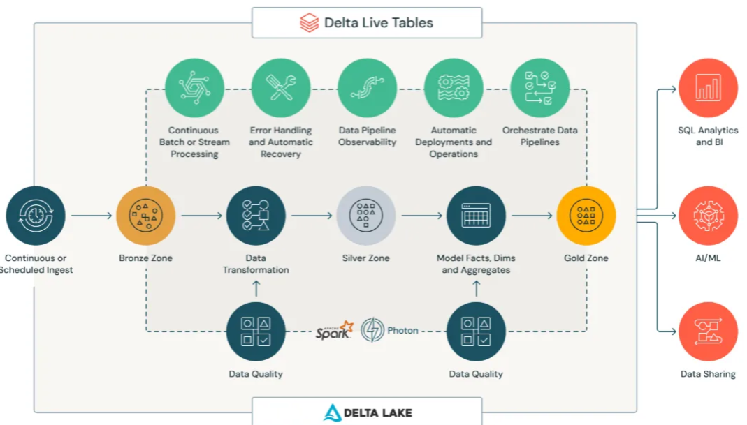

* **✅ Incremental data transformation  
  ✅ Change Data Capture (CDC) support  
  ✅ Type 2 Slowly Changing Dimensions (SCD2) handling out of the box**
* **However, DLT is not recommended for:**
* **❌ Writing to external tables  
  ❌ Complex transformations that require extensive custom logic**

**DLT Terminologies (data is updated incrementally. Streaming helps to append the data):**

* **DLT is a framework for creating batch and streaming data pipelines in SQL and Python**
* **Use cases:**
  + Ingestion from sources such as cloud storage (such as Amazon S3, Azure ADLS Gen2, and Google Cloud Storage)
  + Ingestion from message buses (such as Apache Kafka, Azure EventHub
  + Incremental batch and streaming transformations.
* Streaming tables vs Materialized Views
  + Streaming tables are used for ingesting and transforming append-only data streams.
  + Streaming tables are ideal when you need to process data as it arrives in real-time or near real-time
  + Materialized views are preferred for pre-computing slow queries and frequently used computations.
  + Materialized views are better for optimizing queries on relatively static data.

You can and often should use streaming tables for the bronze and silver layers in Delta Live Tables (DLT) and materialized views for the gold layer

**Features of DLT:**

* CDC Support
* SDC Support
* Data Quality Enforcement
* Data Lineage and Monitoring

**CREATE INCREMENTAL LIVE TABLE – Depreciated. Still supported**

**CREATE STEAMING LIVE TABLE - Depreciated. Still supported**

**CREATE STREAMING TABLE – Recommended**

**Sample script 1:**

**CREATE OR REPLACE STREAMING TABLE customers**

COMMENT "Customers RAW"

AS SELECT * FROM   
cloud_files("/databricks-datasets/retail-org/customers/", "csv");

**CREATE OR REPLACE STREAMING TABLE sales_orders_raw**

COMMENT "Sales Orders RAW"

AS

SELECT * FROM cloud_files("/databricks-datasets/retail-org/sales_orders/", "json", map("cloudFiles.inferColumnTypes", "true"))

**CREATE OR REPLACE STREAMING TABLE sales_orders_cleaned(**

CONSTRAINT valid_order_number EXPECT (order_number IS NOT NULL) ON VIOLATION DROP ROW)

PARTITIONED BY (order_date)

AS

SELECT

f.customer_id,

f.customer_name,

f.number_of_line_items,

TIMESTAMP(from_unixtime((cast(f.order_datetime as long)))) as order_datetime,

DATE(from_unixtime((cast(f.order_datetime as long)))) as order_date,

f.order_number,

f.ordered_products,

c.state,

c.city,

c.lon,

c.lat,

c.units_purchased,

c.loyalty_segment

FROM **STREAM(LIVE**.sales_orders_raw) f

LEFT JOIN LIVE.customers c

ON c.customer_id = f.customer_id AND c.customer_name = f.customer_name

**CREATE OR REPLACE MATERIALIZED VIEW sales_order_in_la**

AS

SELECT city, order_date, customer_id, customer_name, ordered_products_explode.curr,

SUM(ordered_products_explode.price) as sales,

SUM(ordered_products_explode.qty) as qantity,

COUNT(ordered_products_explode.id) as product_count

FROM (

SELECT city, order_date, customer_id, customer_name, EXPLODE(ordered_products) as ordered_products_explode

FROM LIVE.sales_orders_cleaned

WHERE city = 'Los Angeles'

)

GROUP BY order_date, city, customer_id, customer_name, ordered_products_explode.curr

**Sample for SCD 1 and SCD 2**

CREATE OR REFRESH STREAMING TABLE product_silver;

APPLY CHANGES INTO live.product_silver

FROM stream(LIve.products)

KEYS (product_id)

APPLY AS DELETE WHEN operation = "DELETE"

SEQUENCE BY seqNum

COLUMNS * EXCEPT (operation,seqNum ,_rescued_data,ingestion_date)

STORED AS SCD TYPE 1;

CREATE OR REFRESH STREAMING TABLE customer_silver;

APPLY CHANGES INTO live.customer_silver

FROM stream(LIve.customers)

KEYS customer_id)

APPLY AS DELETE WHEN operation = "DELETE" SEQUENCE BY sequenceNum

COLUMNS * EXCEPT (operation,sequenceNum ,_rescued_data,ingestion_date)

STORED AS SCD TYPE 2;

**COPY INTO Vs Auto Loader Vs Delta Live Table**

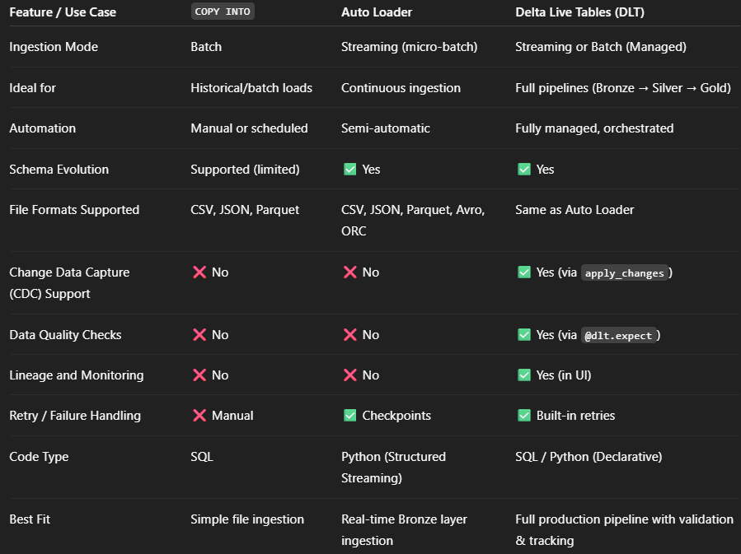

**DLT Pipeline sample**

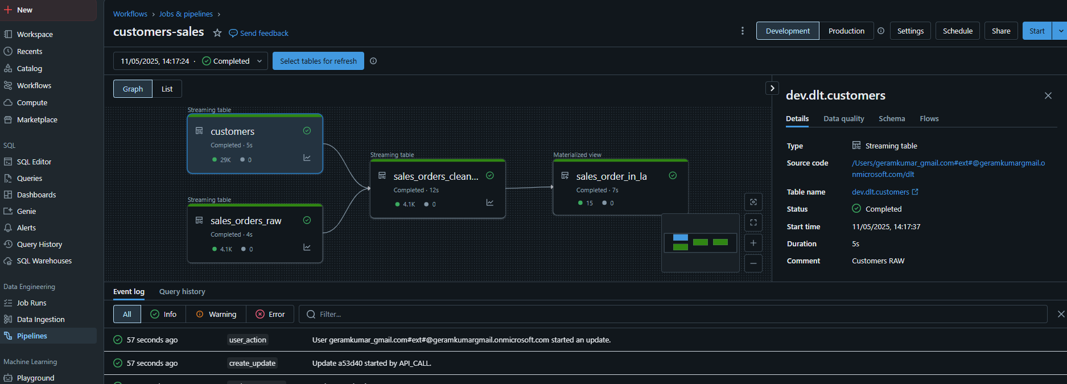

**Databricks Secret Management:**

**Secret Scopes:**

* **Azure Key Vault Backed**
  + Create KV in Azure.
  + In AKV, Create a new secret. geramkumar/Password@123
  + In Databricks workspace url, include #secrets/createScope[https://adb-4248328932240573.13.azuredatabricks.net/?o=4248328932240573**#secrets/createScope**](https://adb-4248328932240573.13.azuredatabricks.net/?o=4248328932240573#secrets/createScope)
  + **create a new secret scope named “akv”**
  + 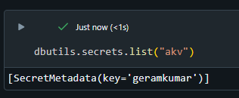
  + 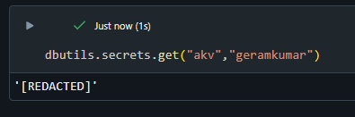
* **Databricks Backed** 
  + **Install Databricks CLI (command prompt)**
    - **winget search databricks  
      winget install Databricks.DatabricksCLI**

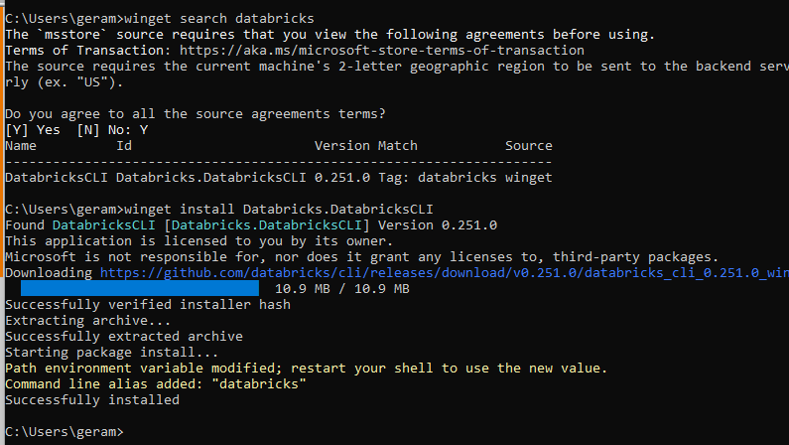

* + - C:\Users\geram>databricks -v

**Databricks CLI v0.251.0**

* + - C:\Users\geram>**databricks auth login** Databricks profile name: dbxauth Databricks host (e.g. https://<databricks-instance>.cloud.databricks.com): **https://adb-4248328932240573.13.azuredatabricks.net**   
      Profile dbxauth was successfully saved C:\Users\geram>
    - **C:\Users\geram>databricks secrets list-scopes**Scope Backend Type  
      akv AZURE_KEYVAULT
    - C:\Users\geram>**databricks secrets create-scope dbx-secret-scope**
    - C:\Users\geram>**databricks secrets list-scopes**

**Scope Backend Type**

akv AZURE_KEYVAULT

dbx-secret-scope DATABRICKS

* + - C:\Users\geram>**databricks secrets put-secret dbx-secret-scope db-host --string-value=secrethost.com**
  + In Databricks Workspace
    - dbutils.secrets.listScopes()

[SecretScope(name='akv'), SecretScope(name='dbx-secret-scope')]

* + - 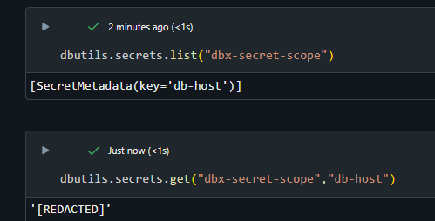

**Databricks CLI**

* **Install Databricks CLI (command prompt)**
  + **winget search databricks  
    winget install Databricks.DatabricksCLI  
      
    Generate token in DBX Workspace -> Developer -> Access Token**
* C:\Users\geram>**databricks configure --token**

Databricks host: <https://adb-4248328932240573.13.azuredatabricks.net>  
Personal access token: ************************************

* C:\Users\geram>**databricks fs ls /**
* C:\Users\geram>**databricks workspace list /**

ID Type Language Path

2739774414175509 DIRECTORY /Users

2739774414175510 DIRECTORY /Shared

2739774414175515 DIRECTORY /Repos

* C:\Users\geram>**databricks clusters list**

ID Name State

0511-075927-1s4wa59j dlt-execution-1b84eb9a-4264-472a-87da-e1580af5f663 TERMINATED

0511-080711-u1sf4d3q dlt-execution-1b84eb9a-4264-472a-87da-e1580af5f663 TERMINATED

0511-082029-z2pz8pue dlt-execution-1b84eb9a-4264-472a-87da-e1580af5f663 TERMINATED

0511-083944-531gzb8o dlt-execution-1b84eb9a-4264-472a-87da-e1580af5f663 TERMINATED

0510-145853-mzf2hek6 dlt-execution-230c7173-5af2-4fd3-8d16-2642aba827e8 TERMINATED

0510-143405-mijahcw3 Ramkumar Gopal's Cluster TERMINATED

* **Databricks clusters start <cluster-id>**
* **databricks libraries list**
* **databricks instance-pools list**
* **databricks jobs list**

**Databricks Identity Management:**

* **Account Admin:** Administrative access on the account console to configure account-level components (workspaces, NCC, etc)
* **Metastore Admin:** Manage Unity Catalog metastore and its components and design downstream permissions model
* **Workspace Admin:** Administrative access on a Databricks workspace to configure workspace-level components (clusters, jobs, users/groups, warehouses etc)

**Databricks Users, Groups and Service Account Management**

* With unity catalog, users of all workspaces can be managed centrally

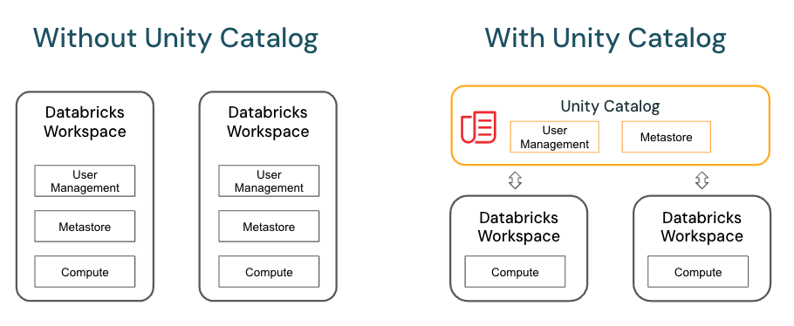

* **Add a new user named “da” in Entra ID**
* **Add the same user in accounts.databricks**

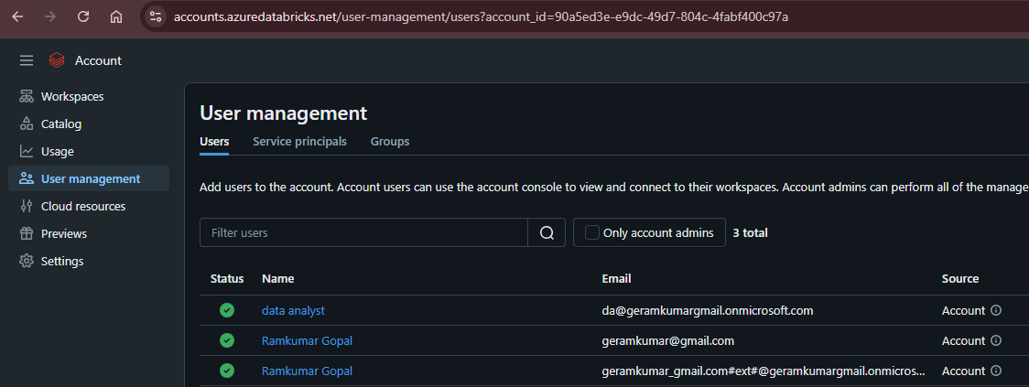

Note: To auto provision Azure users in Databricks automatically via SCIM seeting.  
Under accounts.databricks.com -> Settings -> User provision

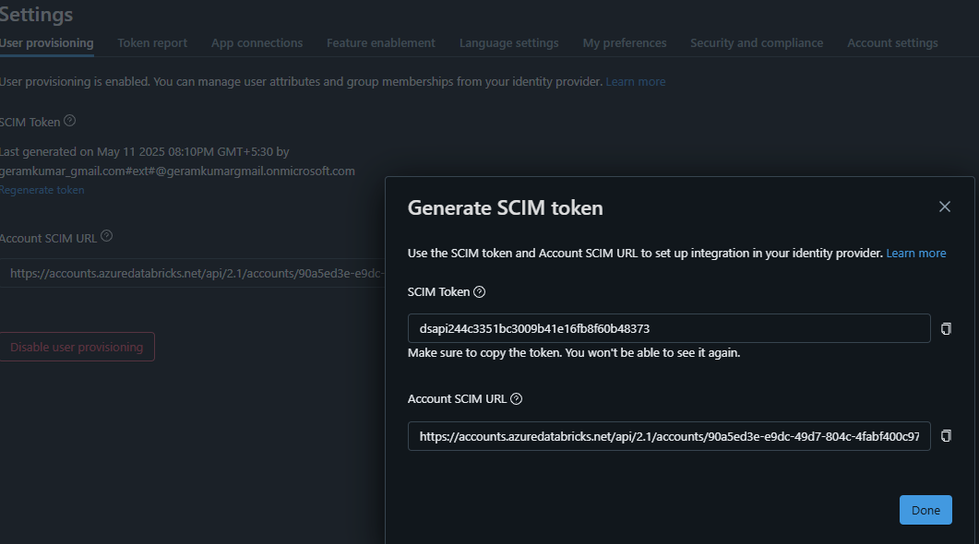

* Create Group and Add members

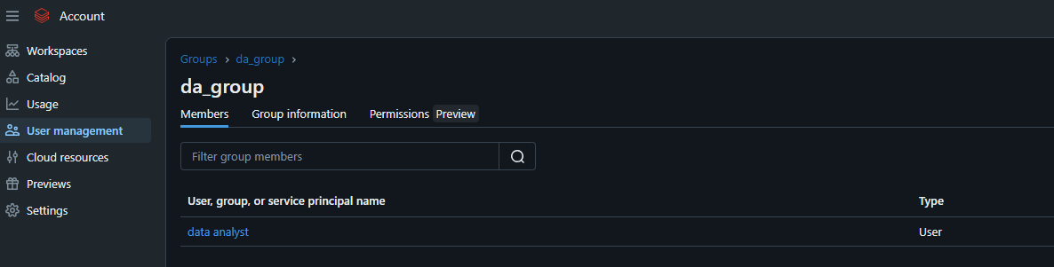

* Now, Da User can’t access the workspace as he doesn’t have the access

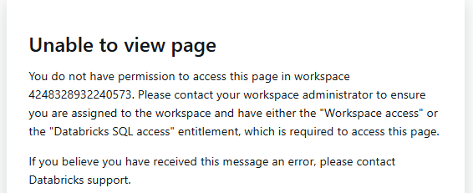

* In accounts.databricks -> workspace -> Permissions  
  Add the user or group in the workspace  
  Give the permission as user or admin

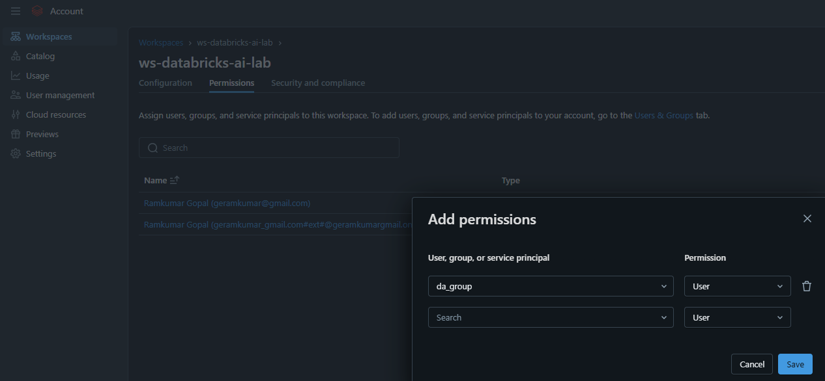

* **Then provide workspace level access within the workspace  
  Note:** user/group created in accounts.databricks will automatically reflect in workspace

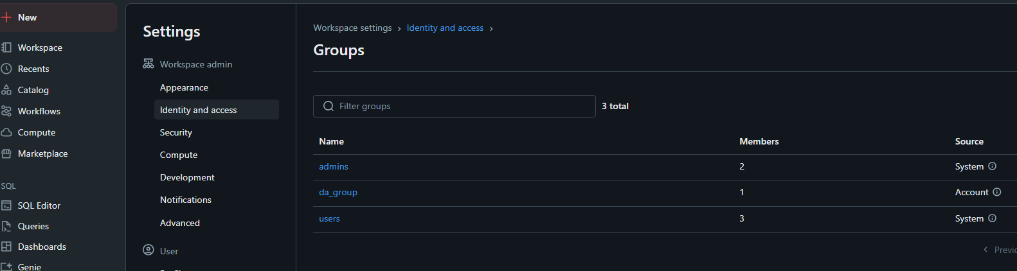

**By default, workspace level entitiements won’t be given to the users created in accounts.**

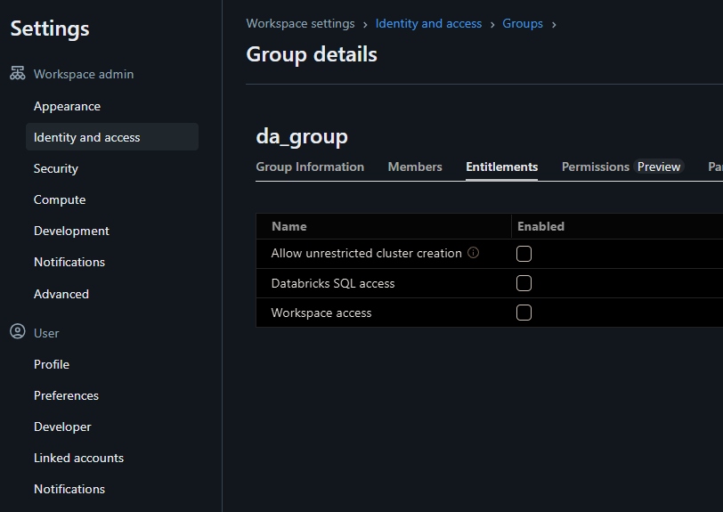

**Service Principal (Databricks scope, Entra Scope):**

**Primarily for running jobs**

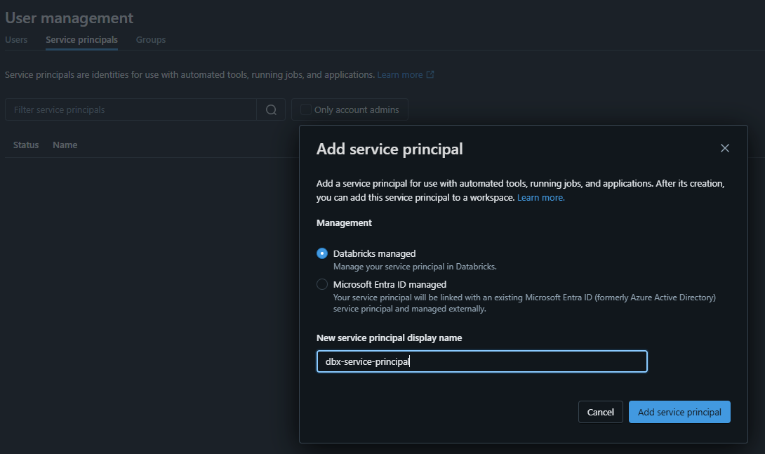

**Then generate secret**

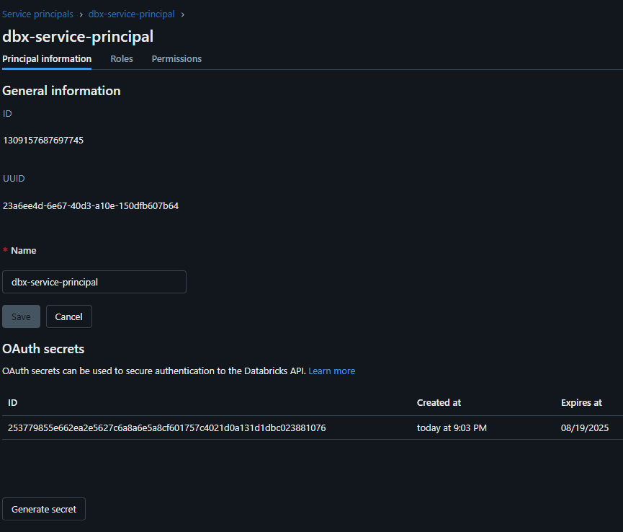

**Azure Entra based Service Principal:**

**Azure -> Entra ID -> App registration**

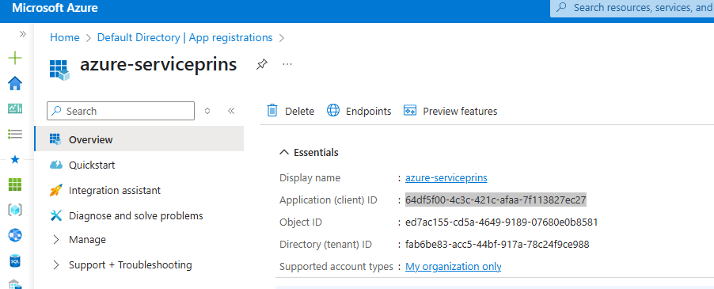

**And add the sp in accounts.databricks.com**

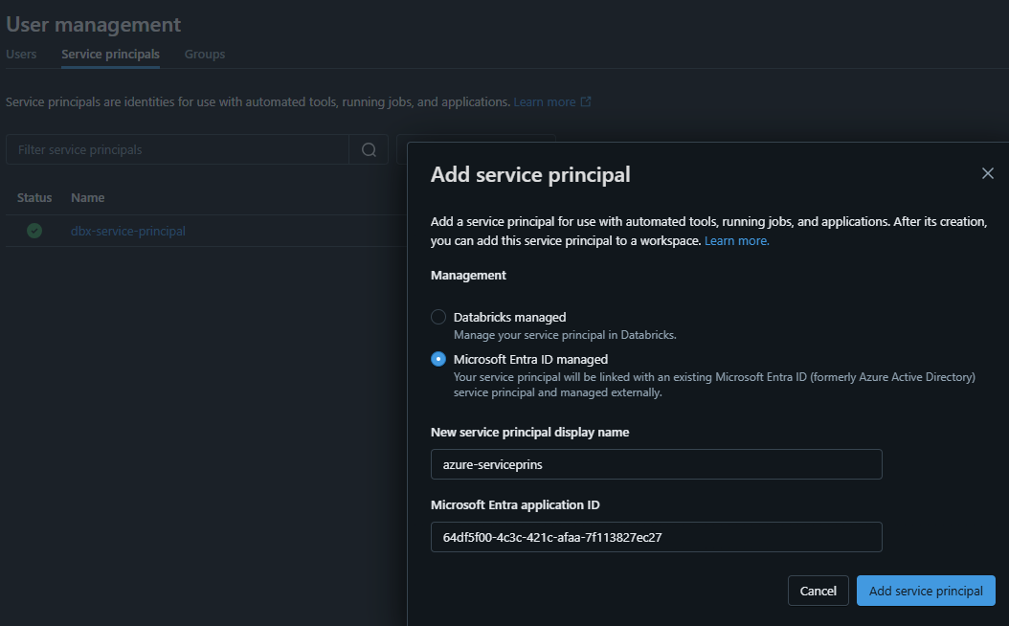

**Then in workspace -> “Identity and Access” -> Select “Service Principal”**

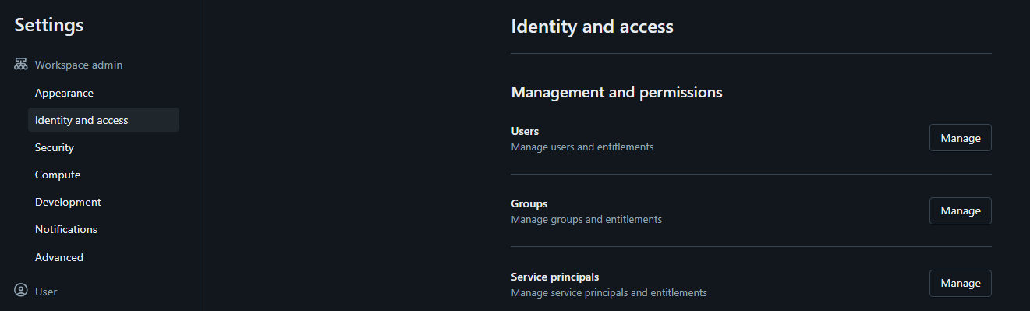

**Its automatically sync’d in workspace:**

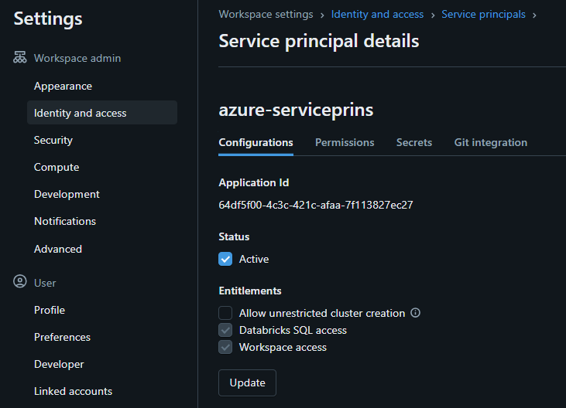

**Object Level Permissions in Unity Catalog**

objects in Unity Catalog are hierarchical, and privileges are inherited downward.

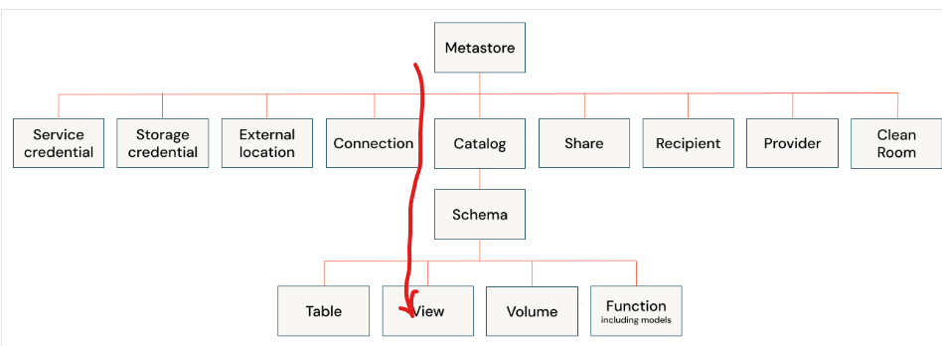

**Top down Inheritence:**

* Metastore admin has access to all catalogs
* If permission is given in CATALOG level, it will be inherited in SCHEMA level
* If permission is given in SCHEMA level, it will be inherited in all Objects level

**Bottem:**

* **If select table is given to user, user can access only that object**

**Note: Owners of an object are automatically granted all privileges on that object**

**Metastore Admins:**

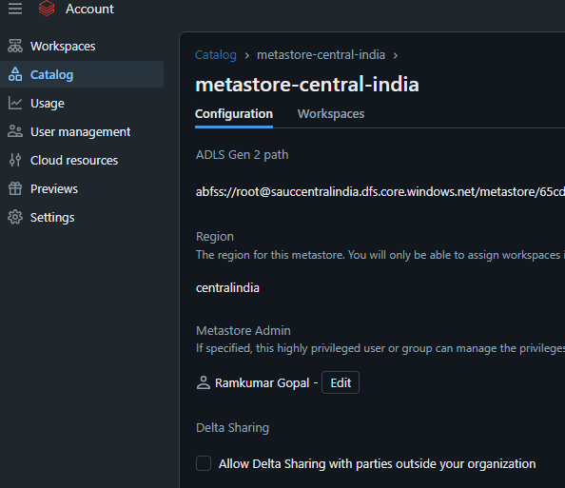

**BY DEFAULT ALL USERS HAVE BROWSE PERMISSION IN CATALOG level.**

In Databricks Unity Catalog, all users have USE CATALOG privilege on the main catalog by default. Additionally, workspace users receive USE CATALOG, USE SCHEMA, CREATE TABLE, CREATE VOLUME, CREATE MODEL, CREATE FUNCTION, and CREATE MATERIALIZED VIEW privileges on the workspace catalog's default schema

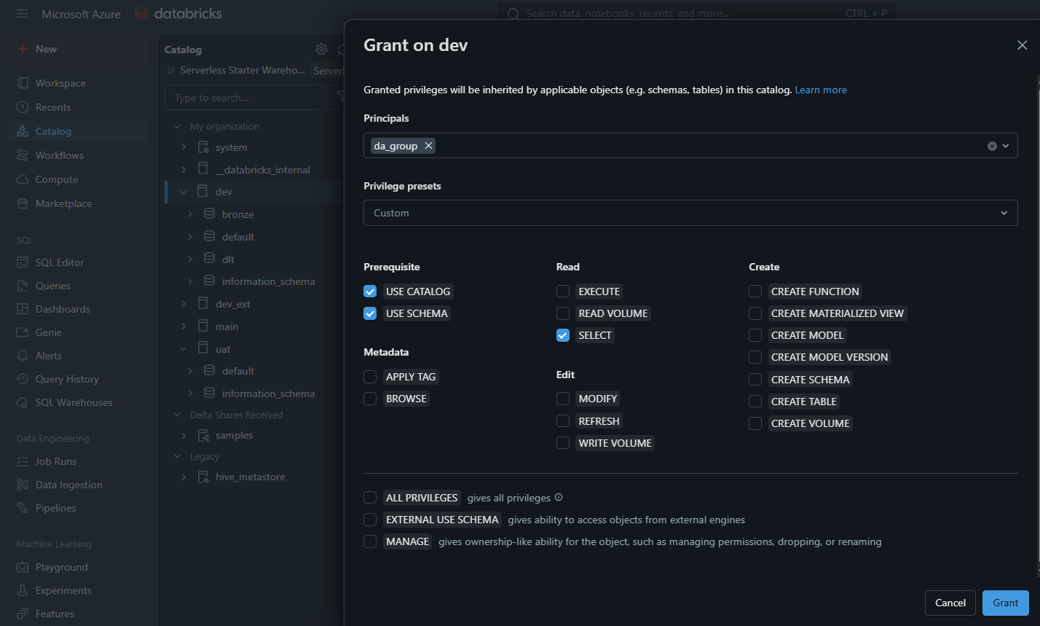

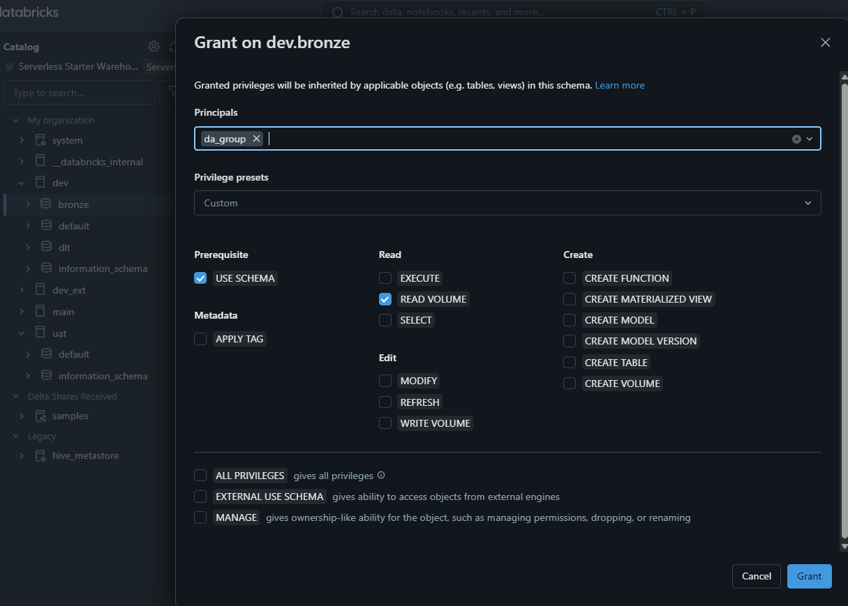

In Databricks SQL, backticks (` `) are used to enclose table, column, and schema names that contain special characters (like hyphens, spaces, or reserved words), or when the name is case-sensitive. They are also necessary for referencing names in a case-sensitive manne

**Commands:**

%sql SELECT current_user();

%sql SHOW GRANTS `geramkumar_gmail.com#ext#@geramkumargmail.onmicrosoft.com` ON METASTORE

**CATALOG LEVEL:**

1. **Specify Privileges:** Choose the appropriate privileges for the catalog. Examples include:
   * **USE CATALOG**: Allows users to use the catalog to access its schemas and tables.
   * **CREATE SCHEMA**: Allows users to create schemas within the catalog.
   * **CREATE TABLE**: Allows users to create tables within the catalog.
   * **CREATE FUNCTION**: Allows users to create functions within the catalog.
   * **ALL PRIVILEGES**: Grants all available privileges on the catalog.

**EXAMPLE:** GRANT USE CATALOG, CREATE SCHEMA ON CATALOG main TO `user@example.com`;

**SCHEMA LEVEL:**

You can grant permissions like SELECT, CREATE TABLE, MODIFY, and ALL_PRIVILEGES at the schema level.

**OBJECT LEVEL:**

Understanding Privileges:

* SELECT: Grants read access to data within the object (e.g., a table).
* CREATE: Allows creating new objects within a schema (e.g., a new table).
* MODIFY: Grants the ability to add, delete, and modify data in the object.
* USAGE: An additional requirement to perform any action on a schema object.
* ALL PRIVILEGES: Grants all applicable privileges on the object.

**Examples:**

grant create catalog on metastore to `da_group`

revoke create catalog on metastore from `da_group`

GRANT SELECT ON CATALOG dev TO `da@geramkumargmail.onmicrosoft.com`

GRANT SELECT ON SCHEMA dev.bronze TO `da@geramkumargmail.onmicrosoft.com`

SHOW GRANTS `da@geramkumargmail.onmicrosoft.com` ON SCHEMA dev.bronze

GRANT CREATE TABLE ON SCHEMA main.default TO `finance-team`;  
 GRANT USE SCHEMA ON SCHEMA main.default TO `finance-team`;  
 GRANT USE CATALOG ON CATALOG main TO `finance-team`;

GRANT EXECUTE ON FUNCTION prod.ml_team.iris_model TO `ml-team-acme`;

REVOKE <privilege-type> ON <securable-type> <securable-name> FROM <principal>  
 REVOKE CREATE TABLE ON SCHEMA main.default FROM `finance-team`;

**System tables in Unity Catalog**

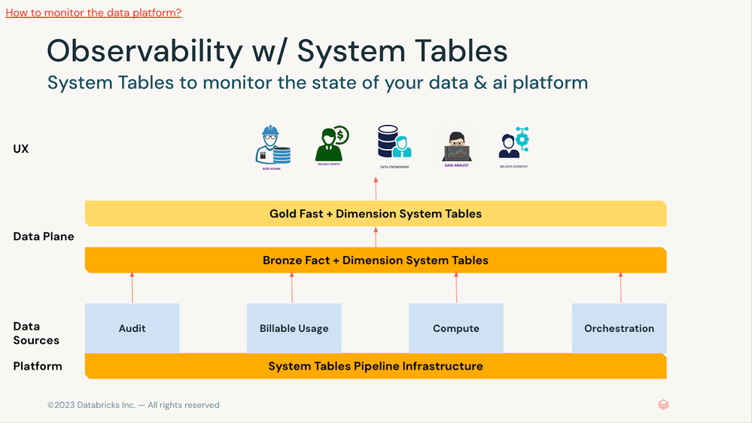

**System catalog tables:**

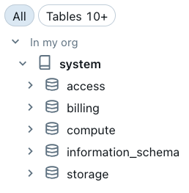

SELECT * FROM system.information_schema.catalogs

SELECT * FROM system.information_schema.schemata where catalog_name = 'dev'

SELECT * FROM system.information_schema.tables where table_catalog = 'dev'

SELECT * FROM system.information_schema.views

SELECT * FROM system.information_schema.columns

SELECT * FROM system.information_schema.metastore_privileges

SELECT * FROM system.information_schema.catalog_privileges

SELECT * FROM system.information_schema.schema_privileges

SELECT * FROM system.information_schema.table_privileges

SELECT * FROM system.information_schema.volumes

SELECT * FROM system.access.audit

SELECT * FROM system.access.audit

SELECT * FROM system.storage.predictive_optimization_operations_history

WITH agg_data AS (

SELECT ds, sku1 as sku, workspace_id, SUM(dbus) AS dbus, SUM(cost_at_list_price) AS cost_at_list_price

FROM

(

select workspace_id, ds, dbus, cost_at_list_price, sku,

CASE

WHEN sku LIKE '%ALL_PURPOSE%' THEN 'ALL_PURPOSE'

WHEN sku LIKE '%JOBS%' THEN 'JOBS'

WHEN sku LIKE '%DLT%' THEN 'DLT'

WHEN sku LIKE '%SQL%' THEN 'SQL'

WHEN sku LIKE '%INFERENCE%' THEN 'MODEL_INFERENCE'

ELSE 'OTHER'

END AS sku1

from

(

SELECT u.workspace_id, u.usage_date AS ds, u.sku_name AS sku,

CAST(u.usage_quantity AS DOUBLE) AS dbus,

CAST(lp.pricing.default * usage_quantity AS DOUBLE) AS cost_at_list_price

FROM

**system.billing.usage u**

INNER JOIN **system.billing.list_prices** lp ON u.cloud = lp.cloud

AND u.sku_name = lp.sku_name

AND u.usage_start_time >= lp.price_start_time

WHERE

u.usage_unit = 'DBU'

)

)

GROUP BY ds, sku1, workspace_id

)

select ds, sku, sum(dbus) as dbus, sum(cost_at_list_price) as cost_at_list_price

from agg_data

where

ds <= now()

and ds >= SUBSTRING_INDEX('{{start_date}}', ' |', 1)

group by ds, sku

**How to enable system.query.history**

databricks system-schemas list 65cd58cc-8a1a-41df-8a57-f01360651e83

databricks system-schemas enable 65cd58cc-8a1a-41df-8a57-f01360651e83 query

select * from system.query.history

**__databricks_internal Catalog:**

__databricks_internal is a hidden, system-managed space for DLT pipeline materializations, designed for efficiency and security rather than direct user access or modification.

**User Defined Functions**

* **Scalar UDFs -** operate on a single row and return a single result for each row.

CREATE OR REPLACE FUNCTION capitalize_string(input_str STRING)  
 RETURNS STRING  
 RETURN UPPER(input_str);

SELECT capitalize_string("hello") AS capitalized_word;

* **SQL UDFs - SQL UDFs are functions written in SQL that extend SQL capabilities**

CREATE FUNCTION my_catalog.my_schema.get_name_length(name STRING)  
RETURNS INT  
RETURN LENGTH(name);

SELECT name, my_catalog.my_schema.get_name_length(name) AS name_length  
FROM your_table;

* **Python UDTFs (User Defined Table Functions) – Returns a table**

CREATE FUNCTION my_udtf()  
RETURNS TABLE(my_column VARCHAR) AS $$  
 SELECT 'Hello'  
 UNION  
 SELECT 'World'  
$$;

SELECT my_column FROM TABLE(my_udtf());

**Row level filter in Unity Catalog – Filter sensitive data**

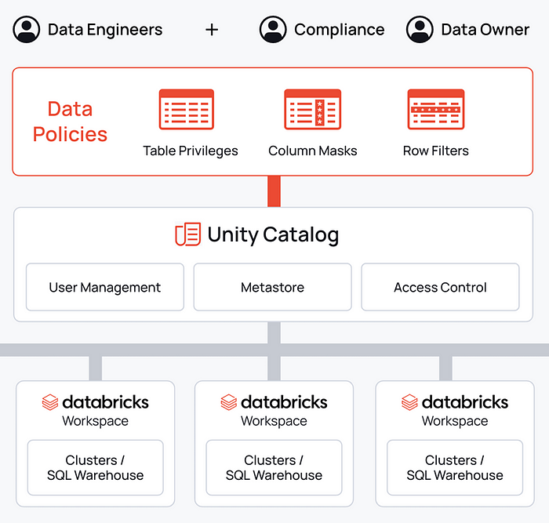

**Challenges in Data Security:**

* Sensitive Data Exposure: Broad access can risk exposing sensitive information.
* Complex Access Controls: Managing detailed access permissions can be intricate.
* Regulatory Compliance: Adhering to regulations requires precise data access control.

**Solution**: Row-Level Masking in Unity Catalog

SELECT * FROM system.information_schema.catalogs

SELECT * FROM system.information_schema.schemata where catalog_name = 'dev'

SELECT * FROM system.information_schema.tables where table_catalog = 'dev'

SELECT * FROM system.information_schema.views

SELECT * FROM system.information_schema.columns

SELECT * FROM system.information_schema.metastore_privileges

SELECT * FROM system.information_schema.catalog_privileges

SELECT * FROM system.information_schema.schema_privileges

SELECT * FROM system.information_schema.table_privileges

SELECT * FROM system.information_schema.volumes

SELECT * FROM system.access.audit

SELECT * FROM system.access.audit

SELECT * FROM system.storage.predictive_optimization_operations_history

WITH agg_data AS (

SELECT ds, sku1 as sku, workspace_id, SUM(dbus) AS dbus, SUM(cost_at_list_price) AS cost_at_list_price

FROM

(

select workspace_id, ds, dbus, cost_at_list_price, sku,

CASE

WHEN sku LIKE '%ALL_PURPOSE%' THEN 'ALL_PURPOSE'

WHEN sku LIKE '%JOBS%' THEN 'JOBS'

WHEN sku LIKE '%DLT%' THEN 'DLT'

WHEN sku LIKE '%SQL%' THEN 'SQL'

WHEN sku LIKE '%INFERENCE%' THEN 'MODEL_INFERENCE'

ELSE 'OTHER'

END AS sku1

from

(

SELECT u.workspace_id, u.usage_date AS ds, u.sku_name AS sku,

CAST(u.usage_quantity AS DOUBLE) AS dbus,

CAST(lp.pricing.default * usage_quantity AS DOUBLE) AS cost_at_list_price

FROM

system.billing.usage u

INNER JOIN system.billing.list_prices lp ON u.cloud = lp.cloud

AND u.sku_name = lp.sku_name

AND u.usage_start_time >= lp.price_start_time

WHERE

u.usage_unit = 'DBU'

)

)

GROUP BY ds, sku1, workspace_id

)

select ds, sku, sum(dbus) as dbus, sum(cost_at_list_price) as cost_at_list_price

from

agg_data

where

ds <= now()

and ds >= SUBSTRING_INDEX('{{start_date}}', ' |', 1)

group by ds, sku

-----------

Earlier Approach:

CREATE OR REPLACE <table_name>_kolkata_view AS Select * from <table> where region='kolkata'

OR

CREATE VIEW <table_name>_kolkata_view

AS SELECT *

FROM <table_name>

WHERE IS_ACCOUNT_GROUP_MEMBER('kolkata');

The is_account_group_member function in Databricks SQL is used to check if a user is a member of a specific account-level group.

It returns true if the user belongs to the group and false otherwise

Example:

SELECT is_account_group_member('admins'); -- Returns false if the user is not a member of the 'admins' group

SELECT is_account_group_member('dev'); -- Returns true if the user is a member of the 'dev' group

**In Row Level Security**

**Step 1:** Create a row filter

CREATE FUNCTION <function_name> (<parameter_name> <parameter_type>, ...)   
RETURN {filter clause whose output must be a boolean};

**Step 2:** Apply the row filter to a table

CREATE TABLE <table_name> (…) **WITH ROW FILTER** user_filter ON (Email)

ALTER TABLE <table_name>   
SET ROW FILTER <function_name> ON (<column_name>, ...);

**TO REMOVE RLS**: ALTER TABLE <table_name> DROP ROW FILTER;

**Example:**

CREATE TABLE IF NOT EXISTS supplier_manager_acl (

group_id STRING,

users ARRAY<STRING>

);

INSERT OVERWRITE supplier_manager_acl (group_id, users) VALUES

('SupplierManager(Packaging)', Array("mcole@hitachisolutions.com", "jonsmith@domain.com")),

('SupplierManager(Clothing)', Array("billybob@domain.com"));

CREATE OR REPLACE FUNCTION supplier_manager_row_filter (CategoryName STRING)

RETURN is_account_group_member('admins')

OR is_account_group_member('Executives')

OR EXISTS(

SELECT 1 FROM supplier_manager_acl v

WHERE CONCAT('SupplierManager(',CategoryName,')') = v.group_id AND ARRAY_CONTAINS(v.users, SESSION_USER()));

/* Apply the UDF Row Filter */

ALTER TABLE gold.dim_supplier **SET ROW FILTER** supplier_manager_row_filter ON (CategoryName);

**Column Masking**

CREATE FUNCTION dev.bronze.phone_mask(phone STRING)   
RETURN IF(  
 IS_ACCOUNT_GROUP_MEMBER('admin'),  
 phone,  
 '****'  
 );

ALTER TABLE dev.bronze.customer **ALTER COLUMN c_phone SET MASK** rsoni.tpch.phone_mask;

ALTER TABLE dev.bronze.customer **ALTER COLUMN c_phone DROP MASK**

**Workspace catalog binding in UC**

In databricks, we can create multiple workspaces and share a catalog across workspaces.

We can restrict a catalog to specific workspace.

Ex: dev catalogs shouldn’t be available in QA workspace.

Do do that, Uncheck “All workspace have access” and next “Assign to specific workspace”

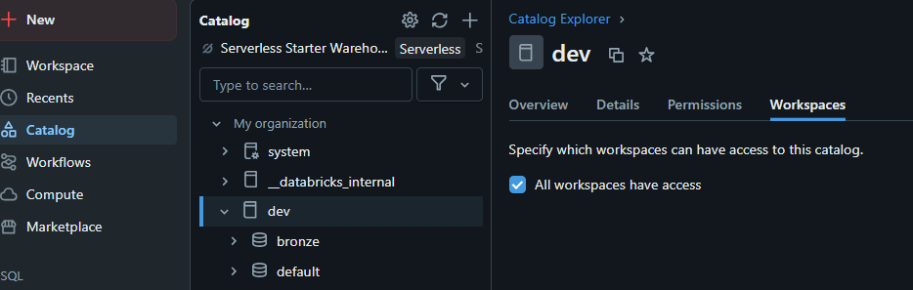

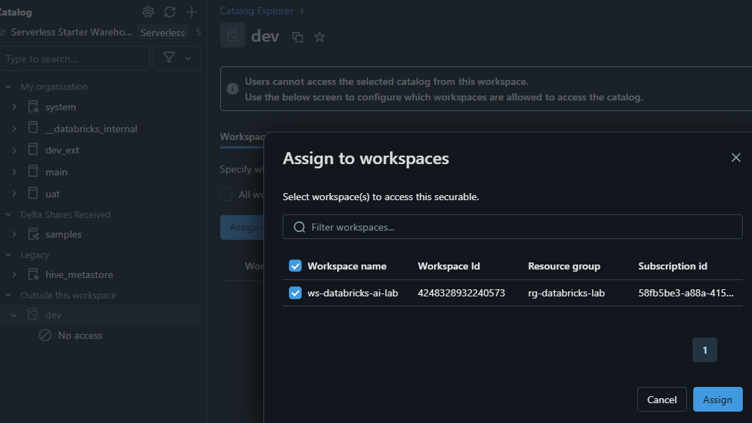

**Delta Sharing :**

Share data within and outside in read only mode.

* Open sharing – share with external party (doesn’t use Databricks)
* Databricks to Databricks

Step 1 : Enable “Allow data sharing outside your organization” in Accounts console  
**Note:** this step is not required if we share delta within the same organization to other metastore

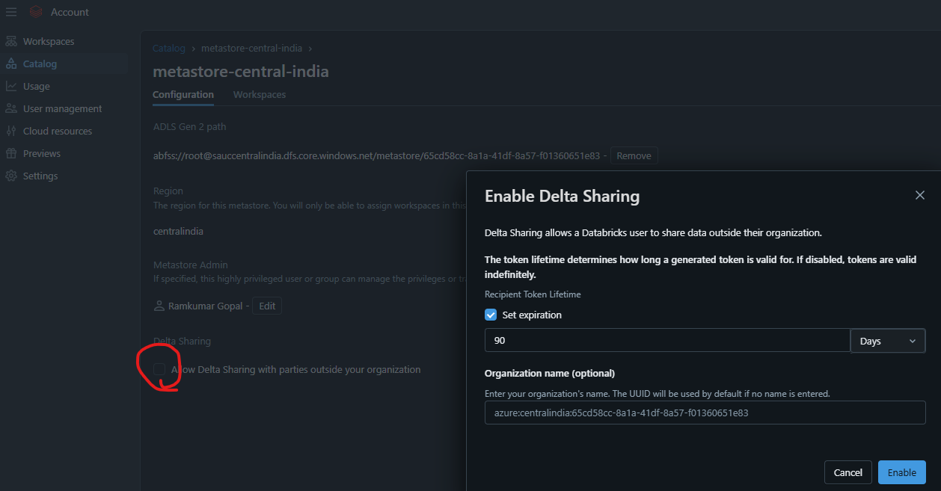

Step 2: In Workspace, select the metastore -> permission

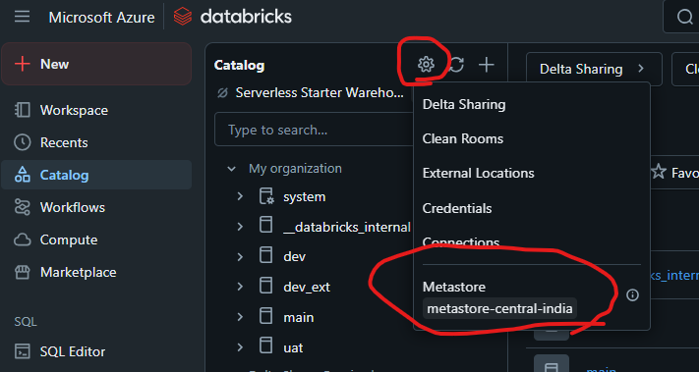

**To Provide Sharing:** Step 3 Provide Create Provider, Create Recepient, Create share permission

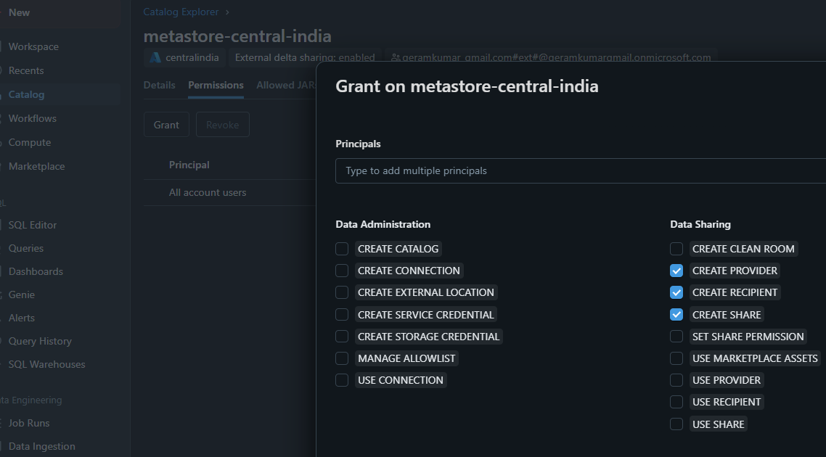

**Note: To use delta sharing we need below 3 permissions**

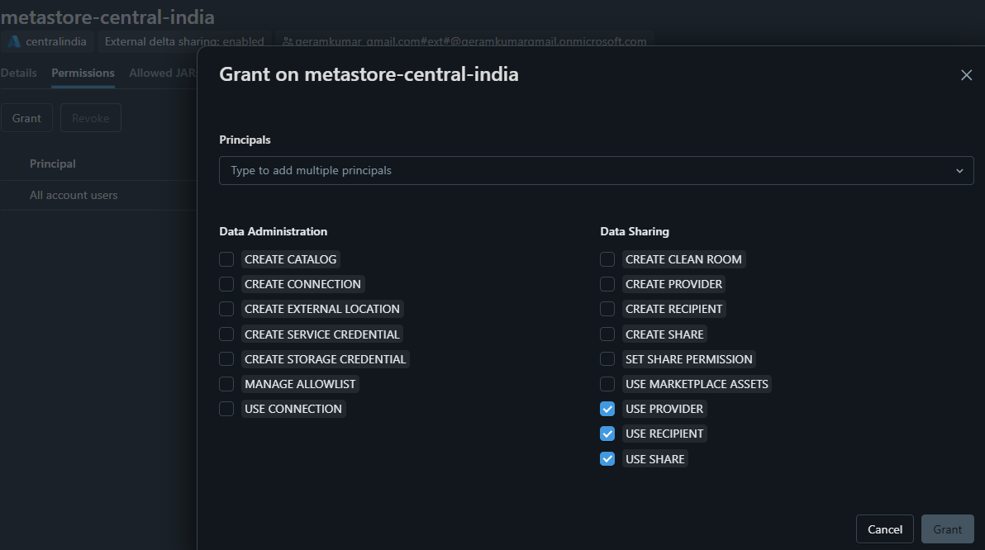

**Step 4: select the catalog -> select delta sharing**

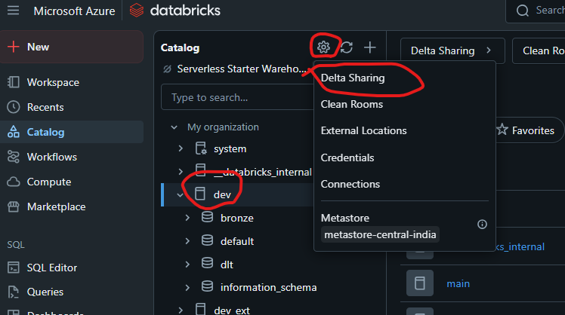

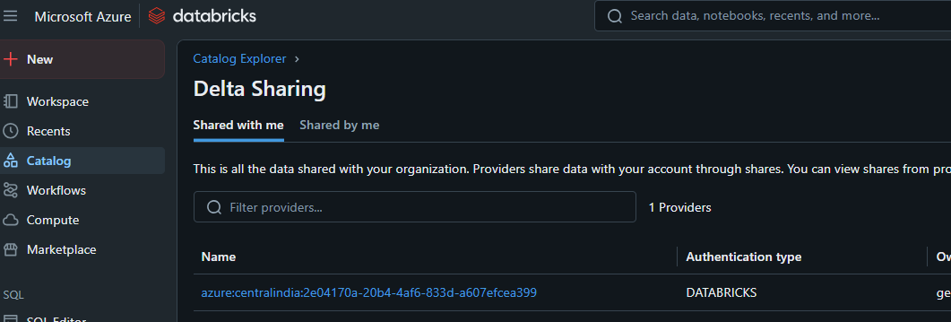

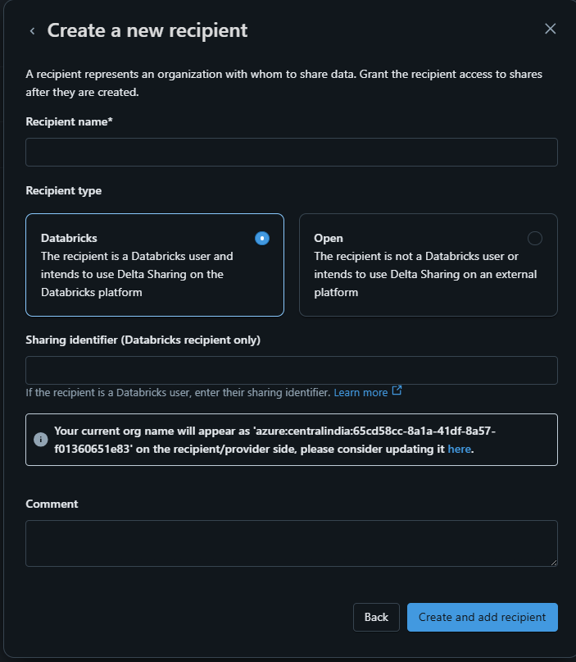

**Serverless Compute in Databricks:**

* Guaranteed isolation via NW isolation. Will be auto scaled based on workload.
* Databricks will take care of Compute cluster. Both compute and runtime will be billed by Databricks.
* Cluster will reside in Control plane in your databricks account
* Serverless is available for some regions. WIP.
* Need to be enabled.

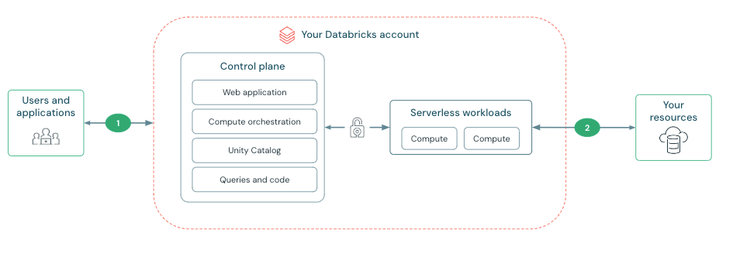

**Enable Serverless compute:**

Under accounts -> settings -> Enable “Serverless compute for Notebooks and workbooks”

**Serverless compute (Memory Standard 16 GB, High 32 GB):**

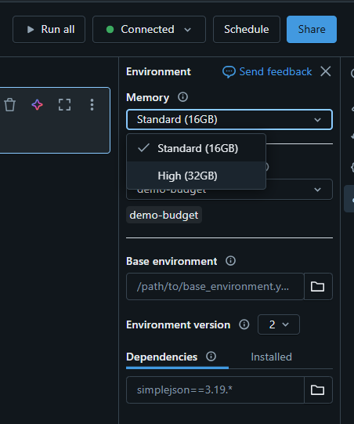

**Serverless configurations and Logs:**

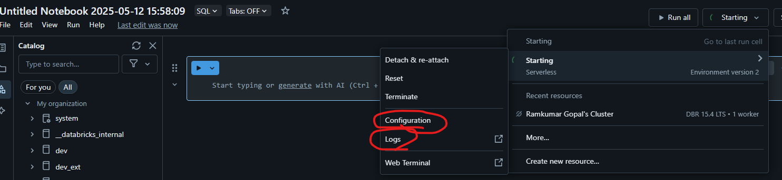

**Use Serverless in Jobs:**

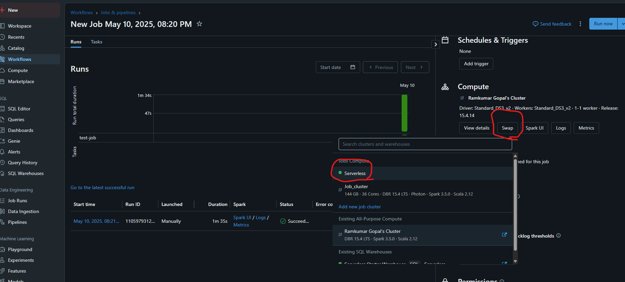

**Serverless Compute in DTL pipelines**

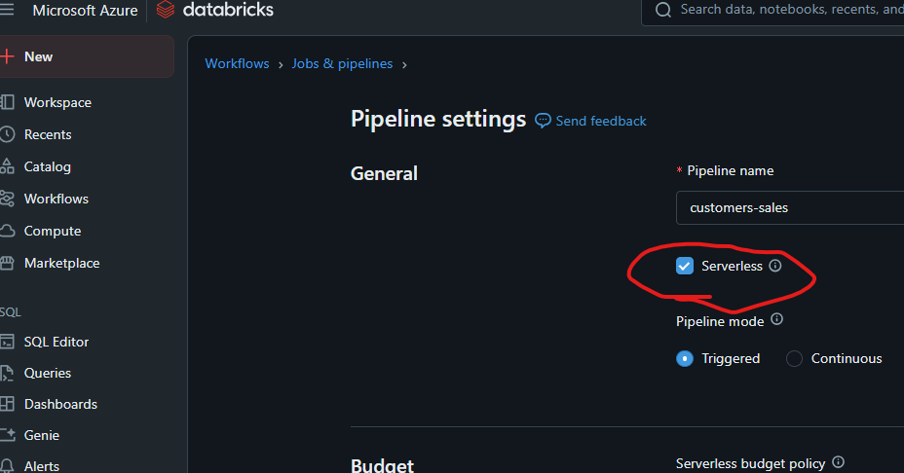

**Parameters across databricks:**

select * from sales where product :=pproduct and amount :>pcountry

this will add a text boxes on top of notebook for passing the value

introduced in 15.4 Databricks runtime.

The **named parameter marker syntax** can be used by simply adding a colon (:)

**SQL Warehouse and DBSQL**

**Azure Databricks Standard vs Premium Tier – Key Feature Comparison**

| Category | Feature | Standard Tier | Premium Tier |
| --- | --- | --- | --- |
| Security & Governance | Table Access Control (Table ACLs) | ❌ Not supported | ✅ Supported – Fine-grained access on tables |
|  | Unity Catalog Support | ❌ Limited/Not supported | ✅ Full support – central metadata & RBAC across workspaces |
|  | Cluster Policies | ❌ Not available | ✅ Enforced for standardizing cluster configurations |
| Monitoring & Auditing | Audit Logs (Diagnostic Settings) | ❌ Basic (limited diagnostic logs) | ✅ Full – via Azure Monitor, Log Analytics, Event Hub |
| Data Access & Controls | Notebook Permissions | ❌ No notebook-level permissions | ✅ Fine-grained notebook access control |
|  | Repos Access Control | ❌ Not supported | ✅ Git-integrated with permissions |
|  | Databricks SQL Permissions | ❌ Not available | ✅ Row-level, column-level security via Unity Catalog |
| Compliance & Enterprise Readiness | HIPAA, SOC, ISO Compliance | ✅ Partial | ✅ Full – meets enterprise compliance needs |

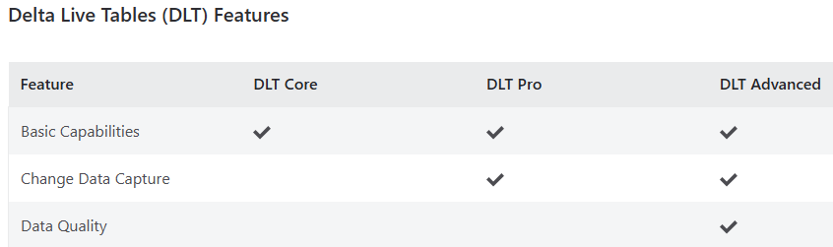

**Pricing:**

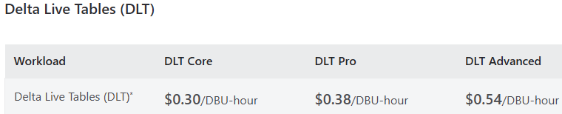

**Workload & Pricing:**

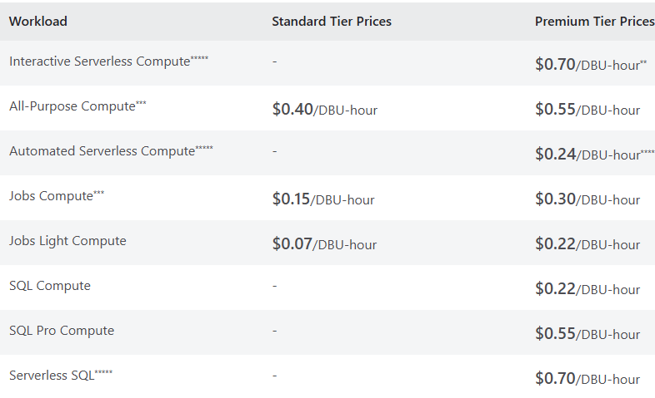

**DBU Pre-purchase & Discounts:**

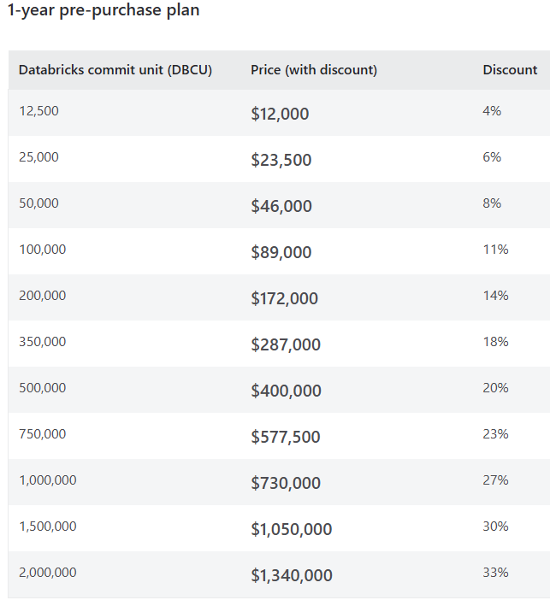

**Azure VM cost depends on:**

* Enterprise level agreements
* Region
* OS (Windows, Linux)
* VM Size and series
* Type of storage (HDD, SSD – standard/premium/ultra
* Azure Hybrid benefit
* Pricing Model
  + Pay as you go
  + Reserved instance
  + Spot Instances

**Commonly used Azure VM in Databricks – General Purpose**

**standard_d16ads_v5**

* General purpose VM – AMD based, Temp disk, Premium storage

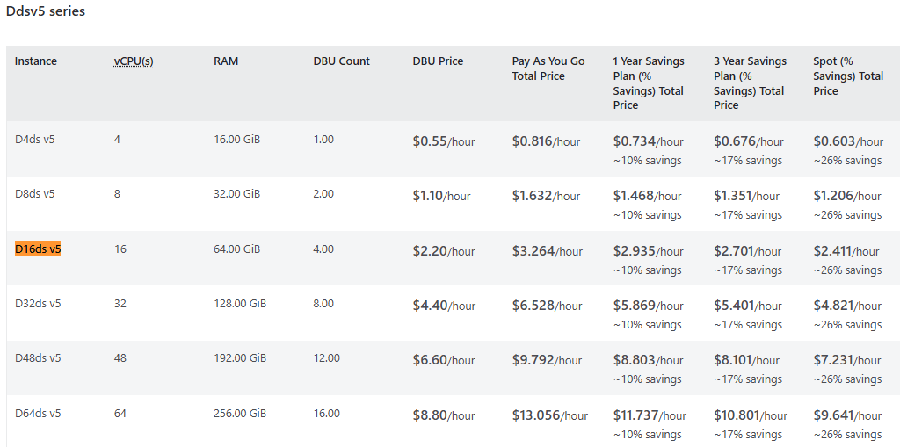

**Comprehensive Guide to Optimize Databricks, Spark and Delta Lake Workloads**

**Databricks Performance Benefits**

**1. Photon Engine (for SQL & Python Workloads)**

**Databricks’ Photon is a vectorized query engine written in C++, delivering 2x–20x faster performance for SQL and Python workloads compared to the traditional Spark engine.**

**2. Databricks Runtime Optimizations**

Databricks Runtime includes **optimized libraries**, improved **Spark scheduling**, and execution enhancements that outperform open-source Apache Spark.

3. **Autoscaling Clusters (Vertical & Horizontal Scaling)**

**4. Intelligent Caching (Databricks IO Cache)**

**5. Adaptive Query Execution (AQE)**

**6. Broadcast Hash Joins for Small Tables**

**7. File Compaction and Partition Pruning**

*df.write.partitionBy("year", "month").parquet("/mnt/data/sales_partitioned")*

*df = spark.read.parquet("/mnt/data/sales_partitioned")*

*df.filter("year = 2023 AND month = 1").count()*

**8. Cluster Warm Pools (Cluster Reuse)**

Databricks provides **job clusters** with pre-warmed pools, reducing cluster start-up time and boosting job SLAs.

**Delta Lake Performance Tuning (Mostly in-built. No action required)**

• **Data Skipping via Statistics:** Faster queries by skipping irrelevant data files using metadata.

-- Delta Lake automatically leverages statistics for data skipping

SELECT * FROM delta_table WHERE date = '2025-05-13';

• **File Compaction**: Improved read speed by **reducing small file** overhead.

OPTIMIZE delta_table

• **Z-Ordering**: Enhanced filtering performance through **data co-location**.

OPTIMIZE delta_table ZORDER BY (user_id, event_timestamp)

• **Delta Cache**: Blazing-fast **reads from local disk** for frequent data (**automatic**).

-- Delta Cache is automatically utilized by the Databricks runtime

SELECT count(*) FROM delta_table WHERE country = 'USA'; -- Subsequent runs faster

• **Transactional Writes**: Predictable ingestion, avoiding partial/corrupted data.

-- Transactions ensure atomicity of write operations

INSERT INTO delta_table VALUES (...);

DELETE FROM delta_table WHERE session_id = '...';

• **Bloom Filters**: Further data skipping for high-cardinality columns (configuration dependent).

-- Enabling Bloom filters (implementation details may vary by Databricks runtime)

ALTER TABLE delta_table SET TBLPROPERTIES ('delta.enableBloomFilter' = 'true', 'delta.bloomFilter.columns' = 'user_id');

• **Faster Schema Evolution**: Avoids costly rewrites during schema changes.

ALTER TABLE delta_table ADD COLUMNS (new_column STRING);

• **Deletion Vector** **Optimized Updates/Deletes**: Efficient modification of specific records.

UPDATE delta_table SET status = 'inactive' WHERE last_activity < '2025-05-01';

DELETE FROM delta_table WHERE age < 18;

• **Time Travel**: Fast historical queries by accessing relevant past data.

SELECT * FROM delta_table VERSION AS OF 1;

SELECT * FROM delta_table AT TIMESTAMP AS OF '2025-05-10 10:00:00';

**Public Cloud** – Common bad practices and recommendations

**Bad practices:**

* Procure and forget
* Do not review the utilization and bill
* Lack of knowledge on the choices and cost implications
* Oversizing and under-utilization
* Forget to setup budgets and alarm
* Not spending time for reviews, resource clean-ups, right-sizing

**Recommendations:**

* Shutdown unused resources
* Right-size underutilized resources
* Enable auto-scaling
* Terminate after x minutes
* Choose the right instance type and size
  + Reserved, PAY, Spot
* Choose PAAS over IAAS
* Tag your Azure resources
* Set budgets/alerts
* Regularly review the resources and utilizations

**Azure Blob Storage vs ADLS Gen2**

|  |  |  |
| --- | --- | --- |
| **Feature** | **Azure Blob Storage** | **Azure Data Lake Storage Gen2 (ADLS Gen2)** |
| Purpose | General-purpose object storage for various storage scenarios. | Optimized for big data analytics workloads, including machine learning, data warehousing, and data lake architectures. |
| Namespace | Flat namespace (containers and blobs) | Hierarchical namespace (directories and files) - like a file system |
| File System | No built-in file system semantics | Hierarchical namespace, file system semantics |
| Analytics | Good for storing data for analysis, but not optimized for analytical workloads. | Optimized for big data analytics, offering better performance and cost-effectiveness in analytics scenarios. |
| Security | Access control through containers, shared access signatures (SAS). | Role-based access control (RBAC), Azure Active Directory (AAD) authentication, POSIX permissions, ACLs. |
| Hadoop Compatibility | Not natively Hadoop compatible. | Hadoop-compatible storage (supports Apache Hadoop ecosystem, including Hive and Spark). |
| Performance | Good storage retrieval performance, but may be slower for large-scale analytics. | Better storage retrieval performance, especially for analytical workloads, due to hierarchical namespace. |
| Cost | Potentially higher cost for analytical workloads due to less optimized architecture. | Lower cost for analytical workloads due to optimized architecture and features. |
| Soft Delete | Soft delete feature available. | No soft delete feature. |
| Hierarchical Organization | Data organized into containers and blobs, no inherent hierarchical structure. | Data organized into directories and files, allowing for better organization and management of large datasets. |
| Use Cases | General-purpose data storage, media storage, web hosting, backups, etc. | Big data analytics, machine learning, data warehousing, data lake architectures. |

**ADLS Redundancy Types**

|  |  |
| --- | --- |
| **Redundancy Type** | **Description** |
| Locally Redundant Storage (LRS) | Stores three copies of your data within a single physical location (data center). Suitable for applications needing high availability within a region but not for regional disasters. |
| Zone-Redundant Storage (ZRS) | Replicates your data synchronously across three separate availability zones within the same region. Each zone has independent power, cooling, and networking, offering protection against zonal failures. |
| Geo-Redundant Storage (GRS) | Stores three copies of your data in the primary region and replicates it to a secondary region (geographically distant). This protects against regional outages and disasters. |
| Geo-Zone-Redundant Storage (GZRS) | Combines the benefits of ZRS and GRS. It replicates your data within three zones in the primary region and also asynchronously replicates it to a secondary region. |

**Azure Data Services for Azure Data Architect**

**Azure Data Lake Storage Gen2 (ADLS Gen2)**

**1. Features**

| **Feature** | **Description** |
| --- | --- |
| Hierarchical Namespace | Organize data in directories for efficient data management. |
| Security & Access Control | Supports Azure AD integration and fine-grained ACLs. |
| Scalability | Scalable to handle large volumes of structured/unstructured data. |
| Delta Lake Integration | Supports Delta Lake for ACID transactions, data versioning, and schema enforcement. |
| Cost-Effective Storage | Offers Hot, Cool, and Archive tiers for cost-efficient data storage. |
| High Availability | Use RA-GRS replication for geo-redundant storage. |

**2. Use Cases**

| **Use Case** | **Description** |
| --- | --- |
| Big Data Analytics | Store massive data for Spark, Hadoop workloads, and analytics. |
| Machine Learning | Ideal for storing datasets for ML model training and experimentation. |
| Data Warehousing | Acts as raw and staging storage for data warehousing in Azure Synapse. |
| IoT Data Storage | Stores real-time sensor data or logs for IoT applications. |
| Data Lakehouse | Use Delta Lake for combining data lake flexibility with data warehouse features. |
| Archiving | Store infrequently accessed data in Cool and Archive tiers for long-term cost-effective storage. |

**3. Approximate Cost per Hour**

| **Cost Component** | **Approximate Cost** |
| --- | --- |
| Hot Tier | $0.0184 per GB/month (varies by region) |
| Cool Tier | $0.01 per GB/month |
| Archive Tier | $0.002 per GB/month (cheaper but retrieval costs higher) |
| Transaction Costs | $0.0004 per 10,000 operations (e.g., PUT, GET, LIST requests) |
| Retrieval Costs | $0.02 per GB (for Cool and Archive tiers) |
| Replication Costs | RA-GRS adds extra cost based on replication region and data volume. |

**4. Service Offerings**

| **Service Offering** | **Description** |
| --- | --- |
| ADLS Gen2 | Combines Azure Blob Storage with enhanced features for big data analytics. |
| Hot Tier | For frequently accessed data; optimal for real-time analytics and processing. |
| Cool Tier | For infrequent access data; lower cost for long-term data storage. |
| Archive Tier | Cheapest option for infrequently accessed data; higher retrieval latency and costs. |
| RA-GRS (Geo-Redundant Storage) | Provides geo-replication across regions for disaster recovery and high availability. |
| ZRS (Zone-Redundant Storage) | Provides multi-zone replication within a region for high availability and fault tolerance. |
| Delta Lake | ACID transaction support, schema enforcement, and data versioning for analytics and machine learning. |

**5. Recommendations**

| **Recommendation** | **Description** |
| --- | --- |
| Use ADLS Gen2 for Big Data Workloads | Best suited for storing large datasets for Hadoop, Spark, and other analytics frameworks. |
| Leverage Delta Lake for ACID Transactions | Use Delta Lake for managing large-scale data with reliability and consistency. |
| Store Active Data in Hot Tier | Store frequently accessed data in the Hot Tier for low-latency access. |
| Archive Infrequently Accessed Data | Use Cool and Archive tiers to store cold data at a lower cost. |
| Enable RA-GRS for High Availability | Use RA-GRS for critical workloads that need geo-redundancy and disaster recovery. |
| Design Efficient Partition Keys | Plan partitioning strategy to improve query and processing performance for large datasets. |

**📌 Key Considerations for Azure Data Architect:**

* Delta Lake on ADLS Gen2: Delta Lake enhances ADLS Gen2 by adding ACID transactions, schema evolution, and time travel for better data management.
* Scalability: ADLS Gen2 is designed to scale to exabytes of data, making it a robust choice for big data analytics, ML, and IoT workloads.
* Cost Optimization: Use Cool and Archive tiers for long-term storage while ensuring Hot Tier is used only for frequently accessed data.
* Security: Leverage Azure Active Directory (AAD) integration and Access Control Lists (ACLs) for fine-grained data access management.

**can you provide 50 databricks tips which only databricks employees know? one example is DBU billing starts when the sparkcontext is available. each not more than 15 words**

• DBU billing starts when SparkContext is available, not notebook execution start.

• Jobs clusters can silently reuse terminated instances if configured properly.

• %run does not carry over all environment variables to the child notebook.

• Autoloader doesn't support schema evolution with nested columns yet.

• Photon engine doesn't support all legacy Spark operations or Python UDFs.

• Delta Lake time travel can significantly impact performance if used heavily.

• Unity Catalog policies can override workspace ACLs silently.

• Autoloader uses checkpoint to avoid reprocessing files even after schema changes.

• DBFS is not recommended for production due to potential mount consistency issues.

• Delta cache is local to the cluster and not shared across all clusters.

• Job cluster startup time improves with pinned runtime versions.

• DBU cost differs based on cluster mode, even for same node type.

• UDFs in SQL can cause Photon to fall back to slower execution paths.

• Workspace UI changes often roll out without clear version updates.

• External locations in Unity Catalog can fail silently if IAM isn’t configured correctly.

• Autoloader with trigger once + cloudFiles.backfillInterval can miss files if misconfigured.

• Repos sync only with default branch; other branches need manual checkout.

• Interactive cluster logs are not retained unless explicitly exported.

• Repos don't support Git LFS or submodules.

• Delta Merge operations are heavy and can bloat transaction logs fast.

• Enable GANG scheduling for optimal Spark + GPU workloads.

• Notebooks executed via Jobs UI have different permission scopes than interactive notebooks.

• Photon accelerates only SQL and Delta operations, not general Spark tasks.

• Serverless compute might take longer to start due to provisioning delays.

• DBFS root is shared across users but not truly collaborative.

• Unity Catalog doesn't yet support streaming Autoloader workflows directly.

• Default cluster policies can silently cap node limits or types.

• Each Job run creates a unique cluster unless configured as shared.

• Notebook widgets don’t persist across Jobs unless redefined each run.

• Delta table vacuum requires table to be closed on all clusters.

• Cluster termination may take minutes even after idle timeout triggers.

• Unity Catalog audit logs aren’t fully visible without enabling diagnostic settings.

• MLflow experiments created via notebooks default to the user’s workspace.

• Cluster pinning prevents automatic runtime upgrades, which can block fixes.

• DBFS mounts may become stale if backing storage credentials expire.

• Managed tables move to workspace storage, not cloud storage, unless external.

• SQL Warehouses don’t support Hive metastore; only Unity Catalog or external.

• Autoloader can skip files with malformed names or extensions silently.

• Global Init Scripts can affect all clusters, including SQL Warehouses.

• Notebooks store execution history locally unless exported manually.

• Serverless SQL warehouses auto-scale within limits defined in SQL endpoint config.

• JDBC connections to Unity Catalog require token scope alignment.

• Overuse of .collect() can silently crash clusters without logs.

• Delta file compaction doesn’t run unless explicitly scheduled.

• Spark UI shows physical plan, but Photon uses a separate optimizer.

• Autoloader logs ingestion metadata to checkpoint path, not to Delta log.

• Table ACLs are not enforced without Unity Catalog being enabled.

• SQL dashboard refreshes may time out without alerts.

• Workspace backups are not automatic—export notebooks to persist.

• Jobs API v2 has different behavior for timeout than v1.

**thanks. provide similar 20 tips on databricks billing which only databricks employees know. each not more than 25 words**

• Billing starts when SparkContext is initialized, not when the first cell is run.

• DBUs accrue during cluster startup and shutdown, not just during active notebook execution.

• Photon DBUs are cheaper but only apply when Photon is actually used in the workload.

• Job clusters accrue DBUs even if your job fails early in execution.

• SQL Warehouses bill per second, clusters bill per minute—important for short-lived workloads.

• Interactive clusters continue billing even when idle, unless an auto-termination policy is enforced.

• Serverless SQL has a higher DBU rate, but no infrastructure management overhead.

• Streaming jobs continue billing as long as cluster is running, regardless of trigger interval.

• Stopping a job in UI doesn’t immediately stop billing, due to graceful cluster shutdown time.

• Free tier usage is capped by workspace, not by user, which can cause surprise billing.

• Unity Catalog billing includes audit logging overhead, especially if diagnostic settings are enabled.

• DBU cost differs by cloud provider, even for the same instance size.

• Use cluster pools to reduce startup time, indirectly reducing billed time for jobs.

• Auto-scaling delays can increase DBU cost if jobs wait long for resources.

• Pinning runtimes avoids unplanned upgrades, which can introduce billing inefficiencies or failures.

• Running notebooks via dbutils.notebook.run() doesn’t reduce DBU cost—child notebooks still run fully.

• Jobs with retries can double or triple DBU usage if failures aren’t managed.

• Notebooks left open don’t accrue DBUs unless the cluster is running.

• Cluster policies can enforce lower DBU configurations, saving costs without user intervention.

• Using Spot instances can lower infra cost, but DBU cost stays constant.